Otter Class Home Learning Week 4
English
In English this week we are going to be looking at ‘The Great Fire of London’ and developing our non- fiction writing skills.
You can find out what happens by using this link
https://www.youtube.com/watch?v=Er3GKw8Z3R4
- After watching the video think about what happened- write down some questions that you would like to find the answers to e.g. where did the fire start? Why did the fire start?
- https://classroom.thenational.academy/lessons/to-create-a-timeline-of-the-events-of-the-great-fire-of-london-c8vkje?step=2&activity=video This video will help you sequence the events in the order they happened.
- If you have a newspaper at home- such as the Kentish Gazette- look at the information about newspaper reports on the powerpoint and identify the key features.
- Plan a newspaper report to inform everybody of The Great Fire of London. You can find a template on the Otter home learning page- you can use this to help you set out your ideas or you can print it off.
- Write a newspaper report of The Great Fire of London- remember to include:
- An interesting headline
- What happened
- Where it started
- When it happened

Phonics
On the website below you will find a selection of phonic games. You can sign in free using the following login:
Username jan21
Password home
https://www.phonicsplay.co.uk/
Pick a different game each day for your child to work on. The children would benefit from accessing games from Phase 4 onwards. Do get in contact with us via phone or email if you would like more advice. For those of you who have picked up a pack you can continue with a game from there.

Reading
We have registered for Oxford Owl reading ebooks. It has a selection of ebooks that you and your child can share together. There is a good book called ‘Our Class Tiger’ which you may like to read. The website is:
www.oxfordowl.co.uk
The login details are:
Username: otter class 2020
Password: Otters1

You can also access the Oak Academy library using this link https://library.thenational.academy/ where you can find a selection of books and activities.

Maths
In Maths this week the focus continues to be multiplication and division. There are 5 lessons which can be accessed by clicking on the Year 2 or Year 3 link below. Each day your child needs to watch one video clip which will teach the children the learning for that day. Once the video has finished there are worksheets attached that your child can work through. Whilst you can print the worksheets, you do not need to as your child can write the answers on a piece of paper. You can either send their work to us via a photo or by dropping it into the office so that we can mark it or you can mark it yourself. Once again some of the Year 2 work may be labelled Year 1 and Year 3 labelled Year 2. This is because as the children learn it’s important to recap on previous learning.

Year 2- Multiplication and Division
https://whiterosemaths.com/homelearning/year-2/week-1-number-multiplication-and-division/
Year 3- Multiplication and Division
https://whiterosemaths.com/homelearning/year-3/week-10-number-multiplication-division/

Science
We hope you enjoyed the science experiments from last week. This week we are saving a superhero. The link below takes you to the investigations and will guide you through them. The equipment needed will be things you have at home, feel free to adapt where needed. Once completed, your child could write or draw about what they have learnt. Again we would love to see pictures so do send them or drop off at the office.
https://www.science-sparks.com/make-a-superhero-float/

Topic
Our topic this week will link with our English topic on The Great Fire of London.
History- Find out about Samuel Pepys by watching the videos below:
https://www.youtube.com/watch?v=VarSSAwiimU
https://www.bbc.co.uk/bitesize/topics/z7d7gwx/articles/zhgxcqt
Once you have watched these clips take the time to complete the activities on the second clip and then create a mind map of all that you have learnt about Samuel Pepys. Now have a go at some Art and DT- see below. We hope to see your work on our zoom call or you can always send in some photos.
Art- recreate your own version of The Great Fire of London 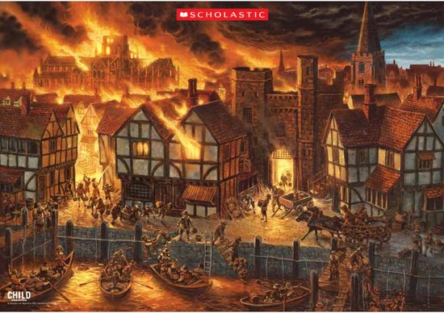

DT- create a model of the bakery where the fire started using junk modelling materials that you can find at home. You might want to model what it was like when it was on fire too.
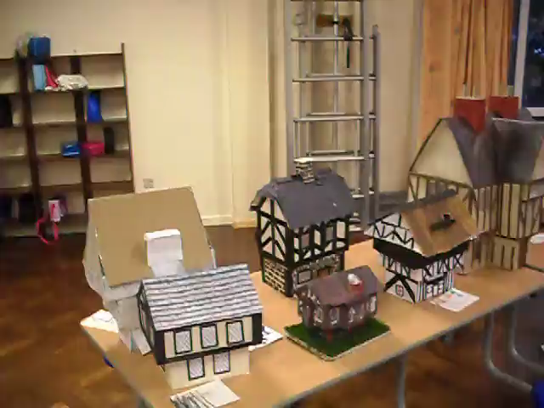
Thank you so much to those of you who have sent us work it was really exciting to see all of your learning. We hope you will have fun with this week’s learning. We are looking forward to seeing your work. Please do contact us if you need any further help or advice - using the class email or by telephoning. We look forward to ‘seeing’ you all on our future Zoom meetings.

