Otter Class suggested home learning activities
English

Reading:
We are sure that you have been reading lots of different types of books whilst you have been at home. We would love to hear about the books have been reading, you may even like to write a short book review recommending a book for the rest of the year group to read, you could do this by writing a short paragraph, you could design a poster or you may draw a picture from your book with a short sentence describing why it is such a good book. We will include the recommendations we receive in our next newsletter. Below are some questions to think about to help you in writing your book review:
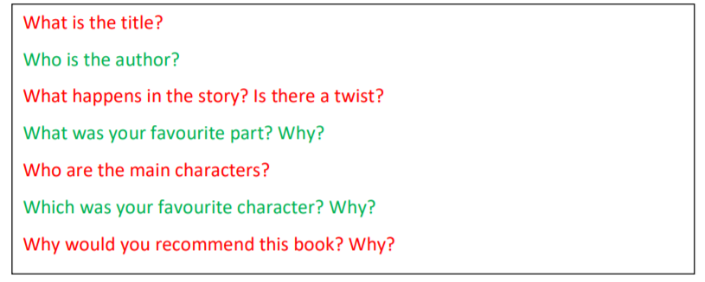

Writing:

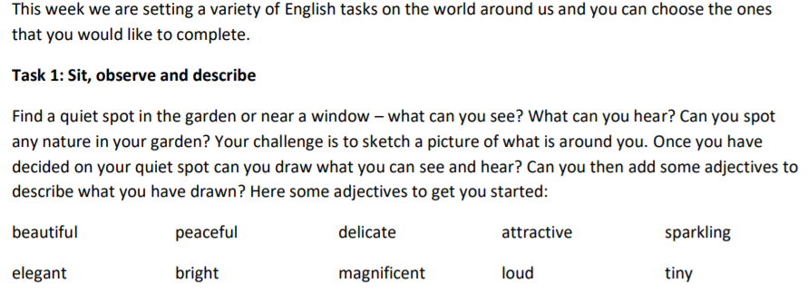

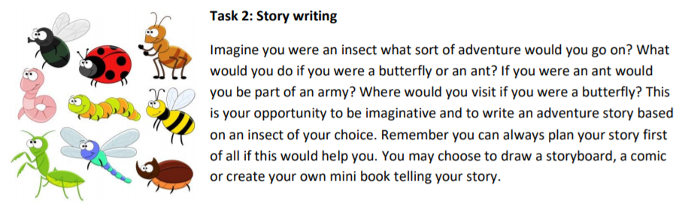

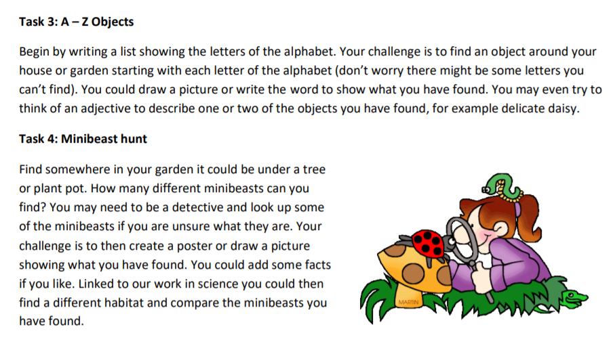

Suggested Maths Activities Maths Year 2

Year 2 link: https://whiterosemaths.com/homelearning/year-2/
This week we have moved on to Summer Term Week 3.
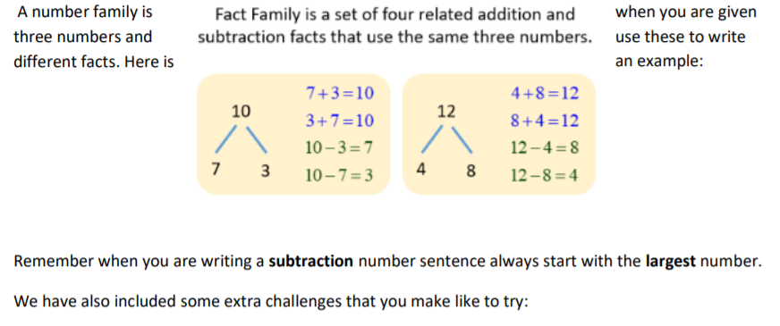

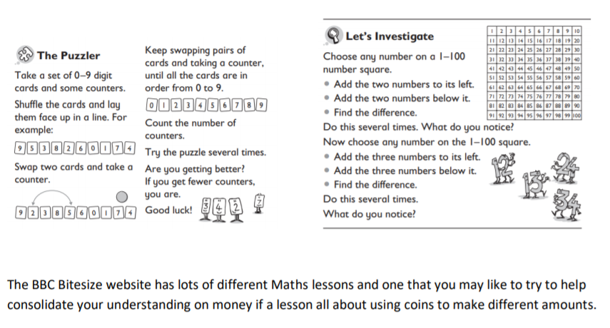
https://www.bbc.co.uk/bitesize/articles/zn4q7nb

Suggested Maths Activities Maths Year 3
Maths https://whiterosemaths.com/homelearning/year-3/
