Otter Class suggested home learning activities
Physical and emotional well being
Exercise Exercise is fun and helps everyone feel energised so we would recommend starting the day with the Joe Wicks live workout at 9:00am or you can take part at a time that suits you by joining in with an existing uploaded video https://www.youtube.com/channel/UCAxW1XT0iEJo0TYlRfn6rYQ)
If you are unable to view or participate, you may wish to create your very own fitness challenge. Can you think of an exercise for each letter of the alphabet? Then you could create different routines by spelling out your name or other words?

PSHE A useful You Tube channel for both yoga and mindfulness is Cosmic Kids. This is a fantastic resource that has a variety of videos that help teach Yoga for children. The videos range in length from 5mins to 15mins and can be sorted into videos that help, focus, calm or activeness. https://www.youtube.com/channel/UC5uIZ2KOZZeQDQo_Gsi_qbQ?sub_confirmation=1

English

Writing
This week we have a poetry task for you to do, based on Pie Corbett’s poem “If I had wings”.
Firstly read the poem through a few times so you get used to the words and the rhythm.
What features can you spot?
Can you underline or write down any repeating phrases or lines?
Can you underline the verbs in yellow, adjectives in green and nouns in orange?
What do you notice about the order of these word types?
Are they in a repeating pattern? How many verses does it have?

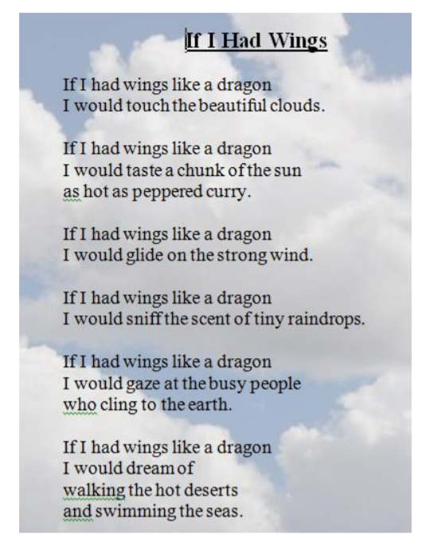

Next you could brainstorm some ideas about what you would do if you had wings for a day.
You might like to watch this clip to help with your ideas; https://www.youtube.com/watch?v=pI63Rbxml5U

Try to use the most interesting adjectives and verbs and even adverbs that you can think of. The lists below might help you.
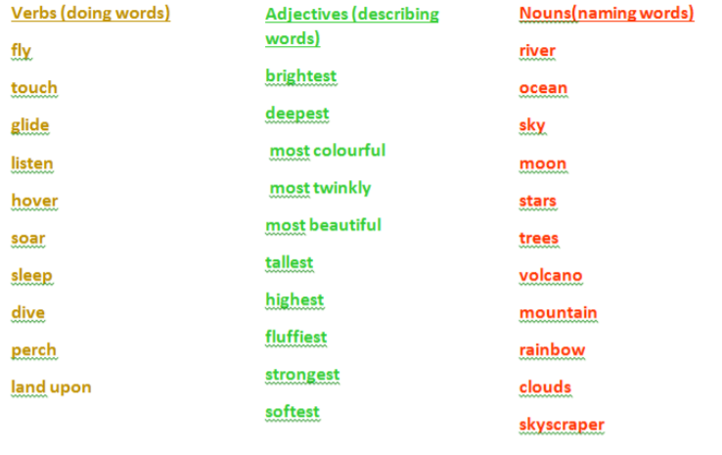
For example;
I would touch the most shimmering stars in the beautiful night sky.
I would glide majestically over the tallest snow-capped mountains.
Now that you have your ideas you can start to create your own poem. Remember to follow Pie Corbett’s structure. You might want to change the flying creature to an eagle, an alicorn or even a hippogriff. Try to create four to six verses
Verse 1: If I had wings like a hippogriff
I would soar elegantly over huge green forests.
Verse 2: If I had wings like a hippogriff I would glide gently across crystal lakes, trailing my talons in their cool waters.
Finally you could try to learn your poem off by heart. Making up actions will help you to remember the words. Practice performing your poem using expression to bring you poem to life. Then perform your poem to an audience.

Suggested Maths Activities Maths Year 2
Maths Year 2 link: https://whiterosemaths.com/homelearning/year-2/

This week we have moved on to Summer Term Week 2. This week continues our learning on measurement. You will be comparing and ordering length and then solving some problems. Make sure you take time to read the questions carefully and use drawing to help you if you need to, they really help
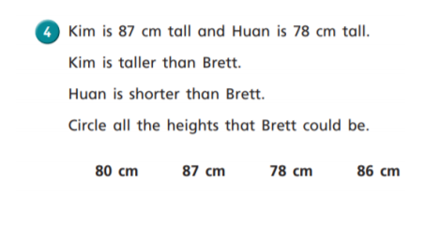
Top tips: We would draw three stick men and then label them with the facts that are given.

Here are a few extra challenges for you as well. Please remember these are extra challenges if you would like to have a go at them, as I know some of you in Year 2 love being given an extra challenge.

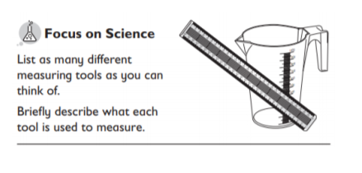

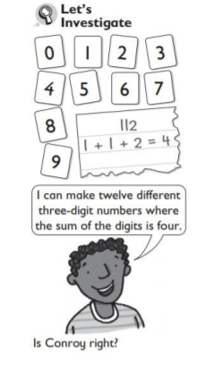

Suggested Maths Activities Maths Year 3
Maths https://whiterosemaths.com/homelearning/year-3/
This weeks’ maths continues with fractions looking at adding and subtracting fractions and some fraction problem solving. Please note this week we are on Summer Term – Week 2 (w/c 27th April). A common misconception when adding and subtracting fractions is that children sometimes add the denominator together. So, when adding 2/5 + 1/5 it does not become 3/10. The denominator stays the same. The denominator is how many parts the whole has been split into. 