Otter Class suggested home learning activities
Physical and emotional well being
Exercise Exercise is fun and helps everyone feel energised so we would recommend starting the day with the Joe Wicks live workout at 9:00am or you can take part at a time that suits you by joining in with an existing uploaded video https://www.youtube.com/channel/UCAxW1XT0iEJo0TYlRfn6rYQ)
If you are unable to view or participate, you may wish to create your very own fitness challenge. Can you think of an exercise for each letter of the alphabet? Then you could create different routines by spelling out your name or other words?

PSHE A useful You Tube channel for both yoga and mindfulness is Cosmic Kids. This is a fantastic resource that has a variety of videos that help teach Yoga for children. The videos range in length from 5mins to 15mins and can be sorted into videos that help, focus, calm or activeness. https://www.youtube.com/channel/UC5uIZ2KOZZeQDQo_Gsi_qbQ?sub_confirmation=1

English

Writing
This week we have a challenge for you based on animals. We would like you to write us a “what am I?” riddle so we can try to guess the animal you are describing by the clues you have given us, try not to make them too hard for us!
Can you guess the animal we are describing?

I am the biggest cat in the world,
I have orange, black and white stripes which help me to blend into the forest,
Unlike other cats I am very good at swimming,
My favourite food is deer and pigs,
What am I?
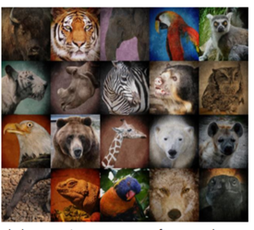

Your first job is to choose an animal. It can be any type of animal a pet, a bird or even a reptile.
Next spend some time researching some interesting facts about your chosen animal. Here are some websites that may help you or I am sure some of you may have some non-fiction books at home to help you
https://www.natgeokids.com/uk/category/discover/animals/
https://animalfactguide.com/animal-facts/
Now you have researched your chosen animal you are ready to start writing your riddle.
Remember to start each clue on a new line, use capital letters, make your clues as interesting as you can and finish your riddle with what am I?
You could draw a picture of your animal and hide it under flap so people at home can see if they have guessed correctly.
As an extra challenge you may like to create a fact file about your chosen animal.
You could draw a picture and write some facts about your chosen animal.
You may like to include what they eat, where they live and other interesting facts you have found out.
We can’t wait to read your riddles and see if we can guess which animal you are describing.

Suggested Maths Activities Maths Year 2
link: https://whiterosemaths.com/homelearning/year-2/
This week we have moved on to summer term week 1. This week finishes with some problems involving fractions and then moves on to measuring. You may like to go outside and find some objects to measure, what is the longest object you can find? What is the shortest object you can find? Remember when you are measuring you need to make sure that you start measuring from 0.
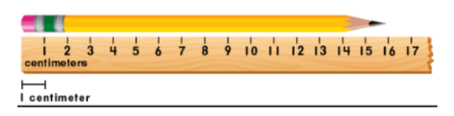

Suggested Maths Activities Maths Year 3
https://whiterosemaths.com/homelearning/year-3/
This weeks’ maths continues with fractions looking at equivalent fractions and comparing fractions. The number at the top is the numerator and the number at the bottom is the denominator.
Remember that a higher denominator does not necessarily mean that the fraction is bigger. For example – ½ is bigger than 1/8 even though 8 is a bigger number than 2.
Remember that the denominator is the number that the ‘whole’ is split into. You can learn about equivalent fractions practically by counting out numbers of objects and dividing into fractions/parts, cutting pieces of fruit up, using lego – make it as fun as you like!
