Otter Class suggested home learning activities

Physical and Emotional Wellbeing
Exercise
Exercise is fun and helps everyone feel energised so we would recommend starting the day with the Joe Wicks live workout at 9:00am or you can take part at a time that suits you by joining in with an existing uploaded video https://www.youtube.com/channel/UCAxW1XT0iEJo0TYlRfn6rYQ
If you are unable to view or participate, you may wish to create your very own fitness challenge. Can you think of an exercise for each letter of the alphabet? Then you could create different routines by spelling out your name or other words?
PSHE
A useful You Tube channel for both yoga and mindfulness is Cosmic Kids. This is a fantastic resource that has a variety of videos that help teach Yoga for children. The videos range in length from 5mins to 15mins and can be sorted into videos that help, focus, calm or activeness. https://www.youtube.com/channel/UC5uIZ2KOZZeQDQo_Gsi_qbQ?sub_confirmation=1

Writing
This week we have challenges for you based on the character Mr Twit from Roald Dahls “The Twits”. Firstly read the chapters below about Mr Twit and, using Roald Dahls description to guide your imagination, draw an illustration of what you think Mr Twit looks like.

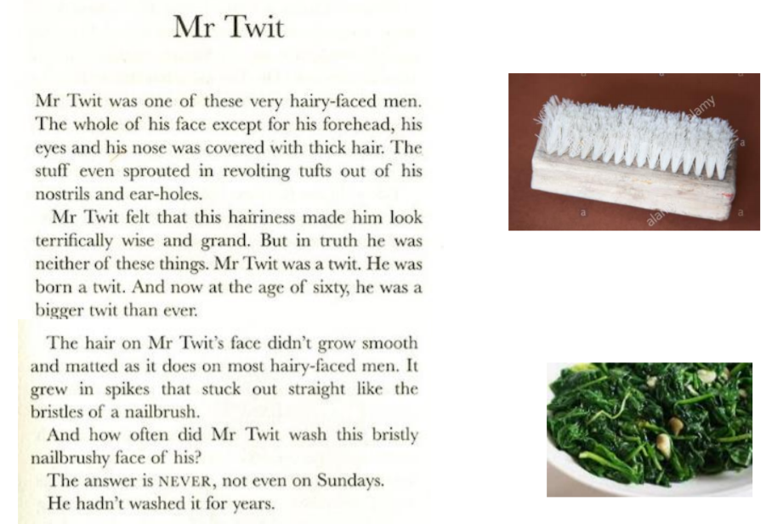

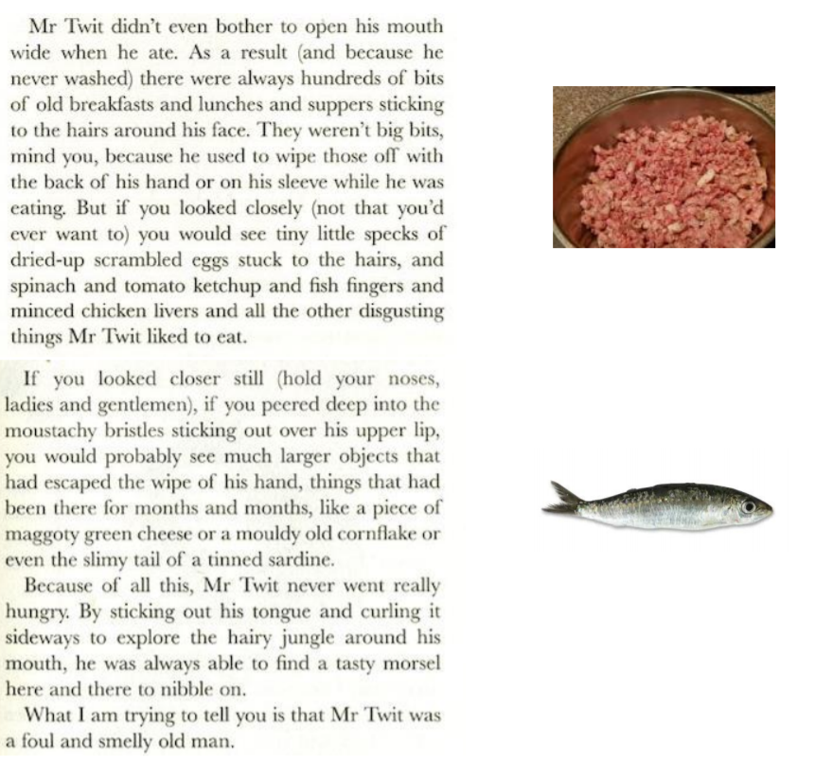

Secondly you could write down some questions that you would like to ask Mr Twit if you had the chance to meet him. You might want to find out if he owns a hair brush or ask, what do chicken livers taste like? Remember to start each question with a capital letter and end with a question mark.
Now you have your questions you are ready for the next challenge. Find someone who can read your questions to interview you, whilst you pretend to be Mr Twit. You might want to dress up like the picture that you have drawn, mess your hair up a bit and maybe create a beard to wear for the interview.
Then, using what you know about this revolting man and your amazing imagination, answer the questions as you think Mr Twit would.
Finally you could have a go at creating your own revolting character. You could draw a picture and label it with lots of brilliant adjectives, descriptive phrases and similes. You might want to create a fact file with a picture and facts about your character such as, how old they are, why they are so revolting, any bad habits they may have, what their personality is like or you might want to simply write a descriptive paragraph. We can’t wait to see how creative you have been.

Year 2 Maths:
Maths Year 2 link: https://whiterosemaths.com/homelearning/year-2/
Week 2 on White Rose will focus on fractions. You can practise recognising and finding a third, recognising unit and non-unit fractions and find equivalent fractions. Remember when we read a fraction like 1/3 we can say “one out of three equal parts” to help us understand more.
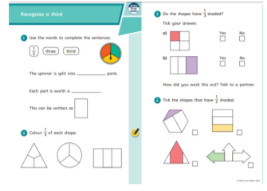

Year 3 Maths:
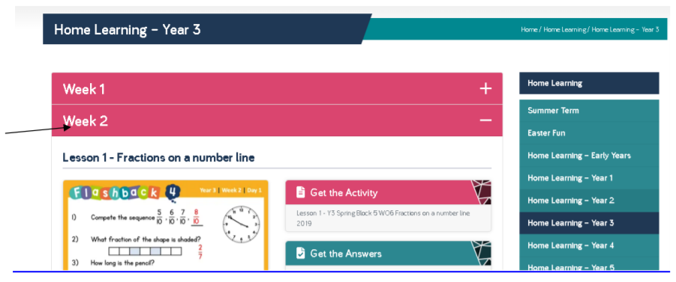

https://whiterosemaths.com/homelearning/year-3/
This weeks’ maths continues with fractions – on a number line, fractions of sets of objects and then at the end of the week equivalent fractions. A common misconception when learning about fractions is that children think that the higher denominator (bottom number) means that the fraction is bigger. For example – they may think that 1/8 of a piece of cake is more than ½. Remember to reinforce that the denominator (bottom number) is the number that the ‘whole’ is equally split into.

