Otter Class suggested home learning activities
Year 2:
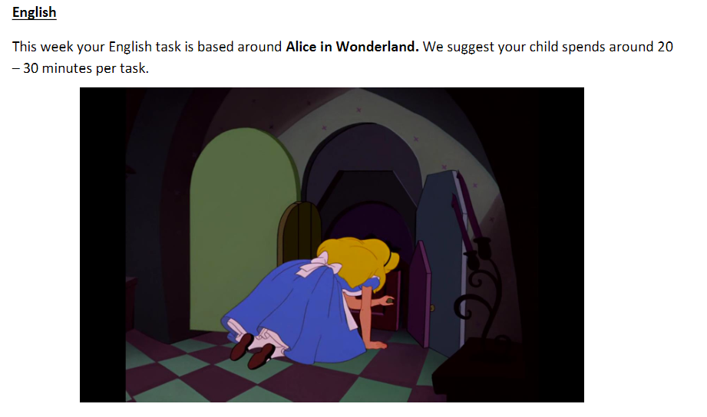
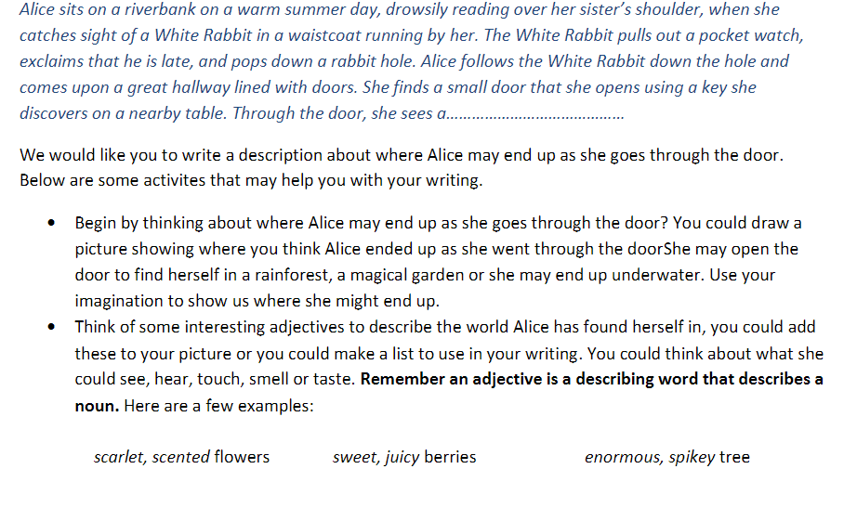

To help you with your writing, you might like to start using a simple plan like the one below:

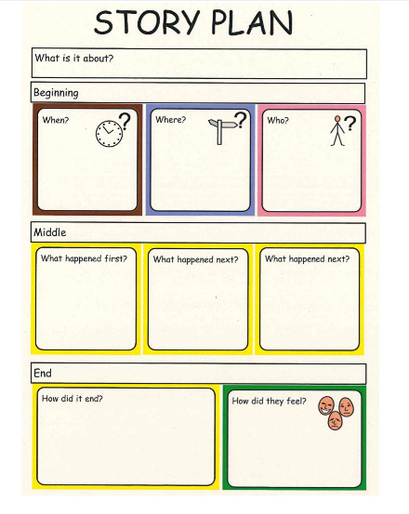

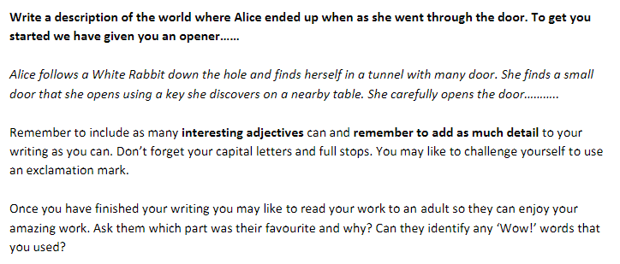

Year 2

Maths Whiterose Maths have created some learning tools for your children to use at home. It begins from the point that we got up to in class so this will be new learning for the children. It is suggested that children complete 1 lesson per day, each lesson includes a short learning video, a downloadable task and a downloadable set of answers which enables your child to self-mark (don’t forget those green pens to attempt questions again if it is incorrect). When you click the link below you will find there are a couple of weeks of lessons there – please start at WEEK 1 – Lesson 1 – Find three quarters Year 2 link:
https://whiterosemaths.com/homelearning/year-2/

Year 3:
