Otter Class suggested home learning activities English

Reading
We hope that some of you have made use of the online books available on the Oxford Owl Reading website. For those of you that are yet to access it we have included the login details below: Reading website www.oxfordowl.co.uk
Username: otter class 2020
Password: Otters1
Here are some reading challenges for you to try:
Read a non-fiction book | Write your own book based on a book you have read | Read a book in your pyjamas
Read a book recommended by a friend | Read a comic or a magazine | Read a book that someone in your family read when they were  young

Writing
Over the past three months we have written for many different purposes. We have written stories, poems, letters and instructions. This week we would like you to choose one of these and create a piece of writing of your choice. Below are some ideas for you:
- Can you choose an interesting an animal and spend some time researching this before you use all of the information you have found out to create a fact file, leaflet or even a booklet? You may choose an animal you don’t know much about or even decide that you would like to find out about a few different animals.
- Using the story plan below can you create your own imaginative story? You could decide to take your favourite characters from a book on an adventure such as Flat Stanley or you may decide to write your own version of a book you have read.
- Can you write a letter to someone you haven’t seen for a long time? You could tell them all about what you have been doing since lockdown began, what you are looking forward to and asking them a couple of questions. If you post it to them they may even send you a reply!
- Could you write a poem all about the summer? You could think about all the lovely activities that you do in the summer like going to the beach, eating ice cream or going on holiday. Remember poems often have repetitive phases or you may even try to write an acrostic poem.

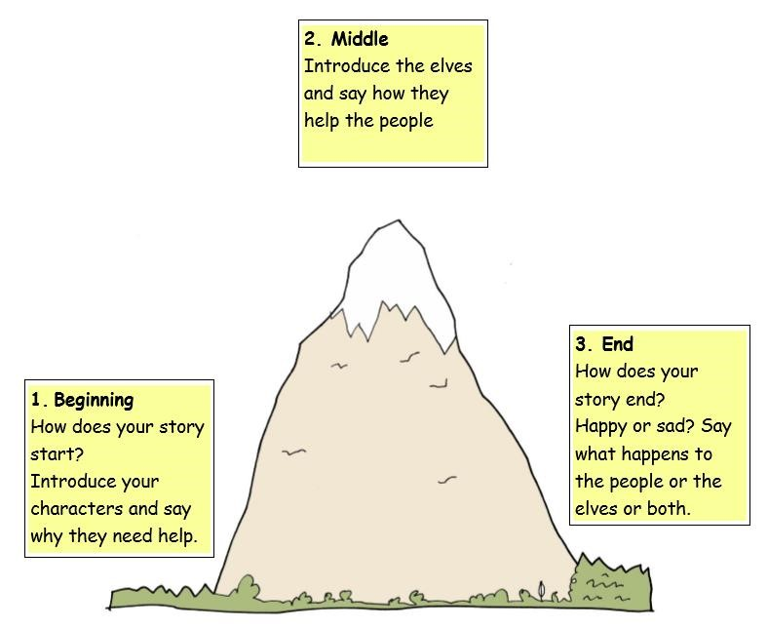

Suggested Maths Activities Maths Year 2 and Year 3

Summer Term - Week 7 (w/c 8th June)

This week we have moved on to Summer Term Week 10. This week we will be learning about measuring mass in grams and kilograms at the start of the week before moving on to looking at capacity. Remember you need to begin by watching the video on the White Rose website and you then need to go onto the school website to download the worksheets. The links for each are below:
Videos: https://whiterosemaths.com/homelearning/year-2/
Our top tips would be to look carefully at the scale and work out what each interval is worth.
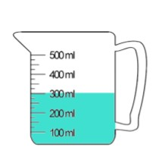
What are we measuring in?
We are measuring in millimetres
What is each interval worth?
Each interval is worth 25ml
There is 300ml in the jug.

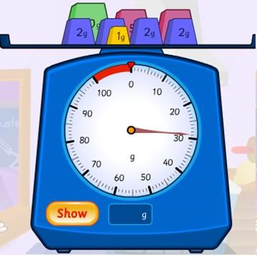
What are we measuring in?
We are measuring in grams
What is each interval worth?
Each interval is worth 1g
There is 29g on the scales.

Year 3

Maths Activities
https://whiterosemaths.com/homelearning/year-3/ this link will take you to the videos for the lessons.

Find the videos attached on the Otter Class page

Summer Term Week 10
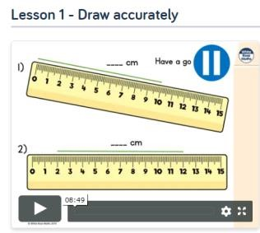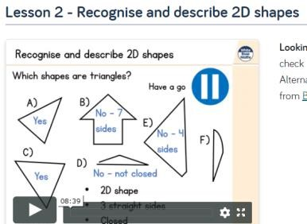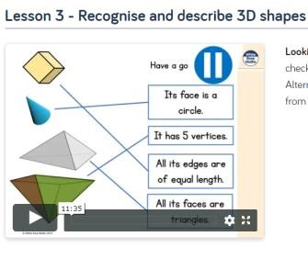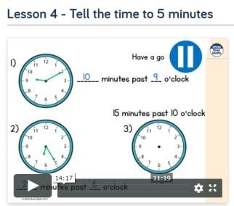

This week’s learning starts off with a lesson on drawing and measuring accurately, using some of the vocabulary you learned last week. Then you will move on to a revision lesson on 2d and 3d shapes, finishing off with a lesson on time( telling time to 5 minutes).

