Otter Class suggested home learning activities English

Reading
We hope that some of you have made use of the online books available on the Oxford Owl Reading website. For those of you that are yet to access it we have included the login details below: Reading website www.oxfordowl.co.uk
Username: otter class 2020
Password: Otters1
Here are some reading challenges for you to try:
Read a non-fiction book | Write your own book based on a book you have read | Read a book in your pyjamas
Read a book recommended by a friend | Read a comic or a magazine | Read a book that someone in your family read when they were  young

Writing
This week our focus links to Science and we are going to find out about different materials and their properties. Can you find a selection of materials at home and choose some of them to write an information page about. There are some word mats and information pages to help you write about each material attached. You may want to include the following:
- Words to describe the properties of the material e.g. bendy, hard,
- What the material can be used for
- Where the material can be found

Suggested Maths Activities Maths Year 2 and Year 3

Summer Term - Week 7 (w/c 8th June)
You are going to be learning lots of different words such as right, left, up, down, backwards, forwards, half turn and quarter turn.
As a warm up you may like to play a quick game with someone at home, ask them to give you instructions to follow such as move forwards, step left, step right, etc. You could then swap roles and you could give someone instructions to follow.
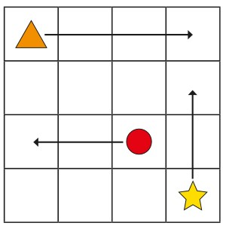
Looking at the grid how would you describe the way the triangle is moving?
The triangle is moving right.
Looking at the grid how would you describe the way the circle is moving?
The triangle is moving left.
Looking at the grid how would you describe the way the star is moving?
The triangle is moving up.
Our top tip would be to read the instructions and look at the pictures carefully to identify the movement or turn being made.

Now complete the worksheet on the website.

Year 3
Summer Term Week 9

Summer Term - Week 9 (w/c 22nd June)
This week we are moving on from fractions and focussing on shapes and angles. Watch the video first before completing the worksheet.
