Otter Class suggested home learning activities English

Reading
We hope that some of you have made use of the online books available on the Oxford Owl Reading website. For those of you that are yet to access it we have included the login details below: Reading website www.oxfordowl.co.uk
Username: otter class 2020
Password: Otters1

Writing
This week are going to be finding out about the life cycle of different minibeasts. Can you choose a minibeast and write about each stage of the life cycle.
You will find some word mats and powerpoints attached to help make sure you use the correct vocabulary.
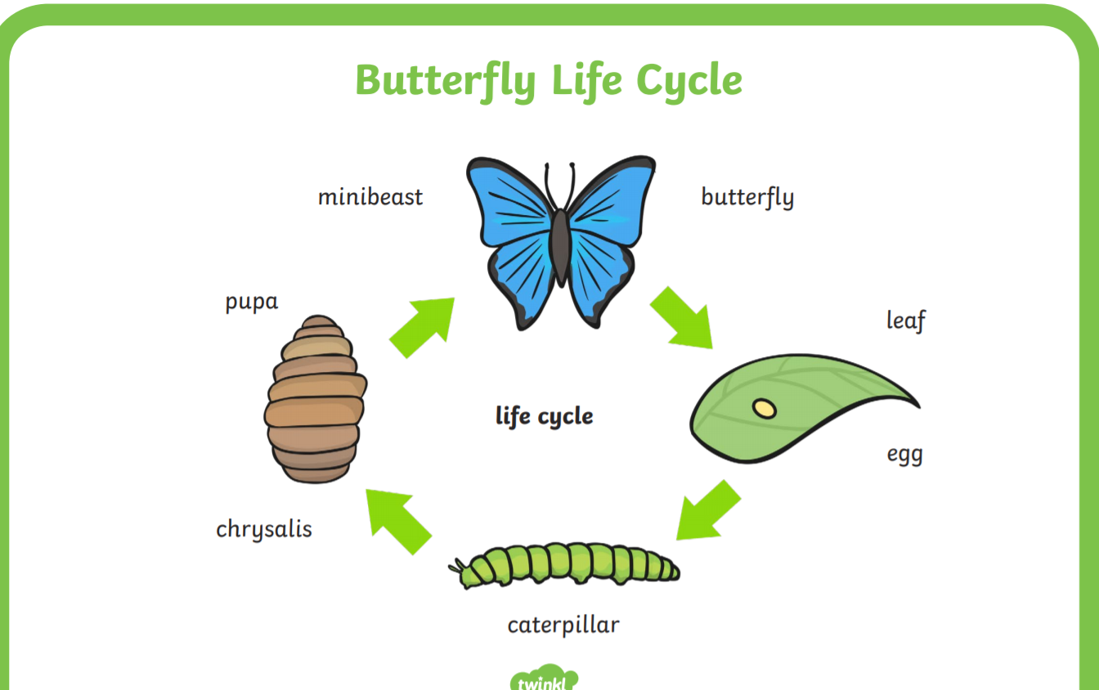
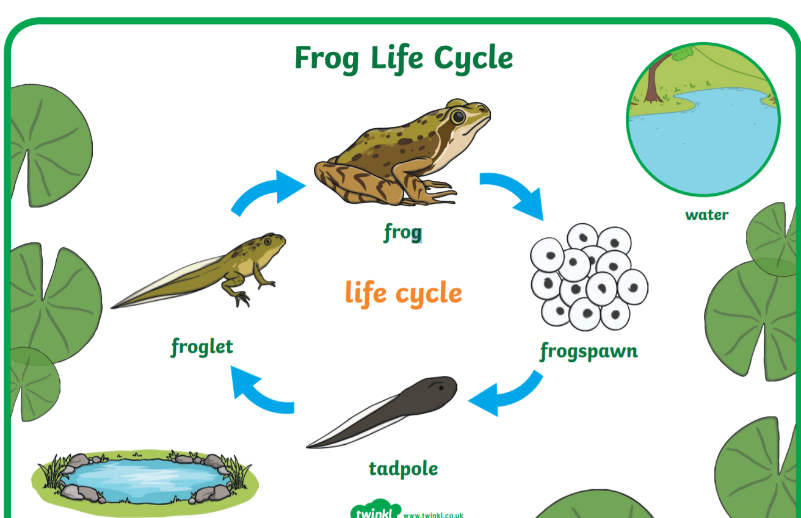

See below for an idea of how to set your writing out with pictures to help your explanations.

Suggested Maths Activities Maths Year 2 and Year 3

Summer Term - Week 7 (w/c 8th June)

Summer Term - Week 7 (w/c 8th June)
Summer Term Week 7- 8th June
This week we have moved on to Summer Term Week 8. We will be revisiting our work on 2D and 3D shapes focusing on their properties and using your knowledge to sort different shapes. At the end of the week you will be using 2D and 3D shapes to make patterns. Remember you need to begin by watching the video on the White Rose website and you then need to go onto the school website to download the worksheets. The links for each are below:
Videos: https://whiterosemaths.com/homelearning/year-2/
Worksheets: https://www.bridge.kent.sch.uk/pupils/classes/year-2
Here are the key properties to remember when looking at 2D shapes:
Corners
side

What shape is this? This shape is a rectangle
How many sides does this shape have? This shape has 4 sides
How many corners does this shape have? This shape has 4 vertices

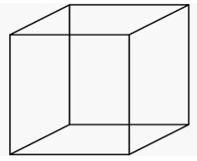

What shape is this?
This shape is a cube

edge

Here are the key properties to remember when looking at 3D shapes:

vertices
face

How many edges does this shape have? This shape has 12 edges
How many vertices does this shape have? This shape has 8 vertices
How many faces does this shape have? This shape has 6 faces which are square shaped

Year 3
Continuing with the work around shape can you use your knowledge of the properties to sort a selection of 2D and 3D shapes. Find the sheets attached to our class page.

