Otter Class suggested home learning activities English

Reading
We hope that some of you have made use of the online books available on the Oxford Owl Reading website. For those of you that are yet to access it we have included the login details below: Reading website www.oxfordowl.co.uk
Username: otter class 2020
Password: Otters1

Continuing with the minibeast theme this week your English work is to develop a poem about one of the minibeasts you may have found in your garden or a favourite minibeast.

You can choose what type of poem you would like to try. You may wish to choose one of the following:
- A rhyming poem
- A shape poem
- An Acrostic poem
Here are a few examples of minibeast poems to help you get started.
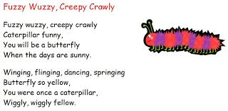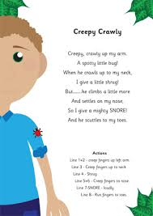

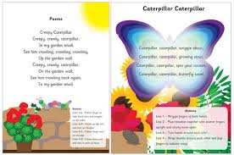
When you have finished your poem please send them into the school or perform it to someone at home.

Suggested Maths Activities Maths Year 2

Summer Term - Week 7 (w/c 8th June)

Summer Term - Week 7 (w/c 8th June)
Summer Term Week 7- 8th June
Year 2
This week we have moved on to Summer Term Week 7. This week we will be revisiting our work on fractions learning what is meant by a unit before moving on to finding a half and a quarter of an amount. Remember you need to begin by watching the video on the White Rose website and you then need to go onto the school website to download the worksheets. The links for each are below:
Videos: https://whiterosemaths.com/homelearning/year-2/
Worksheets: https://www.bridge.kent.sch.uk/pupils/classes/year-2
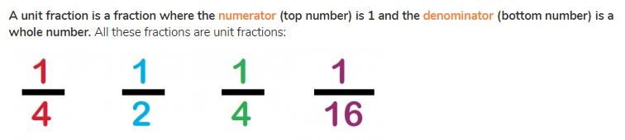

Our top tips when finding a fraction of an amount:
- The denominator (bottom number) tells you how many groups you need
- The numerator tells you how many out of each group you need to circle
In class we have used arrays to help us to find a fraction of a number or an amount for example: of 12 is __?

First you need to look at the denominator to work out how many groups you will need, in this problem you will need
4.
You are then going put 12 objects into groups of 4
x x x x 4
x x x x 8
x x x x 12
Now you need to look at the denominator the top number to find out how many out of each group to circle so in this case it would be 1
x x x x 4
x x x x 8
x x x x 12

of 12 is 3

Year 3
Summer Term Week 7- 8th June Lesson 1
https://whiterosemaths.com/homelearning/year-3/

Please find the worksheet on the website to complete linked to the video.

