Otter Class suggested home learning activities English

Reading
We hope that some of you have made use of the online books available on the Oxford Owl Reading website. For those of you that are yet to access it we have included the login details below: Reading website www.oxfordowl.co.uk
Username: otter class 2020
Password: Otters1

This week in English we would like you to go on a minibeast hunt around your garden and make a list of the minibeasts you can find. Once you have done this we would like you to research one of the minibeasts you found and produce an information page. You may like to include the following:
- Name
- Habitat
- What it looks like
- Where it lives
- What it eats
- A picture

Remember to include the key features of an information page
- Title
- Heading
- Picture
- Caption

Suggested Maths Activities Maths Year 2
Summer Term week beginning 1st June Week – lesson 1
Year 2
How many apples are in each bag?

This week we have moved on to Summer Term Week 6. This week we will be revisiting our work on the 10 times table, division and odd and even number. Remember you need to begin by watching the video on the White Rose website and you then need to go onto the school website to download the worksheets. The links for each are below:
Videos: https://whiterosemaths.com/homelearning/year-2/
Worksheets are attached separately

Our top tips for division are:
- Count how many groups have been made
- Count how many are in each group
- Remember when writing a division number sentence you always start with the largest number
When you move on to practising your 10 times table remember to count in 10s carefully and look at what is shown in the picture. Here is an example:
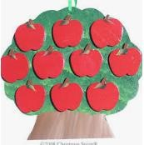
How many apples are on each tree? 10
How many trees are there? 3

There are 3 trees with 10 apples on each tree which would be 3 x 10 = 30 We have also included some extra challenges that you make like to try:
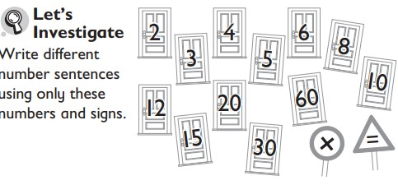
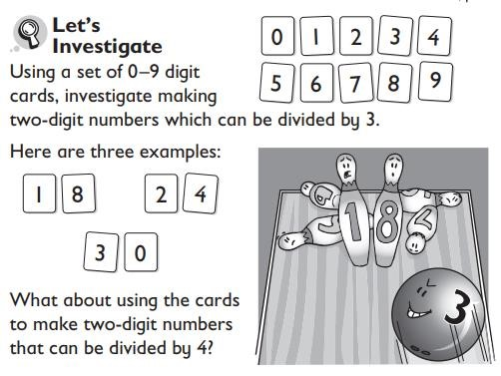

Year 3- week beginning 11th May
Lesson 1 - Multiplying and dividing by 4 and 8
https://whiterosemaths.com/homelearning/year-3/

Now use your knowledge of your 3, 4 and 8 times table to fill in these multiplication wheels. Find all the sheets on the website.

