Otter Class suggested home learning activities English

This week our English is all about writing instructions. Can you think of when we may need to use instructions?
When you are reading or writing a set of instructions you use imperative verbs (we have called these bossy verbs in the classroom). A bossy verb is telling you to do something. For example stir the mixture.
Now have a look at the instructions on the next page, can you spot the bossy (imperative verbs)?
What are the other features you need to include when writing instructions?

We would now like you to make something this could be a cake, making a sandwich, building a Lego model or you could plant some seeds! You can make whatever you like but don’t make it too complicated.
As you are making whatever you have chosen think carefully about the steps you are taking because you are going to be writing a set of instructions for us. You could take photos or draw pictures as you are going along to help you to remember each of the steps.
Now you are ready to write your instructions.
Don’t forget:
Start with a list of what you need to make you chosen object
Use bossy verbs (use the word mat on the next page to help you)
Put numbers at the start of each new instruction
Write the steps in sequence
Start your sentence with a capital letter and end with a full stop
Reading
As we mentioned in the class newsletter we would be really pleased if you could continue reading at home. We now have access to some online reading books on the Oxford Owl Reading website www.oxfordowl.co.uk . The login details are:
Username: otter class 2020
Password: Otters1
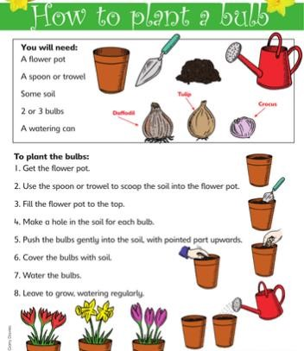

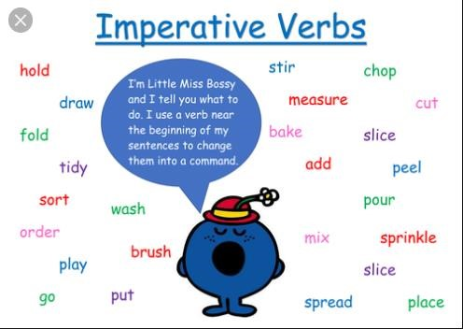

Suggested Maths Activities Maths Year 2
Summer Term week beginning 18th May Lesson 2
https://whiterosemaths.com/homelearning/year-2/

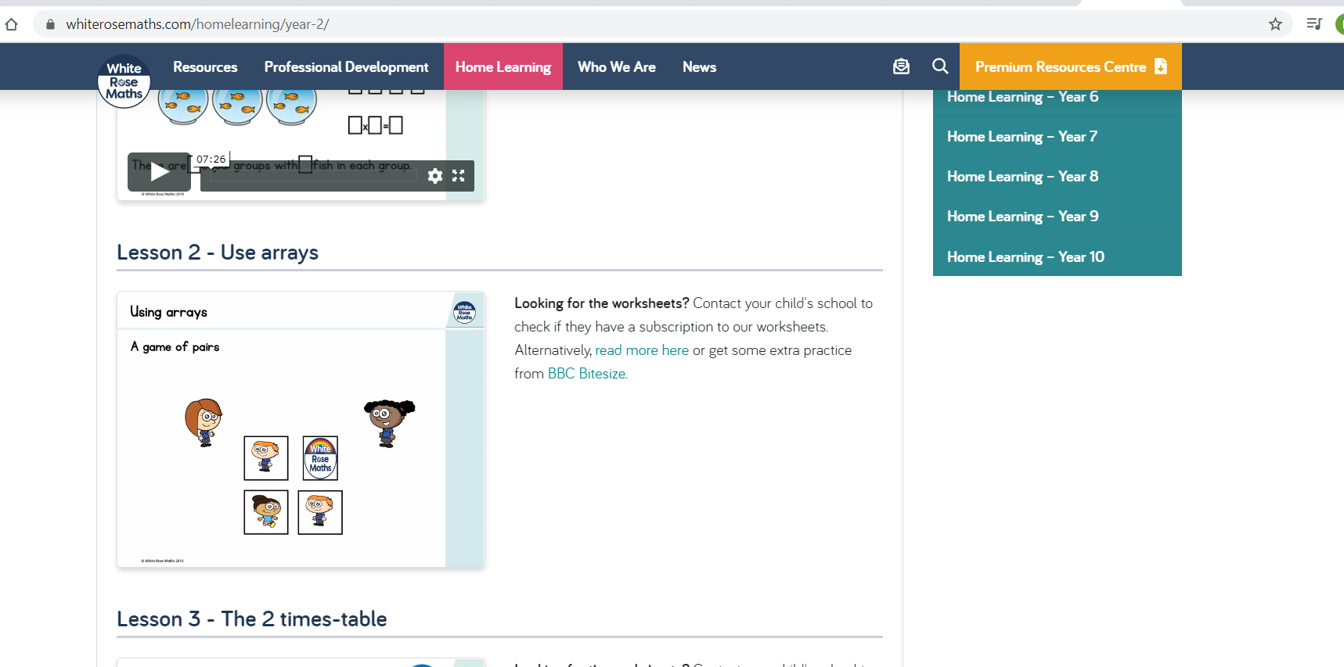
This week we have moved on to Summer Term Week 5. This week we will be revisiting our work on multiplication. You will be practising using arrays and writing multiplication number sentences before moving on to practising your two and five times tables. Remember to watch the videos on the White Rose website but you then need to go onto the Year 2 page of our school website to find the worksheets for this week.

Our top tips on arrays are:
- When writing your number sentence remember to count how many are in each column and row.
- In this array there are 3 rows of 4 so you would write 3 x 4 = 12 or there are 4 columns of 3 which is 4 x 3 = 12
- Remember multiplication can be done in any order
x x x x x x x x x x x x

When you move on to practising your 2 and 5 times table remember to count in 2s and 5s carefully and look at what is shown in each picture. Here is an example:

How many apples are in each bag?
How many bags are there?
There are 4 bags with 5 apples in each bag which would be 4 x 5 = 20.
We have also included some extra challenges that you make like to try:

Three Ball Line Up

Two children are playing with three balls, one blue, one red and one green. They toss up the balls, which run down
a slope so that they land in a row of three.

In how many different ways could the balls land? How do you know you have found them all?

There is an interactive game to help you with this challenge here: https://nrich.maths.org/2858

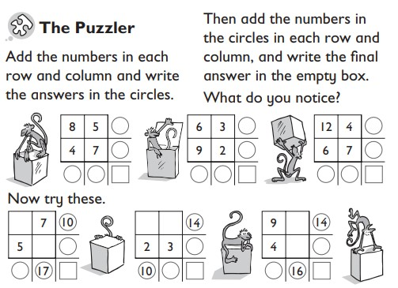

Year 3 Maths
Summer Term Week beginning 18th May Lesson 1
https://whiterosemaths.com/homelearning/year-2/

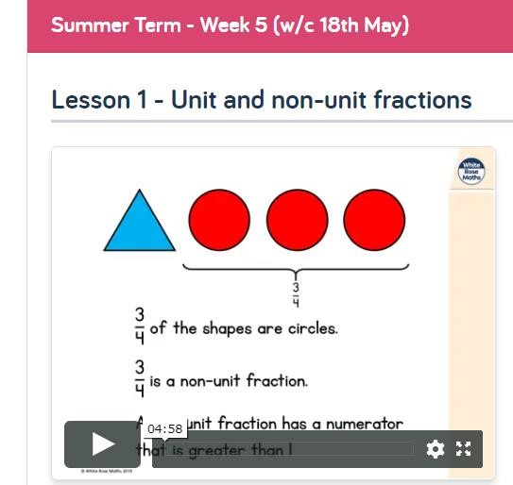

This week, we are looking at Fractions again, The first lesson is a reminder on unit and non-unit fractions.
Remember, a unit fraction is one like ½ (half), 1/3 (third), ¼ (quarter) where the numerator is 1. A non-unit fraction is
one which has a numerator greater than 1, such
as ¾ (three quarters).

