

**Team Parkside**

**Personal Challenge**

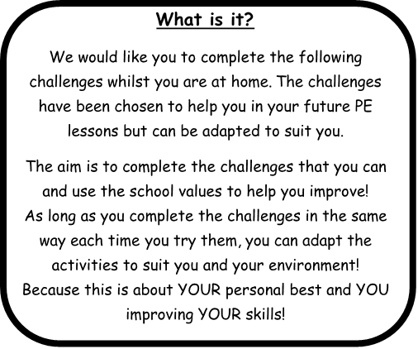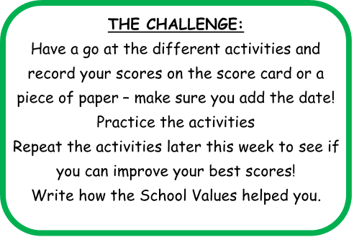

**Share your success!**

If you would like your child’s picture of them doing the challenges, uploaded onto the school website, then please email pictures, videos and permissions to [PE@parkside.kent.sch.uk](mailto:PE@parkside.kent.sch.uk)

**Go Team Parkside!**

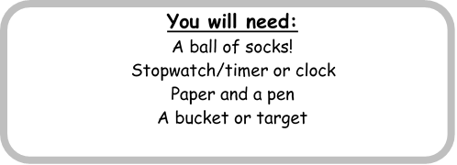



**Speed Jumping**

Place your ball of socks on the floor and see how many times you and back in 1 minuet!

Give yourself 1 point for every jump.

**Star Jumps**

How many star jumps can you do in 2 minutes? Remember to pace yourself, if 2 minutes is to long try 1 minute, if you want to try 3 minutes give it a go.

**Balance**

Balance on 1 leg and time how long you can balance for. Stop the time when your foot touches the floor.

Time how long you can balance on each leg.

**Resilience** – How long can you do the challenge for and never give up.

**Effort** – Hard work in every challenge and always looking to improve.

**Aspiration** - Can you aspire to achieve these targets? Can you aspire to do more?

**Courtesy** – To attempt the challenge in an environment that gives you the best chance to succeed.

**Honesty** - Have you tried your best? Could you try harder?

**Important!**

Always make sure you carry out all challenges in a safe way!

**CREATE YOUR OWN CHALLENGE**

Can you create your own challenge? Perhaps that helps you with either your

Balance

Jumping

Co-ordination



**Star Jumps**

How many star jumps in 1 minute?

**Speed Jump**

How many jumps can you do in 2 minutes?

**One leg Balance**

**Left** **Right**

Time how long you can balance on each leg



**Personal Challenge Score Card**

**Name: Class:**





**Parkside Personal Challenge**

**Creating Your Own Challenge**

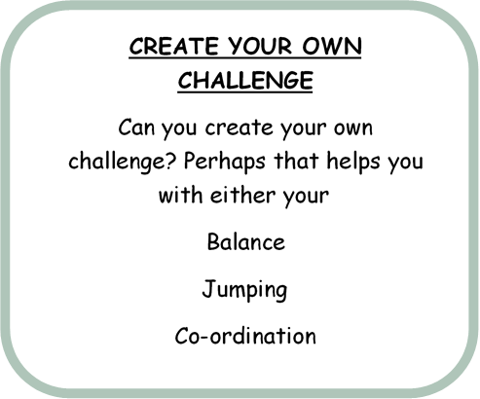

**Rules of my Challenge**

Clearly show how your own challenge works, with clear rules and directions, how you would like the scoring to be used and how does one school value is used or are all of them used. I will pick one challenge from all I receive to add into the next week challenges.