PARKSIDE COMMUNITY PRIMARY SCHOOL

OTTER CLASS LETTER

TERMS 3 & 4
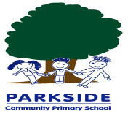

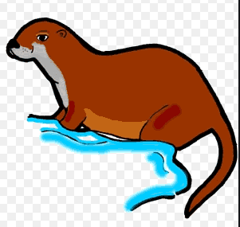
January 2021
Dear Parents and Carers

Happy New Year! We hope the holidays have been fun and restful for you and your children. We are just as disappointed as you that school will look a little different this term. We have still planned lots of exciting things for you and your child to access at home.
Term 4
Our topic this term is:
‘Muck, Mess and Mixtures’.

Our WOW moment will involve us having a messy afternoon where we will investigate a variety of different mixtures using our senses.

In Maths we are going to learn how to multiply and divide and looking at how to handle data.

In English our key text will be George’s Marvellous Medicine and we will be looking at the main characters and developing our character descriptions, looking at examples of poetry linked to food and creating our own and we will be finding out how to use speech to make our characters come to life.

In Science we will continue looking at the uses of everyday materials including what happens when you add water to different materials and which type of soap is the bubbliest.

Term 3

This term we will be providing you with online learning and packs that you can collect from the school office.

We will continue to support you and your child in as many ways as possible.

Please note the class email is:

otterclass@parkside.kent.sch.uk

You can email us work and questions and we will reply to you.

We will be calling you weekly to check in. Please use these calls to update us with how your child is getting on with the home learning or ask us any questions/ queries you have and we will be happy to help you.

We will also be organising Zoom sessions so that we can once again get together as a class!

