Otter Class Home Learning Week 5
English
In English this week we are going to be looking at ‘The Day the Crayons Quit’ you can listen to the story using this link:
https://www.youtube.com/watch?v=489micE6eHU
- What do you think the word ‘quit’ means? Discuss with your grown up what you think the word means. Can you share the reasons why the crayons were cross/ upset and some key phrases from the story? You can set out your writing using the table attached.
- Think about the word ‘persuasion’. How have you managed to persuade someone to do something for you? Think about all of the different colours in the book and think about which colour is your favourite colour. Try to convince your grown up why it is your favourite colour. Write a list of points and give reasons for your favourite choice. Use the worksheet to help you set your writing out.
- Watch the video again and look for words with an apostrophe e.g. can’t (parents see page attached which explains apostrophes) – Now change the words into the contracted form. Now see if you can use them in some of your own sentences.
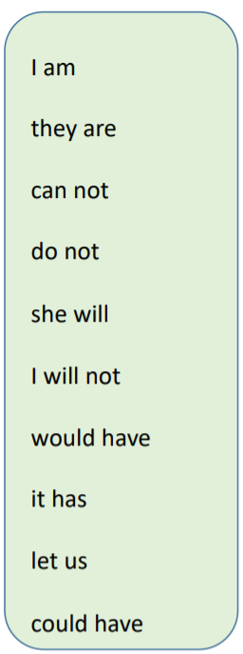
- Now we are going to write a reply to the crayons from Duncan. Think about some of the things the crayon was not happy about and how Duncan can make things better for the crayon. Use the planning sheet to help you set out your ideas
- Today you are going to use your plan to write your letter to the crayons from Duncan. Use the letter template to help you use different sentence starters and key words.
Phonics
On the website below you will find a selection of phonic games. You can sign in free using the following login:
Username jan21
Password home
https://www.phonicsplay.co.uk/
Pick a different game each day for your child to work on. The children would benefit from accessing games from Phase 4 onwards. Do get in contact with us via phone or email if you would like more advice. For those of you who have picked up a pack you can continue with a game from there.

Reading
We have registered for Oxford Owl reading ebooks. It has a selection of ebooks that you and your child can share together. There is a good book called ‘Our Class Tiger’ which you may like to read. The website is:
www.oxfordowl.co.uk
The login details are:
Username: otter class 2020
Password: Otters1
You may also like to try these two websites which provide games for you to play

https://onthespot.offbook-edu.com/
https://onthespot.offbook-edu.com/

You can also access the Oak Academy library using this link https://library.thenational.academy/ where you can find a selection of books and activities.

Maths
In Maths this week the focus continues to be multiplication and division. There are 5 lessons which can be accessed by clicking on the Year 2 or Year 3 link below. Each day your child needs to watch one video clip which will teach the children the learning for that day. Once the video has finished there are worksheets attached that your child can work through. Whilst you can print the worksheets, you do not need to as your child can write the answers on a piece of paper. You can either send their work to us via a photo or by dropping it into the office so that we can mark it or you can mark it yourself. Once again some of the Year 2 work may be labelled Year 1 and Year 3 labelled Year 2. This is because as the children learn it’s important to recap on previous learning.

Year 2- Multiplication and Division
https://whiterosemaths.com/homelearning/year-2/spring-week-2-number-multiplication-and-division/

Year 3- Multiplication and Division
https://whiterosemaths.com/homelearning/year-3/week-11-number-multiplication-division/

Science
I wonder if you managed to help your superhero float last week. This week we are having fun with ‘watery science’. The link below takes you to the investigations and will guide you through them. The equipment needed will be things you have at home, feel free to adapt where needed. Once completed, your child could write or draw about what they have learnt. Again we would love to see pictures so do send them or drop off at the office.
https://www.science-sparks.com/wp-content/uploads/2020/05/Science_Fun_at_Home_8_Watery_science.pdf

Topic
This week we are going to have a Geography focus for our topic sessions and we will be looking at our local area in more detail. To start with we are going to find out about settlements, towns and cities. You can use the links attached to find out more.
https://classroom.thenational.academy/lessons/what-is-a-settlement-74t3ed?step=2&activity=video
Another activity we would like you to do is create a map of your home and garden. Can you hide one of your toys in your house and ask somebody to use your map to find it?

RE
Using the link below you can access lessons 2- 5 on the website which will teach you about Judaism. You will need your brain, a pen/ pencil and some paper to write your ideas down.
https://classroom.thenational.academy/units/judaism-7011

