Otter Class Home Learning Week 6
English
In English this week we are continuing to use ‘The Day the Crayons Quit’ as our key text. You can listen to the story again using this link:
https://www.youtube.com/watch?v=489micE6eHU
- Look at the selection of classroom objects. Why do you think these objects might go on strike? Draw a picture of each item and write reasons for going on strike. E.g a felt tip pen- they may go on strike because the lid keeps getting lost or not put back on. How do you think they would feel? Think back to some of the feelings the crayons shared last week. Which item would be the angriest? Why?
- Read the letter from the glue sticks. How can we make them feel better? What can we make sure we do to keep them happy? Mind map your ideas. We look forward to hearing about your ideas on Wednesday.
- Choose one of the classroom objects that we have looked at this week and use the template to write a letter from their point of view to the whole class about how they have been treated.
- Think of different coloured objects and use the template to record your object- now add some adjectives to describe your object in detail. Try to use more than one adjective e.g. grey- The huge, grey elephant.
- Read the poem below- ‘What is Pink?’ Using your ideas from yesterday use the template to write your own version of the poem.
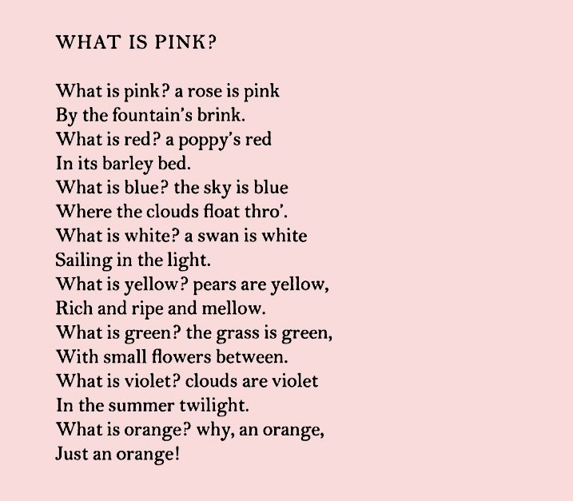

Phonics
On the website below you will find a selection of phonic games. You can sign in free using the following login:
Username jan21
Password home
https://www.phonicsplay.co.uk/
Pick a different game each day for your child to work on. The children would benefit from accessing games from Phase 4 onwards. Do get in contact with us via phone or email if you would like more advice. For those of you who have picked up a pack you can continue with a game from there.

Reading
We have registered for Oxford Owl reading ebooks. It has a selection of ebooks that you and your child can share together. There is a good book called ‘Our Class Tiger’ which you may like to read. The website is:
www.oxfordowl.co.uk
The login details are:
Username: otter class 2020
Password: Otters1
You may also like to try these two websites which provide games for you to play

https://onthespot.offbook-edu.com/

You can also access the Oak Academy library using this link https://library.thenational.academy/ where you can find a selection of books and activities.

Maths
In Maths this week the focus continues to be multiplication and division. There are 5 lessons which can be accessed by clicking on the Year 2 or Year 3 link below. Each day your child needs to watch one video clip which will teach the children the learning for that day. Once the video has finished there are worksheets attached that your child can work through. Whilst you can print the worksheets, you do not need to as your child can write the answers on a piece of paper. You can either send their work to us via a photo or by dropping it into the office so that we can mark it or you can mark it yourself. Once again some of the Year 2 work may be labelled Year 1 and Year 3 labelled Year 2. This is because as the children learn it’s important to recap on previous learning.

Year 2- Multiplication and Division
https://whiterosemaths.com/homelearning/year-2/spring-week-3-number-multiplication-and-division/
Year 3- Multiplication and Division
https://whiterosemaths.com/homelearning/year-3/week-12-number-multiplication-division/

Beat It maths- We have attached a Beat It maths sheet for Year 2 and Year 3 for the children to have a go at. Don’t worry about the time challenge- the children will get quicker the more they practise with these worksheets.

Science
This week in science we are exploring animals including humans. The following link has videos for the children to work through- lessons 1-3.
https://classroom.thenational.academy/units/the-animal-kingdom-3cfa

Topic
This week we are going to continue with our geography topic around settlements and cities. You can complete the activities using the link below:
https://classroom.thenational.academy/units/villages-towns-and-cities-28b9
We would like you to work through lessons 7-10

We would also like you to join in with these music lessons which can be found using the link below:
https://classroom.thenational.academy/units/rhythm-bedc
Work through lessons 1-3

