**Kings School Science Update – 18-05-2020**

**1. SCIENCE ACTIVITIES**

**This week’s activities were suggested by one of our Year 12 pupils, Hiu Yu:**

a)  Origami animals

[**https://www.nhm.ac.uk/discover/origami-tyrannosaurus-rex-dinosaur.html**](https://www.nhm.ac.uk/discover/origami-tyrannosaurus-rex-dinosaur.html)

The Natural History museum had a tutorial on origami dinosaurs.  Hiu Yu says: “I think origami is a nice activity because there's no risk and everyone has paper to make them.”

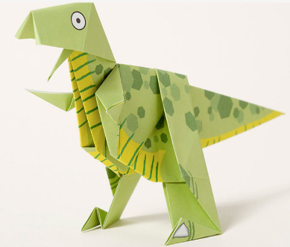

We’d love to see photos of the finished product!

b) Virtual tours

[**https://www.sciencemuseum.org.uk/virtual-tour-science-museum**](https://www.sciencemuseum.org.uk/virtual-tour-science-museum)

This is brilliant!  You arrive on floor 1.5, and I suggest you head straight down to floor 0 (see ‘lifts’ on the right of the screen), then turn around 180 degrees, go past the ticket desks and you’ll head into my favourite section: SPACE!

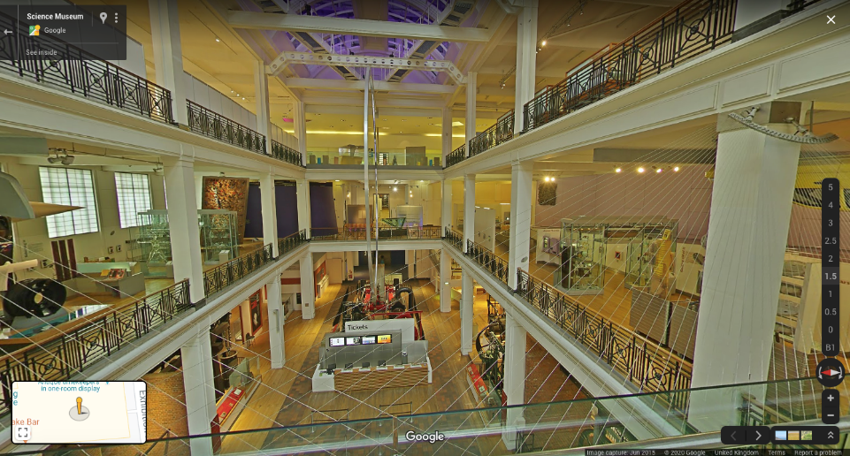

If you visit, why not write up your “Virtual Day Trip to the Science Museum” and share it with us?

**2. SCIENCE FILMS**

a) if you enjoyed the ‘Kitchen Science’ fizzing experiment last week, you might like Steve Spangler’s amazing videos.  Here’s one of my favourite experiments, the density tower: <https://www.stevespanglerscience.com/lab/experiments/density-tower-magic-with-science/>

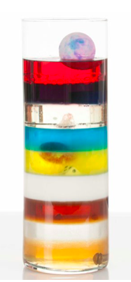

b) and for a bit of relaxing viewing, with amazing film footage, you can’t beat David Attenborough.  Head to BBC iPlayer to watch series such as Blue Planet II: <https://www.bbc.co.uk/iplayer/episodes/p04tjbtx/blue-planet-ii>

**3. QUIZ TIME!**

**Ella and her friends in Mitchinson’s House have devised a quiz about countries of the world – on the attached Powerpoint.  Just click Slide Show and Play from the Beginning for a fun quiz for all the family.  I hope you enjoy it.**