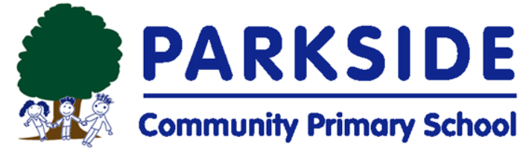
20th March 2020
Dear Parents and Carers,
As you are aware, the government has closed all schools in the UK from Friday 20th March 2020. The most recent scientific advice on how to further limit the spread of COVID-19 is clear. If children can stay safely at home, they should, to limit the chance of the virus spreading.
That is why the government has asked parents to keep their children safe at home, wherever possible, and asked schools to provide care only for those children who absolutely need to attend.
Please ensure that you attempt to use this service only if it is vital to your family. If we are not able to maintain safe levels of staffing, we will have to close to all.
Parkside Community Primary School will provide care for a limited number of children - children who are vulnerable (eg have EHCPS) and children whose parents are critical to the Covid-19 response and cannot be safely cared for at home. However, it is important to be aware that this provision will be for childcare and not to continue with your child’s current curriculum learning.
Parents whose work is critical to the COVID-19 response include those who work in key sectors. More detail of these can be found at www.gov.uk (Closure of educational settings: information for parents and carers)
Many parents working in these sectors may be able to ensure their child is kept at home. It is vitally important that any child who can be safely cared for at home should be.
If you believe that you are classified as a key worker, and are unable to ensure your child remains safe at home, as directed by the government, please email the school at:-
info@parkside.kent.sch.uk
with the following information:
- Child/Children’s name and class
- Occupation and name of employer of parents/carers in your household
Please ensure that you provide us with this information as soon as possible – and no later than 12:00 noon on Saturday 21st March. Once this information is received we will collate this, prioritise the need and contact you as soon as possible to advise you whether your child is eligible for this provision. Please be aware that it may be necessary for you to provide evidence to confirm your employment.
If your child is not in one of the groups mentioned above, school will be closed to all pupils from Monday 23rd March for the foreseeable future. We will reopen as soon as the government issues the instruction for us to do so.
Yours faithfully,
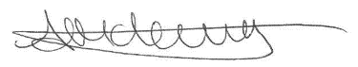

Anthea McLevy
Head of School

