Summer Term Week 5 Literacy- Squirrels!
This week in literacy I would like you to enjoy exploring nature! Due to the lovely weather, I would like to you explore outside and then use inspiration from what you find each day to do some writing.
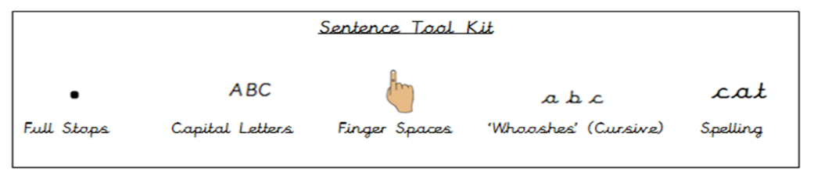
Remember to use your sentence toolkit.

You might like to use some of these ideas for inspiration or you can think of your own.
- What flowers can you see?
Take a walk or go into your garden and explore the different flowers. What colours are they? Are they big or small? Do you know their names? Take a picture if you can to help with your writing.
Now, using the flowers that you have seen, write some sentences to describe your flower! You could draw a picture of your flower and even label it too! When writing your sentence/sentences to describe your flower, use your senses to think about what it look, feels and smells like! Remember to use our sentence tool kit when writing!

- Can you find any mini beasts?
Take a walk or go in the garden and see if you can find any mini beasts! Take some pictures of even some paper out to draw what you see!
Now, using your pictures of what you have found, write some sentences to describe the different mini beasts! You could use the computer or a book to find some facts for you to write about! Or write about what they look like! You could even use your imagination and turn your mini beast into a character in a story and write your own book!

- What is the weather like?
Take a walk or gin in the garden and take some time to think about the weather! Is it sunny and hot, grey or even raining? Are there any clouds in the sky? Can you see any nature out during this weather? If it is sunny, how do you feel whilst standing outside? If it is rainy, what would you need to remember when going out in the rain?
Phonics
Mr Thorne does phonics, Bitesize or Phonics play Phase 2/3 sounds for Year R. Please continue to learn a new sound each day and practise writing the letter and CVC words.
Year 1 recap all sounds and learn a Phase 5 sound every day using Phonics Play.
https://www.youtube.com/results?search_query=mr+thorne+does+phonics+phase+2
https://www.phonicsplay.co.uk/
https://www.bbc.co.uk/bitesize/topics/zf2yf4j

Reading
Listen to an E-book on Oxford Owl and practise your blending to read. Read a bedtime story every night and talk about it in your own words. https://www.oxfordowl.co.uk/for-home/find-a-book/library-page
https://www.teachyourmonstertoread.com/

MATHS
Please signup to White Rose home learning maths activities for our maths! Follow the link each day to watch the teaching videos! Start on Week 1- 'Oliver’s Vegetables'
https://whiterosemaths.com/homelearning/early-years/

Year 1
Ordering numbers
https://whiterosemaths.com/homelearning/year-1/

P:E try Joe Wicks
https://www.youtube.com/user/thebodycoach1

