Hedgehogs English home learning

Week 1:
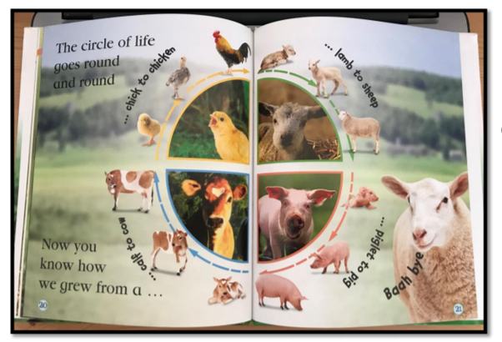
Day 1: Look at the picture. Have a think about what an animal might need to grow. Try and write a list.

Day 2: Looking at the picture, can you write a sentence about each animal? What is it called as a baby? Maybe think about what the animal looks like e.g. The chick is fluffy.

Day 3: Choose one of the animals to make up a story about. Draw the animal – can you write some words to describe it? E.g. fluffy, cute, yellow etc

Day 4: Think about your story today about your animal growing up – they might start school or have a birthday party! Tell your story to your grown up and ask them to write it down with you.

Day 5: Today we would like you to share your story with the rest of your family. Maybe you could make some puppets and make a puppet show of your story!

Week 2:

Day 1: This week we will be focussing on the story of ‘The Enormous Turnip’. Click the link to the online story: https://www.youtube.com/watch?v=mGw5yTOPTSQ
Make a list of all the characters in the story and say how each of them might have been feeling

Day 2: Below you will find pictures from the story – cut them out and stick them on a piece of paper in the right order.
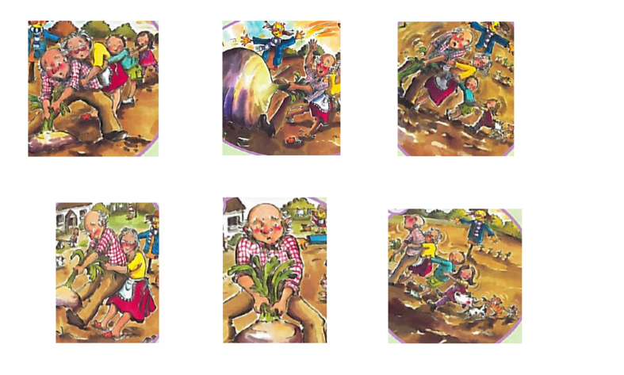

Day 3: Using the pictures from yesterday, can you tell your grown up the story? See if you can write a sentence about each picture!

Day 4: With your grown up, make up your own story about your family planting a vegetable that grows and grows! Ask your grown up to help you write it down.
Day 5: Act out your story to your family

