Number and Place Value – Understanding the order and value of numbers.
Day 1
Can you count forwards and backwards and write numbers to 20 in numerals and words?
Aut1.11.1 - Count forwards and backwards and write numbers to 20 on Vimeo (Video Link)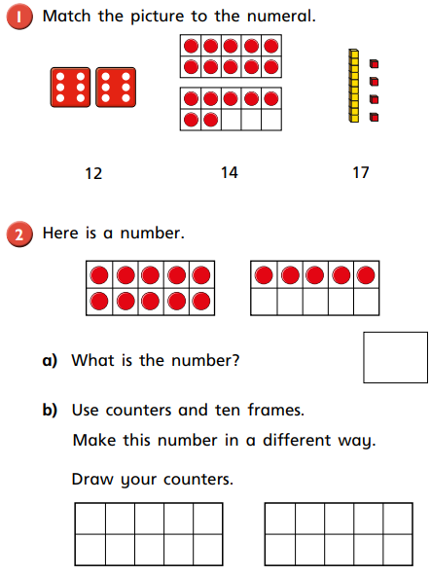

Day 2 Take a peek at the bottom of the page.
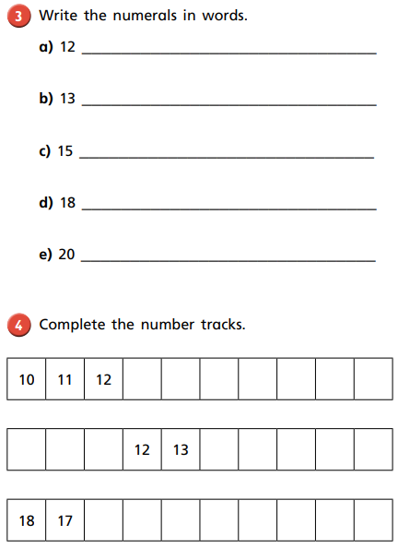
Day 3
Do you know your numbers from 11 to 20?
Aut1.11.2 - Numbers from 11 to 20 on Vimeo (Video Link)
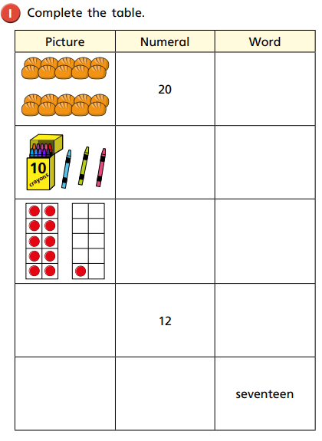
Day 4
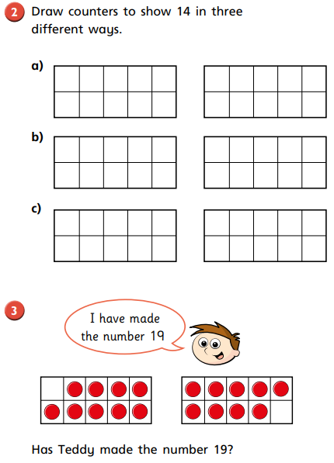
Day 5
How many tens and how many ones in any number?
Aut1.11.3 - Tens and ones on Vimeo
How many tens? How many ones?
For example; 10 has 1 ten and 0 ones.
24 has 2 tens and 4 ones.
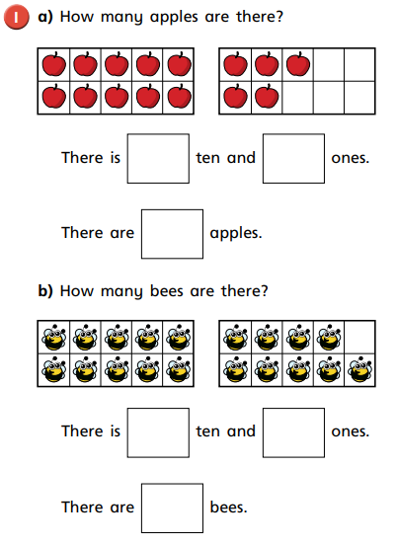
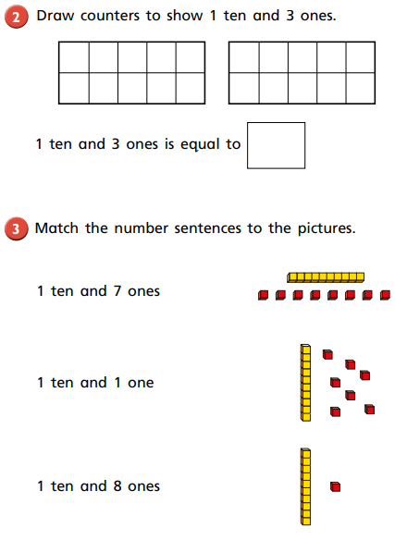
Day 6
Aut1.11.4 - Tens and ones on Vimeo (Video Link)
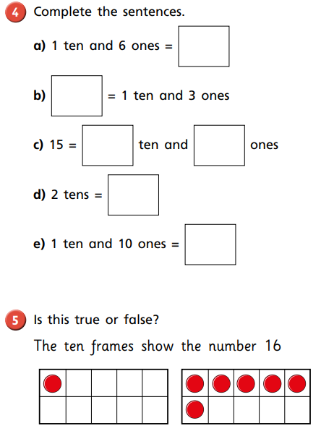
Day 7
Can you count one more and one less than any given number?
Aut1.11.5 - Count one more one less on Vimeo
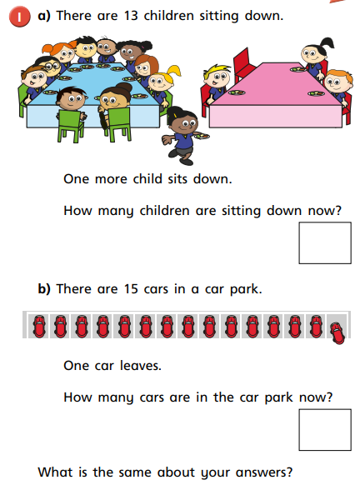
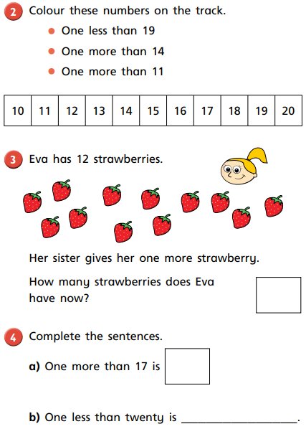
Day 8
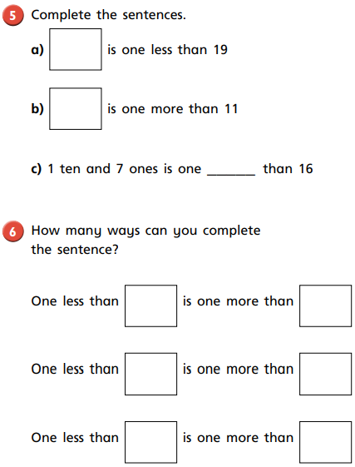
Day 10
Can you compare the number of objects in different groups?
Aut1.12.1 - Compare groups of objects on Vimeo (Video Link)
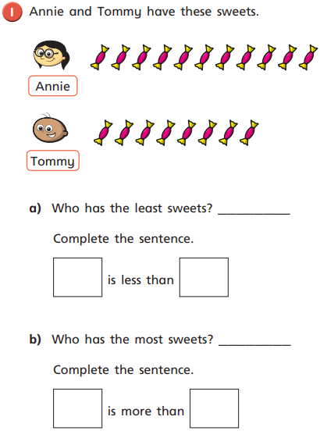

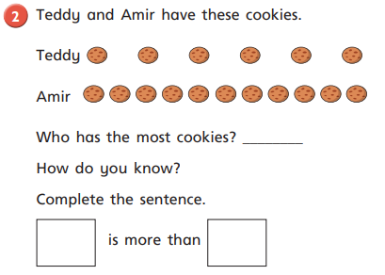
Day 11
Words you need to know and use;
greater than (more, bigger) less than (smaller, fewer)

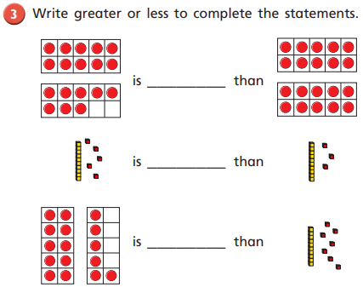

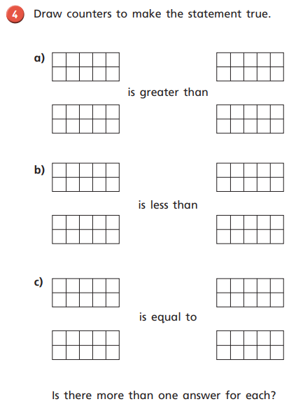
Day 12
Can you compare numbers?
Aut1.12.2 - Compare numbers on Vimeo (Video Link)
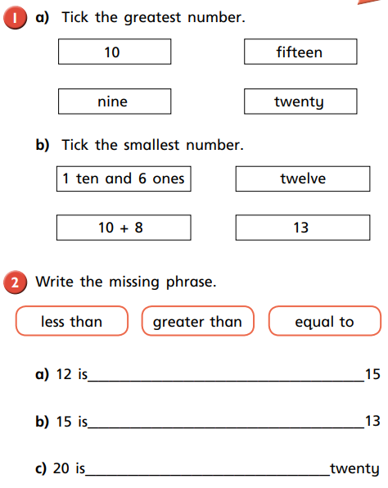
Remember, Charlie Crocodile likes to eat the biggest number. For example, 2 is less than 4 is the same as 2 < 4. Or 8 is greater than 5 is the same as 8>5.
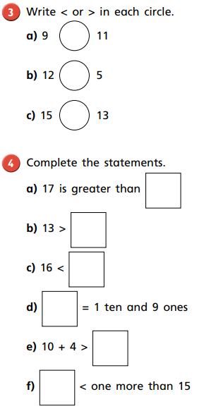

Day 13
Can you order groups of objects?
Aut1.12.3 - Order groups of objects on Vimeo (Video Link)
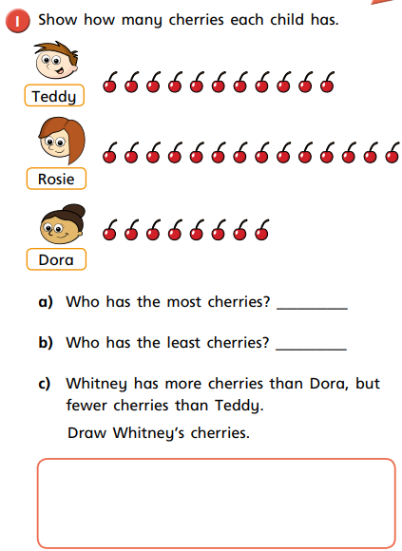
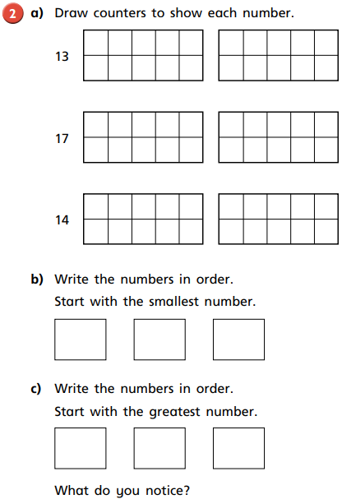
Day 14
Can you order numbers?
Aut1.12.4 - Order numbers on Vimeo (Video Link)
Use whatever you have; buttons, lego?

