Please try to read every day. There is some reading material included in the printed packs. Please practice the sounds at the start of each story then listen to your child reading.
Free reading books can be accessed at Oxford Owl https://www.oxfordowl.co.uk/for-home/find-a-book/library-page/?view=image&query=&type=book&age_group=Age+5-6&level=&level_select=&book_type=&series=#
Please inform me how your child finds reading this material, so that I can provide/suggest more appropriate reading levels.
On the Spot Oracy is a really fun way of building and developing vocabulary. They put in their names and numbers of players up to three, then choose the setting and the game generates key vocabulary that the players have to use in 60 seconds. It’s quick and fun.

60 second Oracy On the Spot: https://onthespot.offbook-edu.com/ ​

Read for Good is a great way to get children reading at home. They fill in the blanks on the template to create their own unique stories which are then turned into published really funny published books for them to read and enjoy. It is really simple to use and ensure that your children are continuing to read at home.

Read for Good​: https://onthespot.offbook-edu.com/​

Phonics and reading should be done every day. Each English task can be spread over a couple of days.

Phonics
On YouTube follow the Letters and Sounds Spring Term Learning to Blend Video Lessons (links provided below);
Lesson 1 ar for dark
https://www.youtube.com/watch?v=Jf2dx5IbeZE (Video Link)
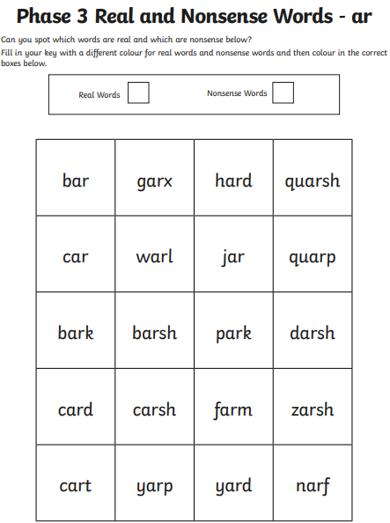

Lesson 2 or for born
https://www.youtube.com/watch?v=X2C_ANTT7zs (Video Link)
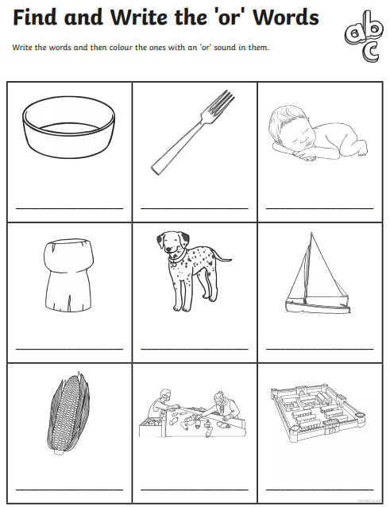

Lesson 3 ur for fur
https://www.youtube.com/watch?v=pcNgbnrvWqo (Video Link)
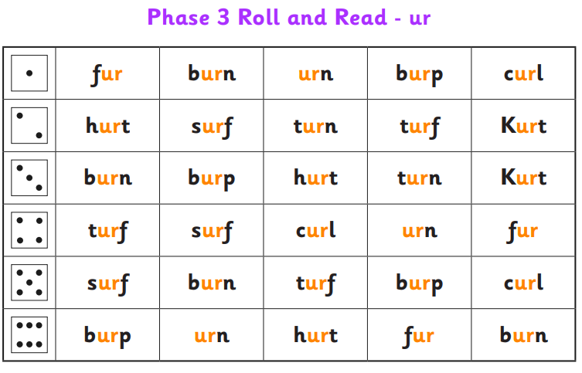

Lesson 4 ow for owl
https://www.youtube.com/watch?v=DV3vzwk9E_Q (Video Link)
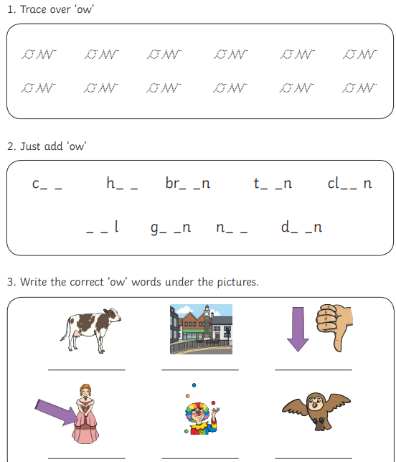

Lesson 5 – Review the Week!
https://www.youtube.com/watch?v=-GungrFDNmk (Video Link)

Lesson 6 oi for coil
https://www.youtube.com/watch?v=8-t0pHoi-O8 (Video Link)

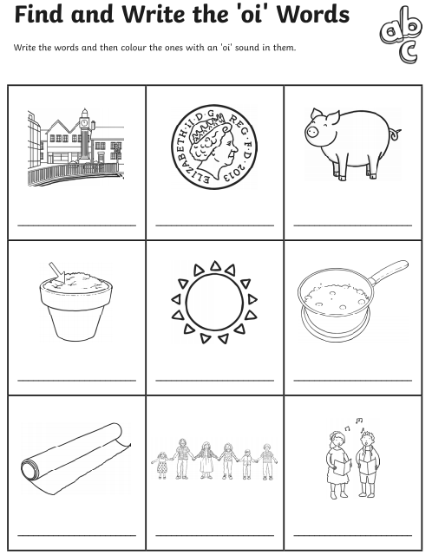

Lesson 7 ear for near
https://www.youtube.com/watch?v=l5pPdWSeljY (Video Link)
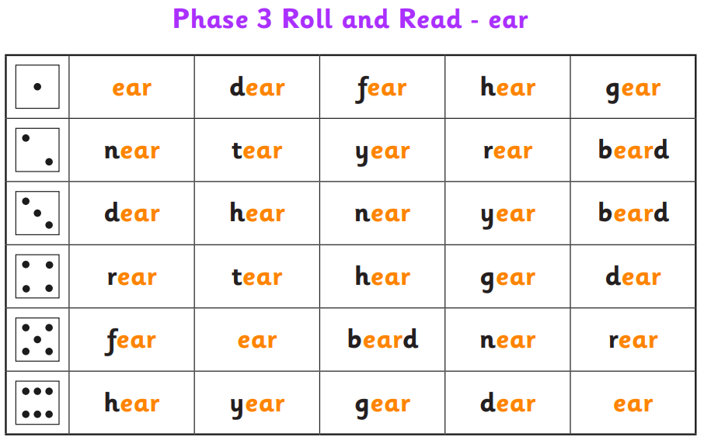
Lesson 8 air for chair
https://www.youtube.com/watch?v=By9B_lnASvE (Video Link)
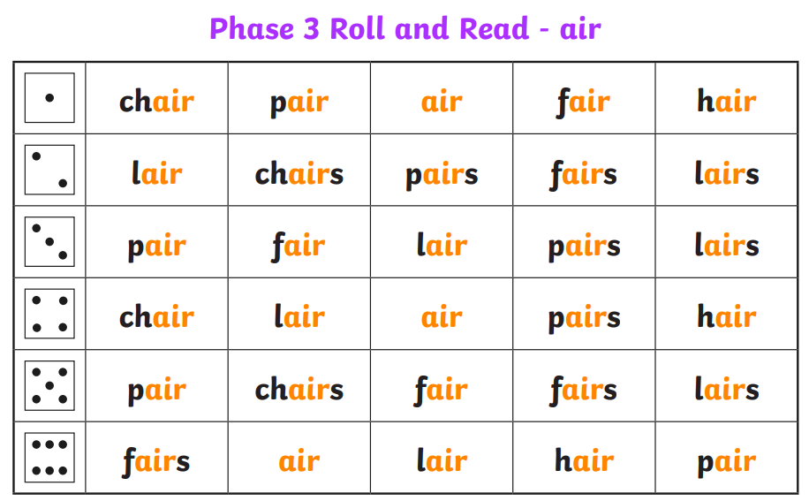

Lesson 9 er for bigger
https://www.youtube.com/watch?v=IzMAPSVasSM (Video Link)
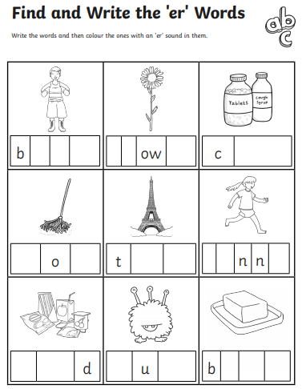
Lesson 10 - Review the week
https://www.youtube.com/watch?v=Ir3cxjyrMaA (Video Link)
Use your finger to point at the sounds so your child can say the sounds. This can be done daily!

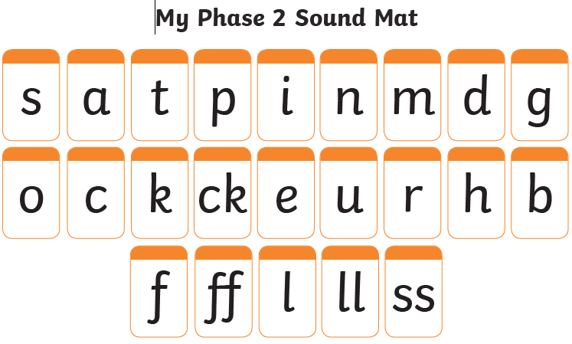

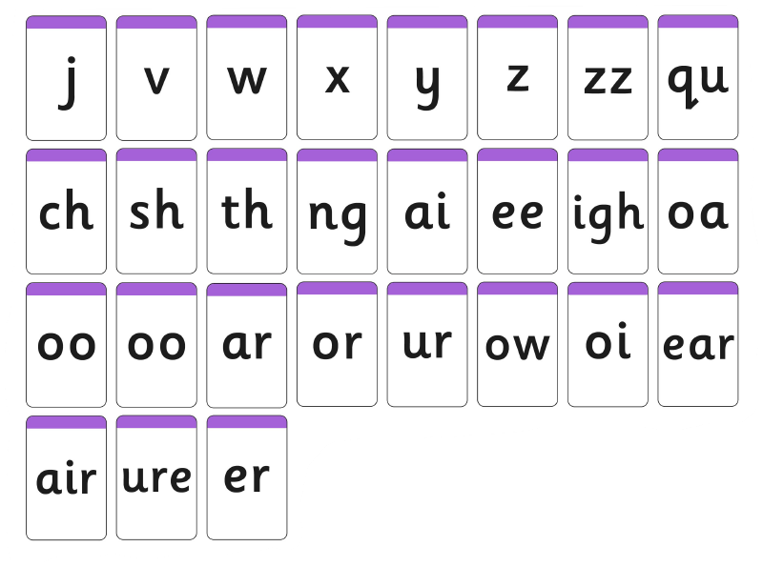
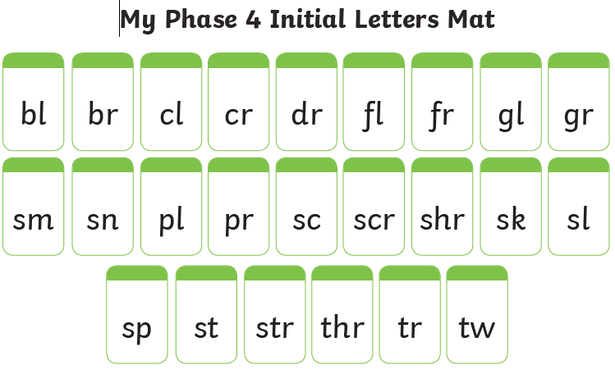
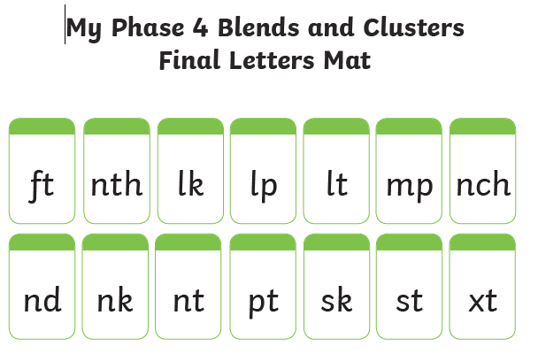
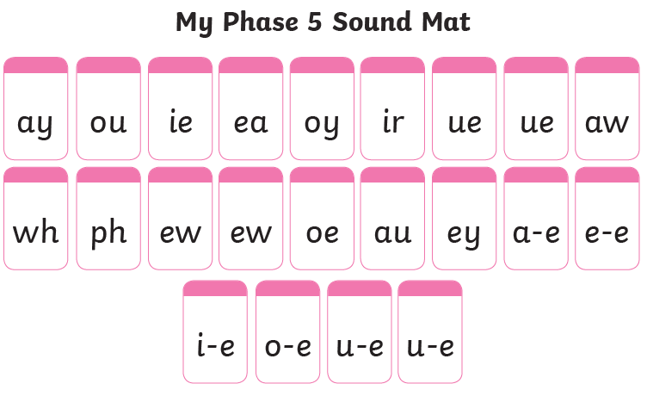

English
- Retell a story that you know well. For example the Gruffalo, The Tiger Who Came to Tea or a fairy tale that you know of by heart.
Using as much descriptive language as you can, retell the story.
Tips; Who are the characters, what happens to them and how does the story end?
Here are some examples of stories that we have shared at school.
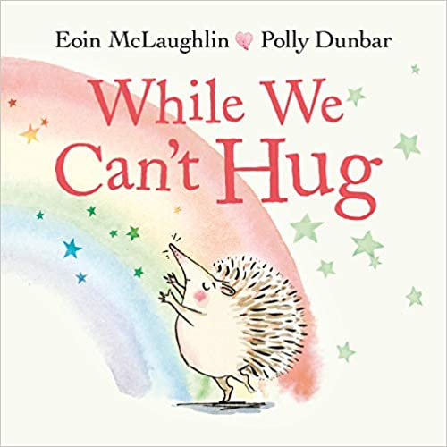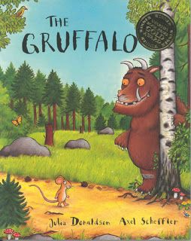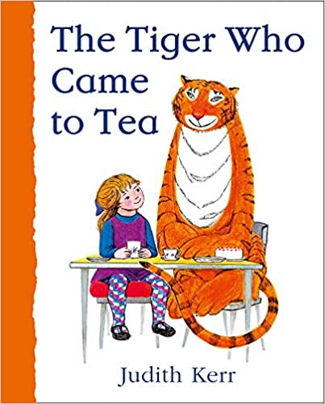
YouTube Links to these stories being read aloud.

https://www.youtube.com/watch?v=s8sUPpPc8Ws (The Gruffalo)

https://www.youtube.com/watch?v=kh2KRoqsUlI (While We Can’t Hug)

https://www.youtube.com/watch?v=BXgW9UCgpc8 (The Tiger Who Came to Tea)

- Role play the story (on your own or cast family members as characters).
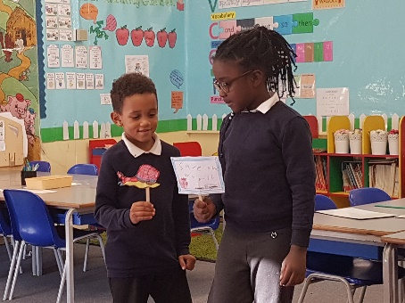
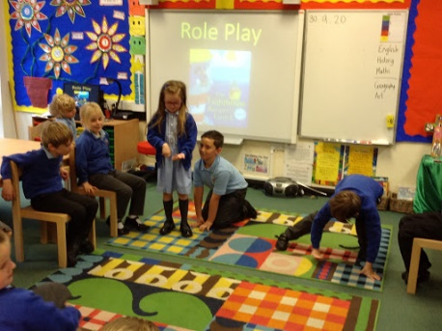

- Create a story map. Using pictures and some key vocabulary, draw the main events that happen in your favourite story. Here are three format choices;
- 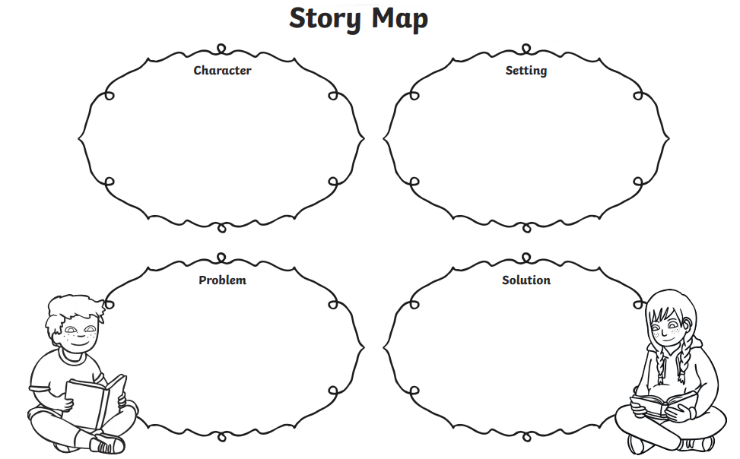
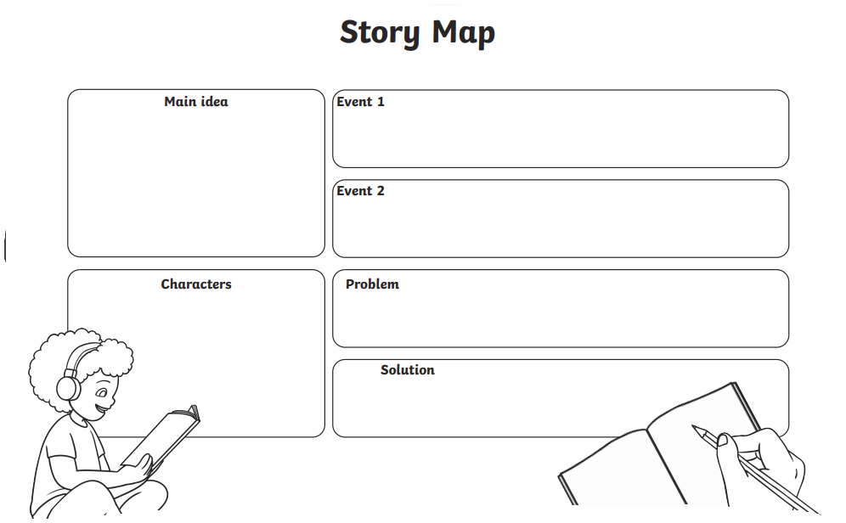
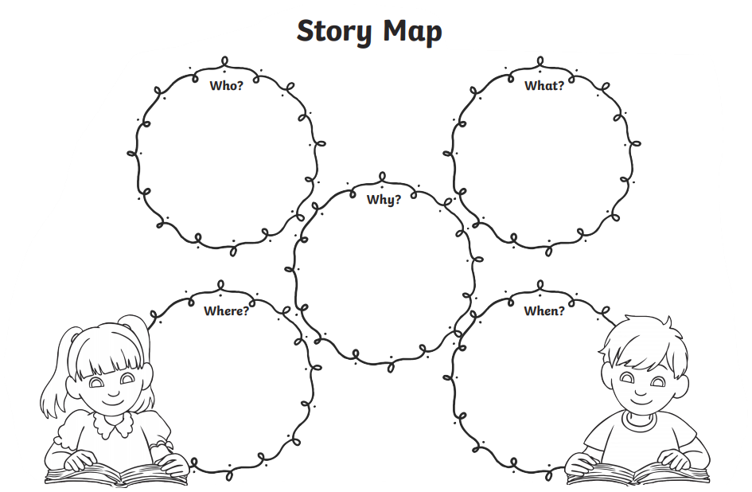

- Compose sentences and record in order to form a story.
Choose a familiar or favourite animal and make up a story about one of their special features. For example ‘How the rabbit got long ears,’ or ‘How the dog got it’s bark.’
First draw a picture of the animal and how it got it’s special feature.

- Next say the sentences out loud to an adult before writing
Practice saying out loud what you would like to write down to your adult or record yourself and listen to it before you write it down. There are lines on the next page for writing.

- Read aloud what you have written clearly and so that others can hear and understand it!
You might like to perform your story after you have read over it and know it well.

