Topic Activities
- Can you spot minibeasts when you are out and about?
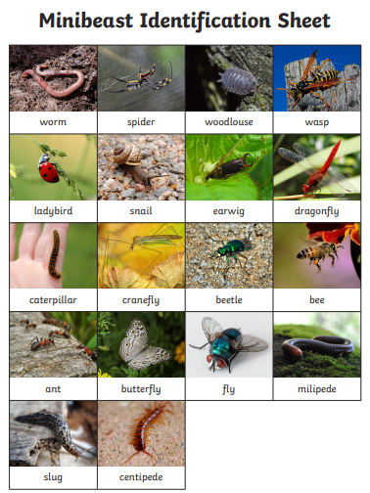
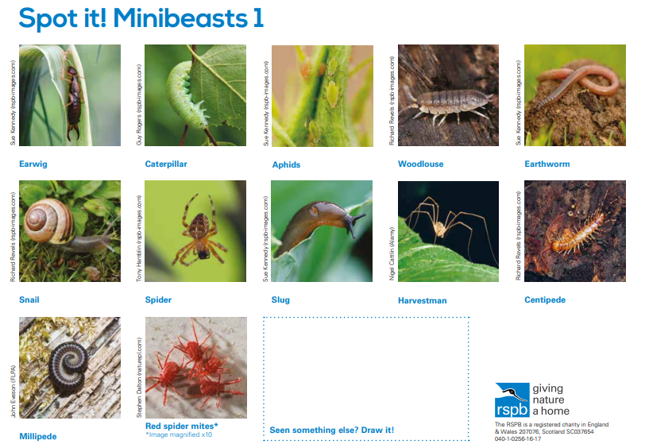
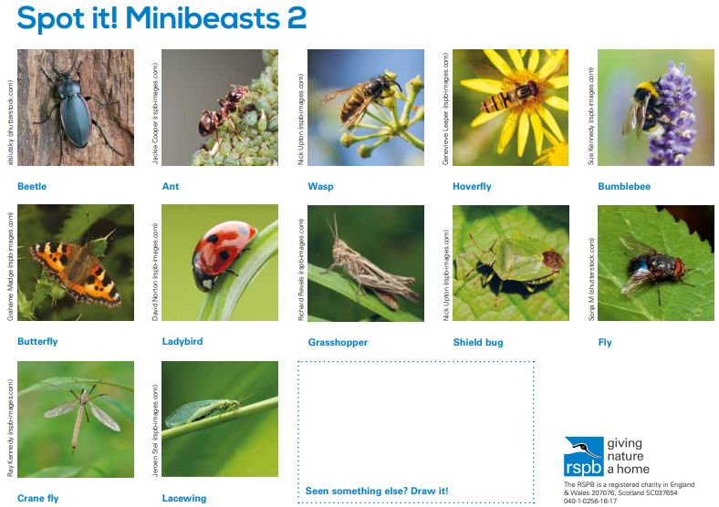

*Minibeasts such as caterpillars and bees don’t tend to come out until the spring time. Tick each creature when ever you spot one.
- Can you do some research about different minibeasts?

How many legs does a spider have? ___________________

How many legs do insects have? ___________________

How many legs does a centipede have? _______________

Do snails and slugs have any feet? ______________ Are you sure?

- Can you label these minibeasts?

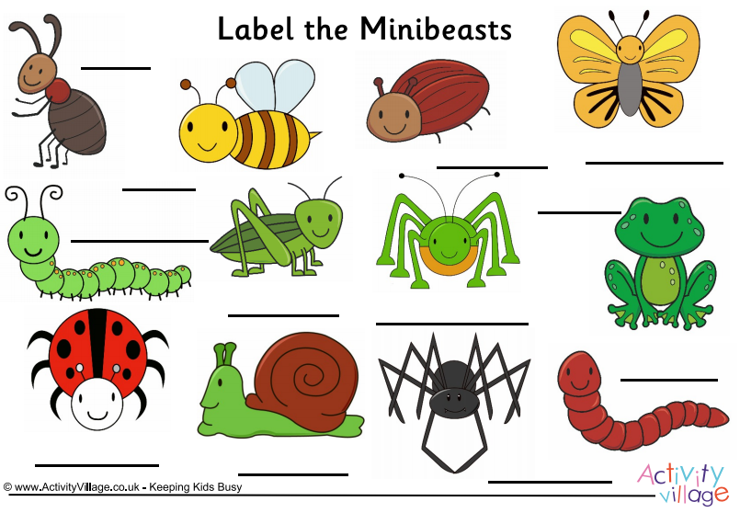

Watch out for these birds when you are next outside;
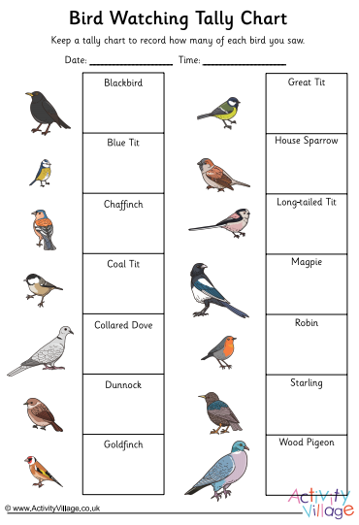

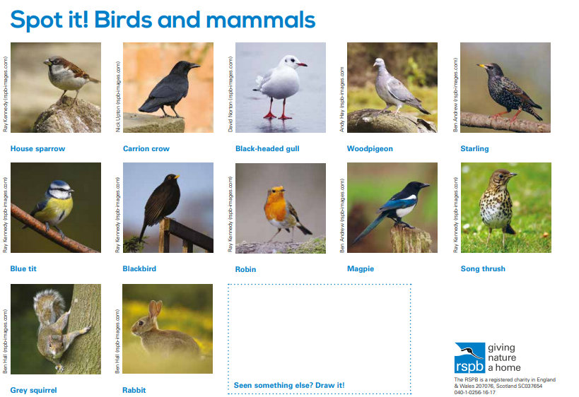

- Draw around your own body and label as many parts of the human body as you can. You can use one of the pictures below.
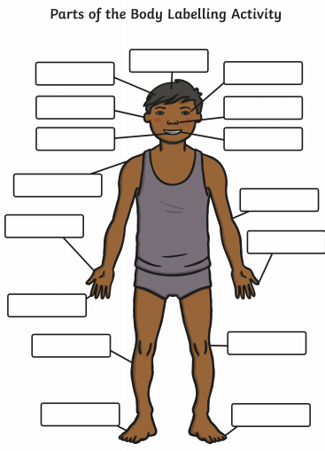
Join the Learning station on YouTube with this body parts song https://www.youtube.com/watch?v=TSdeIhmv6v0

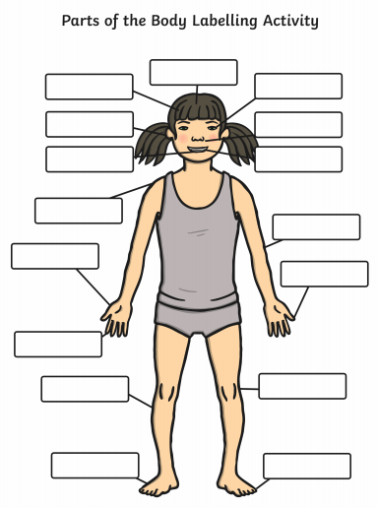

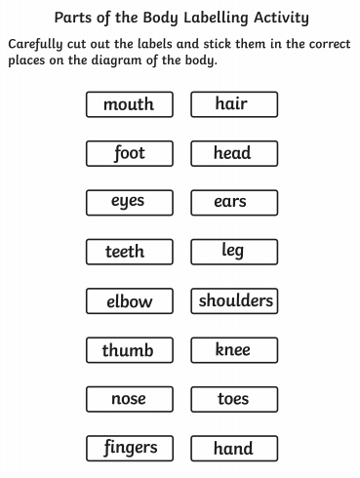

-Do you know all of the five bodily senses? Watch these videos
https://www.bbc.co.uk/bitesize/topics/z9yycdm/articles/zxy987h
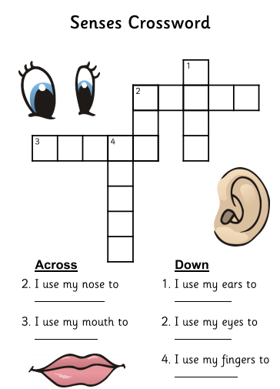
Wellbeing activities
Oak National Academy have a whole host of lessons online that you can access for free. This week is Child Wellbeing week (1st – 5th February). I recommend accessing the ‘It’s OK not to be OK’ lessons at this link;
https://classroom.thenational.academy/units/its-ok-not-to-be-ok-5ada
Each video is between 9 – 12 minutes long and deals with different ways that your children might be feeling.
Lesson 1 Feeling Good (9 minutes)
Lesson 2 Cool Down Corner (10 minutes)
Lesson 3 Turn Things Around (12 minutes)
Lesson 4 Don’t Worry About A Thing (12 minutes)
Lesson 5 Keep Calm and Carry On (11 minutes)

Mindfulness Colouring
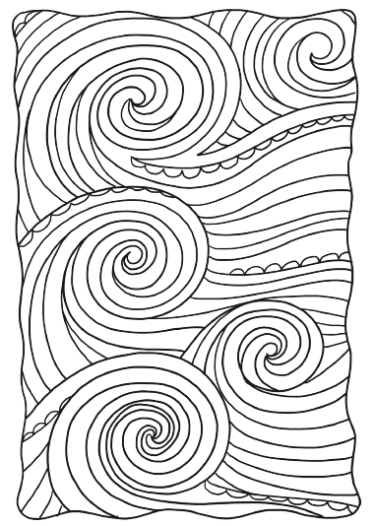

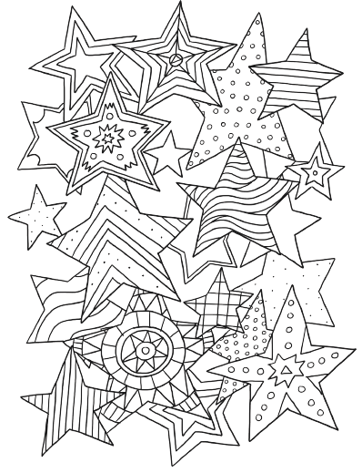

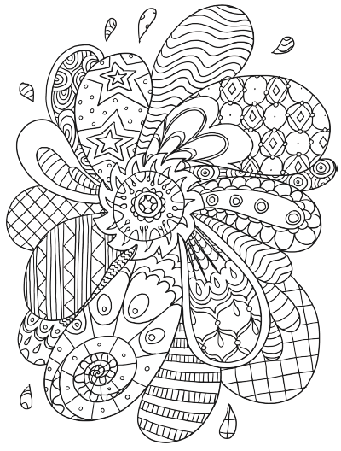

Science Activities
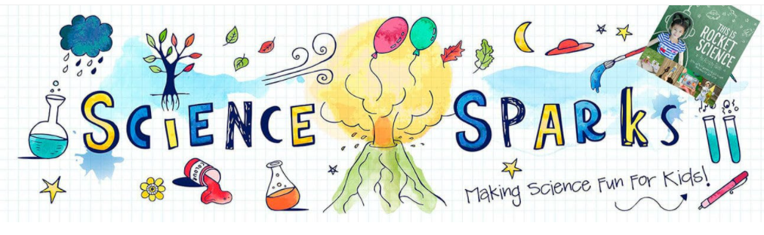
The Science Sparks website has really amazing and easy ideas for science projects! There are the ‘Tray a Day’ activities which just need everyday items from around your home. Get investigating and have fun!
Snot Trap!
https://www.science-sparks.com/make-a-snot-trap-gross-science-for-kids/
Why Food decays
https://www.science-sparks.com/great-science-projects/
Human body activities
https://www.science-sparks.com/learn-about-bones/
Learn about your bones! Create a skeleton picture using cotton buds.
