Badger Class Topic home learning
Our topic for Term 3 is ‘Road Trip USA’. So, buckle up and put your sunglasses on as we are going on a (virtual) road trip across the USA! We’ll start by looking at the physical geography of The Americas which includes both North American and South America.
We will look at famous sights and landmarks and use the internet to research New York and write postcards to family members. Using maps, we’ll locate the USA and find the names of the states.
Later this term we will explore the history of the United States of America. We will explore Native American myths and write our own.
Lesson 1 - Physical Geography of South America
This lesson we will recap our knowledge of the seven continents of the world, then we will zoom into the continent of South America. We will name and locate the countries of South America and then look at some of the physical geographical features we can find on the continent. We can then compare these to the area of the UK where we live! Today’s lesson is online at https://classroom.thenational.academy/lessons/which-countries-are-in-south-america-what-physical-features-can-we-find-in-south-america-crw3gr
Task 1 - Label the seven continents of the world
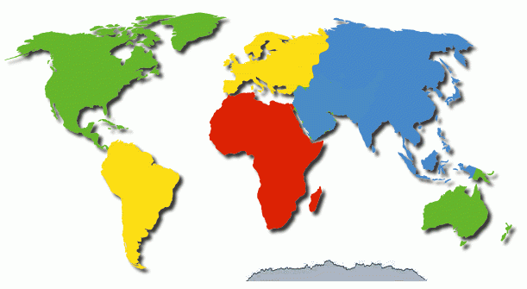

Task 2 – Label the countries in South America
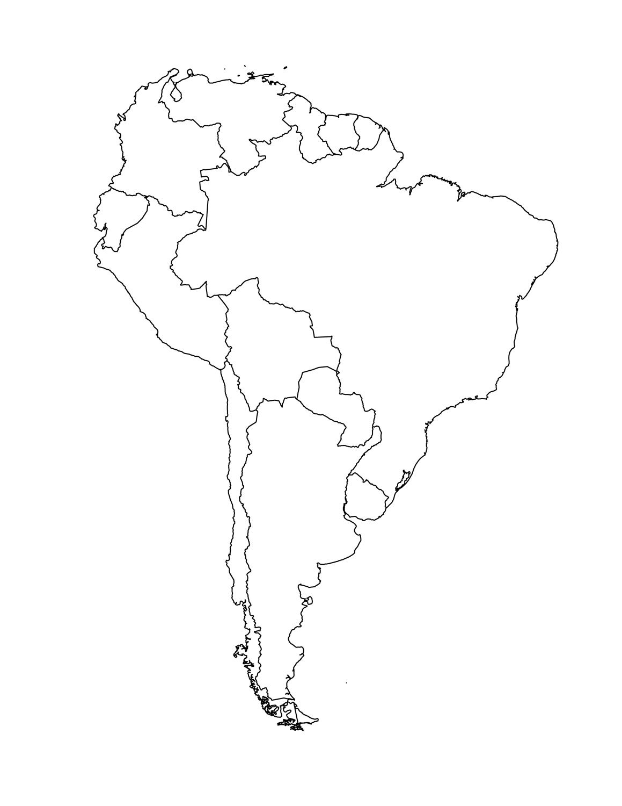

Task 3
How is the geography of Canterbury similar or different to South America?
What are some physical features in Canterbury?
_______________________________________________________________________
_______________________________________________________________________
_______________________________________________________________________
What is one similarity between the geography of Canterbury and South America?
_______________________________________________________________________
_______________________________________________________________________
_______________________________________________________________________

What is one difference between the geography of Canterbury and South America?
_______________________________________________________________________
_______________________________________________________________________
_______________________________________________________________________

Task 4 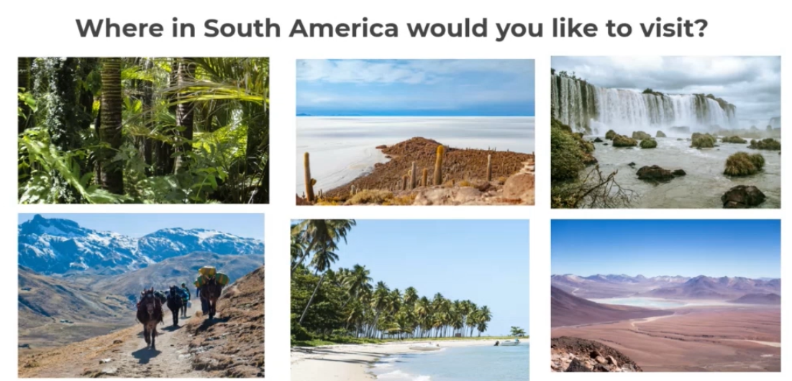
Where would you like to visit in South America?
Why do you want to go there? What do you think it will look like? What do you hope to see? What do plan to do there? _______________________________________________________________________
_______________________________________________________________________
_______________________________________________________________________
_______________________________________________________________________
Where would you NOT like to visit in South America?
_______________________________________________________________________
_______________________________________________________________________
_______________________________________________________________________
_______________________________________________________________________

Lesson 2 - The Physical Geography of North America
In this lesson, we will be learning to locate North America, as well as the countries within North America, on a map. We will also be learning about the five different regions of North America and at the end of the lesson, comparing two of the regions. Click this link to watch the online video https://classroom.thenational.academy/lessons/what-are-north-americas-countries-and-physical-features-ctgked
Task 1
Using what you have learned so far, and using maps and research draw some of the major physical geographical features of the United States of America on the map below. Try and include the following geographical features on your map:
- The Rocky Mountains 2) Appalachian Mountains 3) Great Plains 4) Mississippi River 5) Atlantic Ocean 6) Pacific Ocean 7) Gulf of Mexico 8) Mexico 9) Canada

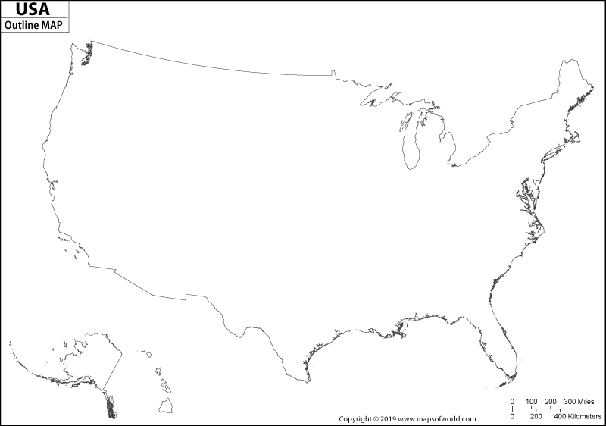

Lesson 3 - The United States of America
The USA (United States of America) is a rich and powerful country in the continent of North America. It is made up of 50 smaller states and the capital city is Washington DC. You can see the states coloured below on a map of the US.
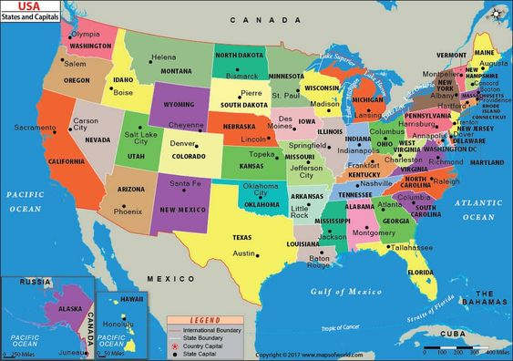
Task 1
Use the map above to find the capitals for these states. The name of the state is in CAPITALS and the capital city is in regular letters.
- The capital city of Colorado is Denver.
- The capital city of Washington is ________________________.
- The capital city of Florida is ________________________.
- The capital city of California is ________________________.
- The capital city of Arizona is ________________________.
- The capital city of Texas is ________________________.
- The capital city of Nevada is ________________________.
- The capital city of Georgia is ________________________.
- The capital city of California is ________________________.
- The capital city of New York is ________________________.
- The capital city of Mississippi is ________________________.
- The capital city of Kentucky is ________________________.

Lesson 4 - Create a Fact File on the United States of America
Use online sources, books, the internet or by asking an adult to create a fact file about the United States of America.
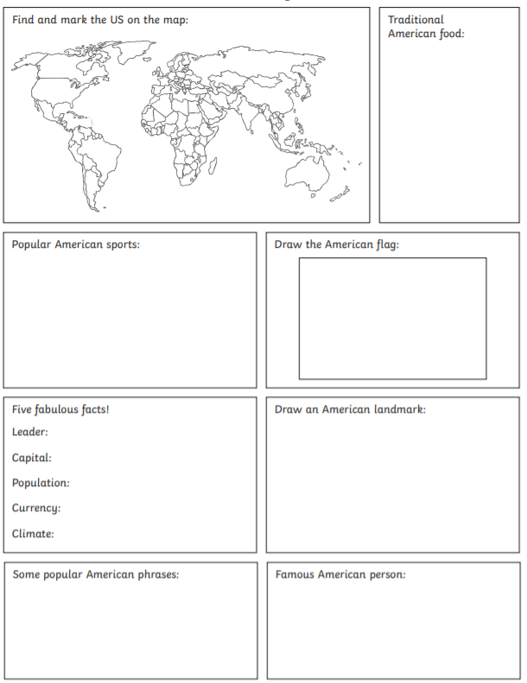

Lesson 5 : New York City
New York City is a popular tourist attraction in USA. We are going to explore some of the many famous tourist attractions in New York. Watch this video to learn about some of the reasons people visit New York City. https://www.youtube.com/watch?v=MtCMtC50gwY
Task 1 – Find the names of these famous landmarks
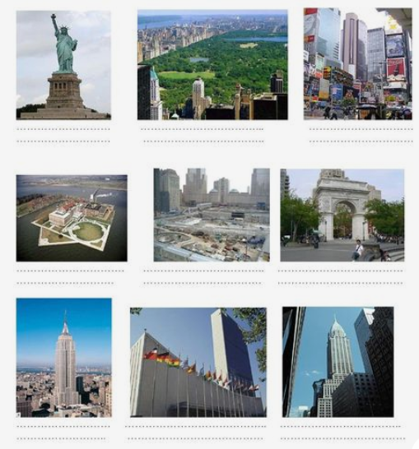

Choose 3 landmarks use online sources or ask an adult to help you find out some facts and information about each one. Then draw a picture and write a few sentences about why you would visit each one.
Name and Drawing | Facts and Information

Lesson 5 : Design and Create a ‘New York City’ Postcard
Today, I want you to imagine you have visited the famous landmarks you researched and looked at yesterday. We are going to write back home to someone in your family or a friend writing about what he have seen and done. Below is an example of a postcard from someone who has visited New York. 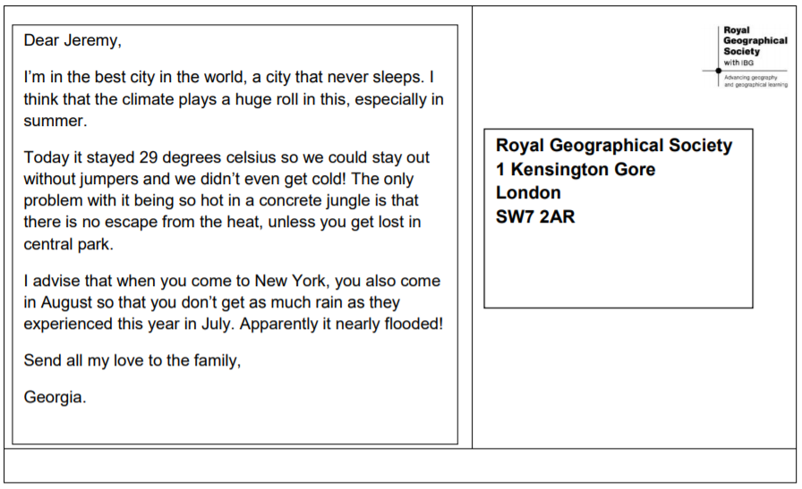
Task 2 – Design Your Postcard Image
On the back of your postcard draw a picture of New York. Remember to include some of the famous landmarks. Remember to make it look appealing. Here is an example below.
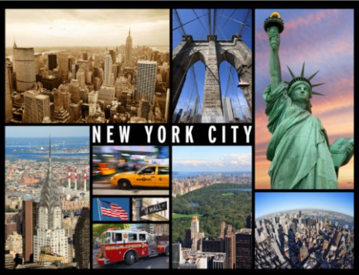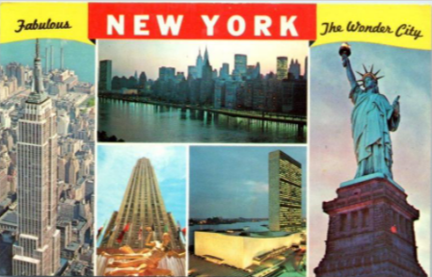
Use this template to write your own postcard.

