Week 1, Day 1: Column Addition

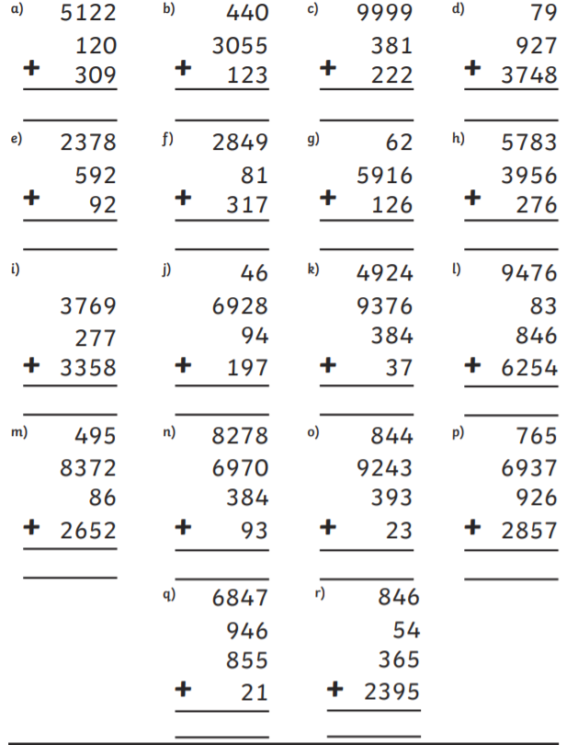

Week 1, Day 2: Addition Pyramids

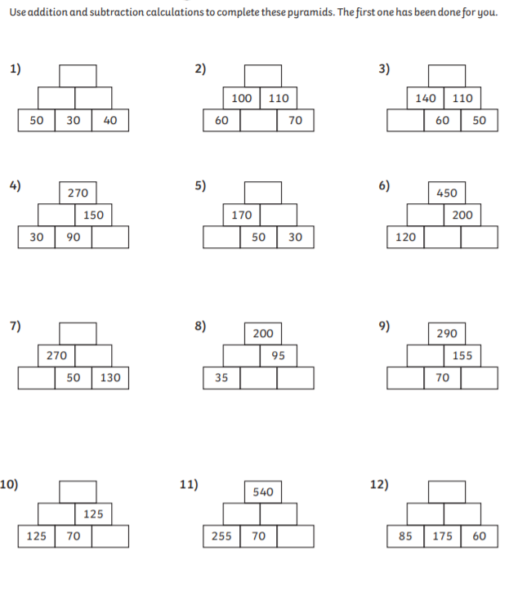

Week 1, Day 3: Repeated Subtraction of a Factor
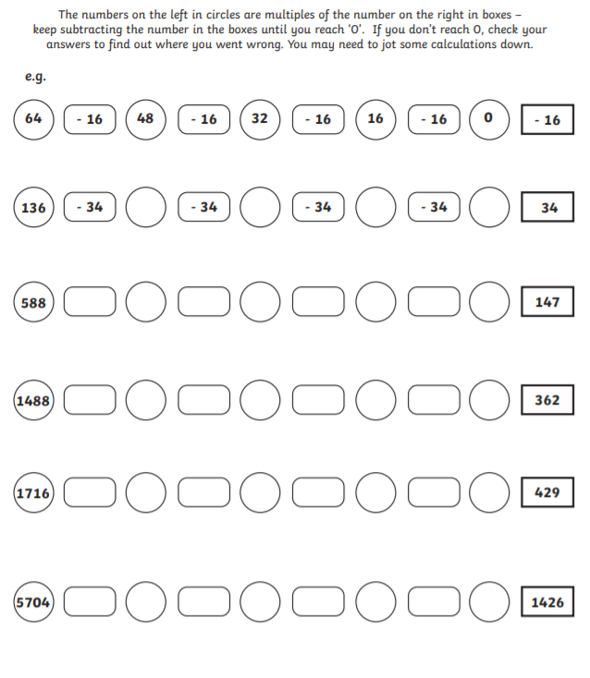

Week 1, Day 4: Column Subtraction Challenge!
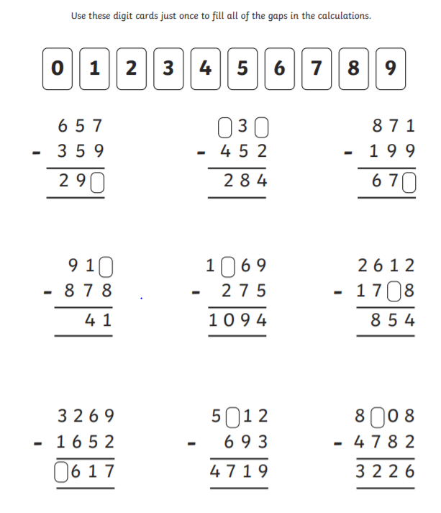

Week 1, Day 5: Two-step Addition and Subtraction word problems
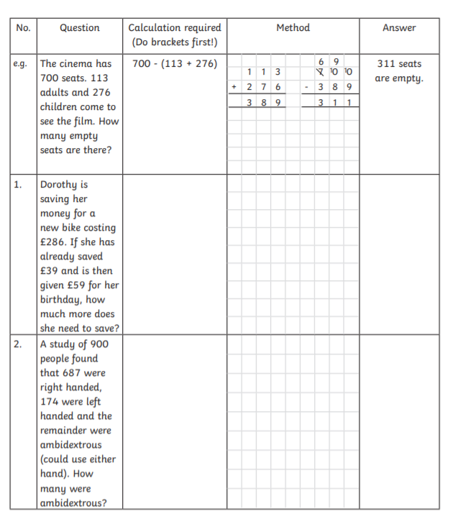

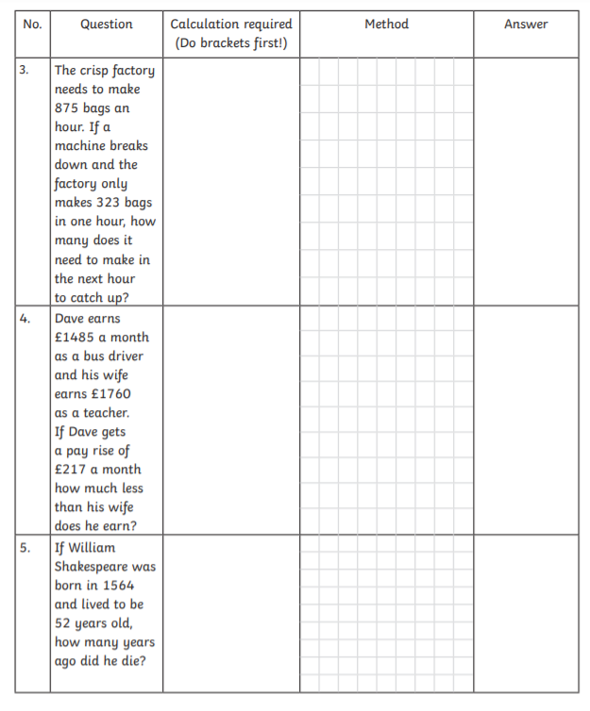

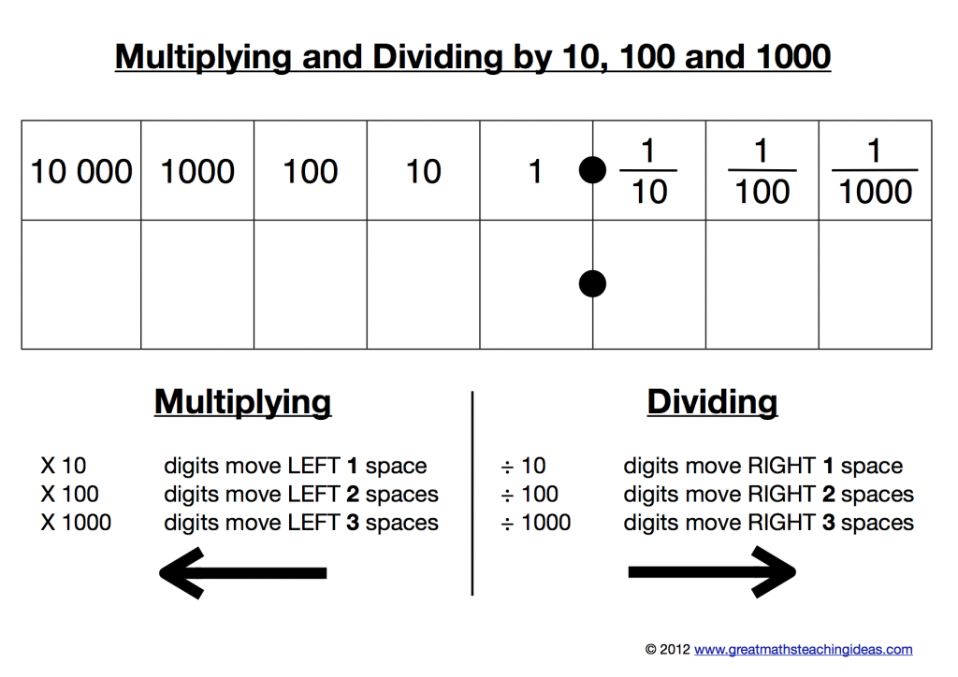
Week 2, Day 1: Multiplying and Dividing by 10, 100 and 1000

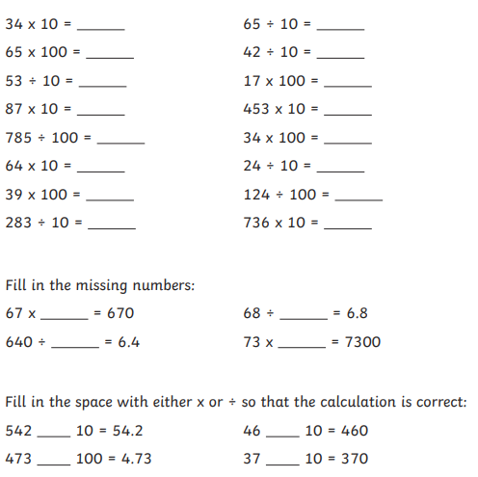

Week 2, Day 2: Multiplying and Dividing by Multiples of 10
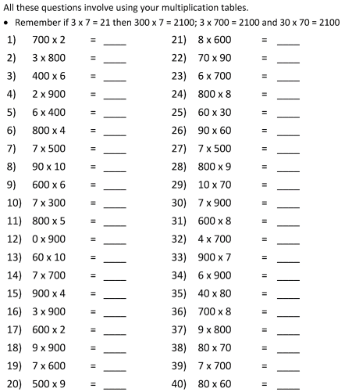

Week 2, Day 3: Word Problems involving Multiplication and Division by Multiples of 10

- There are 360 horses evenly divided into four fields. How many horses are there in each field?

- Sara has 480 packets of crisps. She must share these equally between her 4 friends. How many crisp packets will each friend get?

- Last year, 4 people each paid £3200 for an insurance package. How much did the people pay in total?

- For a school party, the headmaster bought 20 big bags of candy. There were 13 pieces of candy in each bag. How many pieces of candy did the headmaster buy in all?

- You want to share 480 pencils among 6 friends. How many would each friend get?

- A pet store has 4 tanks of tadpoles. There are 5200 tadpoles in each tank. How many tadpoles does the pet store have in all?

- In a school there are 360 children. There are 9 classrooms. How many children are in each class?

- An art dealer bought a set of 4 beautiful vases. Each of the vases is worth £80. How much is the set of vases worth in all?

- There are 4 rows of seats at the Memorial Stadium. Each row can seat 40 fans. How many fans can sit on the 4 rows?

- A sweet shop has 6 boxes of chocolates. Each box has 40 pieces. How many pieces is there altogether in the 6 boxes?

Week 2, Day 4: Multiplication Triangles
Use your time tables knowledge to complete these multiplication pyramids. E.g.
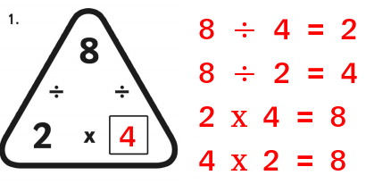

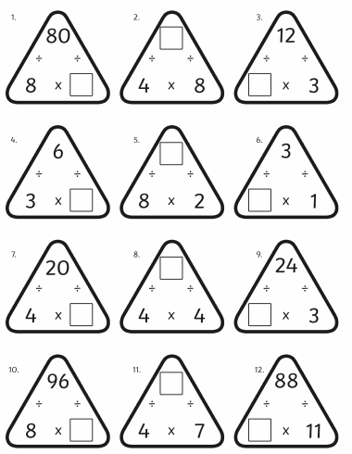

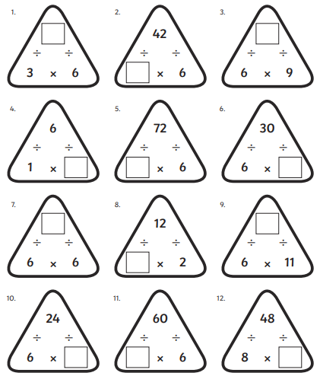

Week 2, Day 5: Multiplication and Division Word Problems

- Bubblegums come in packs of 3. If there are 21 Bubblegums. How many packs are there?  - There are 15 pieces of fruit. They are shared equally in to 3 bowls. How many bowls are there?  - A gardener is planting 24 onions. She plants them in rows of 4. How many rows will there be?  - There are 32 chairs. They are out in stacks of 4. How many stacks?  - I have 40 sweets. I share them with my 8 friends. How many do they have each?  - There are 36 children in a class. The teacher says to get in groups of 4. How many groups will there be?  - Altogether there are 56 eggs. They are put into boxes or 8. How many boxes will there be? | - There are five towers of 3 cubes. How many cubes are there altogether?  - There are seven boxes of 4 eggs. How many eggs are there altogether?  - There are nine pots with 3 pencils. How many pencils are there altogether?  - There are six rows of onions with 8 onions in each row. How many onions are there altogether?  - There are seven packs of 4 bananas. How many bananas are there altogether?  - There are six bags of 8 apples. How many apples are there altogether?  - There are eight boxes of 3 cubes. How many cubes are there altogether?

Now, write your word problems for the following calculations.
9 x 6 = __ 32 ÷ 4 = ___

