Badger Class English home learning
Day 1: To use all four word classes (nouns, adjectives, verbs and adverbs)

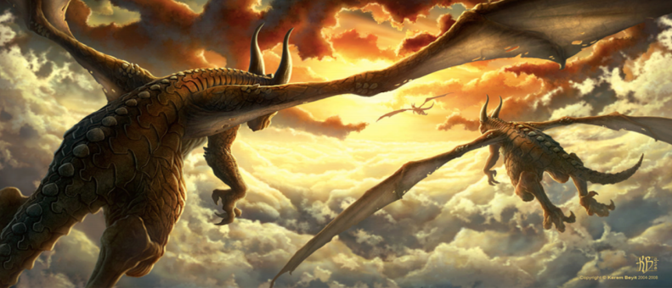
Look at the picture talk to your adult about what you can see.
Next, think about words for each of the word classes above and write 4 lists.
Nouns | Adjectives | Verbs | Adverbs
dragon | huge | flying | happily

Have a go at using the words you generated above in sentences... you will need these for tomorrow!
________________________________________________________________
________________________________________________________________
________________________________________________________________
________________________________________________________________
________________________________________________________________
________________________________________________________________
________________________________________________________________
________________________________________________________________
________________________________________________________________
________________________________________________________________
________________________________________________________________
________________________________________________________________
________________________________________________________________
________________________________________________________________
________________________________________________________________
________________________________________________________________
________________________________________________________________
________________________________________________________________
________________________________________________________________
________________________________________________________________
________________________________________________________________
________________________________________________________________
________________________________________________________________
________________________________________________________________
________________________________________________________________
________________________________________________________________
________________________________________________________________
________________________________________________________________

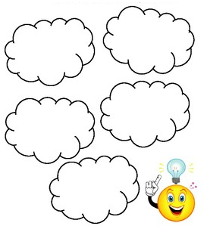
Day 2: Generating Story Ideas

We are working towards writing a story about this picture. Use a thought bubbles, below, to make a note of as many possible ideas as you can.

Day 3: Plan Your Story
Today, you need to plan your story, think carefully about what will happen in each section
 | Ideas | Key Words
Opening
What happens at the beginning? Who are the main characters? Where is it set? How are the characters feeling?
Build up
What happens next? How does the story hint at a problem? How are the characters feeling?
Problem
What is the problem within the story? How are the characters feeling?
Solution
How is this problem resolved/ sorted out? How are the characters feeling?
Ending
How does the story end? Does it end happily? Is there a twist to the plot? How are the characters feeling?

Day 4: Use speech punctuation
Today we are going to write speech to make our stories more exciting for the reader.
Look back at your plan and think about what the character could do and say. Write speech sentences using the rules below.

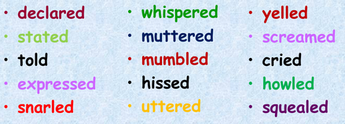
Try to use more exciting words for said

E.g. “Run! There’s a dragon heading right for us,” shouted Max as he grabbed Ted’s hand and ran for cover.
_______________________________________________________
_______________________________________________________

_______________________________________________________
_______________________________________________________

_______________________________________________________
_______________________________________________________

_______________________________________________________
_______________________________________________________

_______________________________________________________
_______________________________________________________

Day 5: Use your plan to have a go at writing your story. The idea of a shared write is that you work with someone to help each other form the best sentences possible. Think about:
▪ Description ▪ Word choices ▪ Sentence structure ▪ Speech

________________________________________________________________
________________________________________________________________
________________________________________________________________
________________________________________________________________
________________________________________________________________
________________________________________________________________
________________________________________________________________
________________________________________________________________
________________________________________________________________
________________________________________________________________
________________________________________________________________
________________________________________________________________
________________________________________________________________
________________________________________________________________
________________________________________________________________
________________________________________________________________
________________________________________________________________
________________________________________________________________
________________________________________________________________
________________________________________________________________
________________________________________________________________
________________________________________________________________
________________________________________________________________
________________________________________________________________
________________________________________________________________
________________________________________________________________
________________________________________________________________
________________________________________________________________
________________________________________________________________
________________________________________________________________
________________________________________________________________
________________________________________________________________
________________________________________________________________
________________________________________________________________
________________________________________________________________
________________________________________________________________
________________________________________________________________
________________________________________________________________
________________________________________________________________
________________________________________________________________
________________________________________________________________

Week 2 – Poetry
This week we are going to write a poem on climate change.
Day 1: Gathering ideas for a poem on climate change
Look at these photos and write a list of words, adjectives and feelings you have towards these pictures.

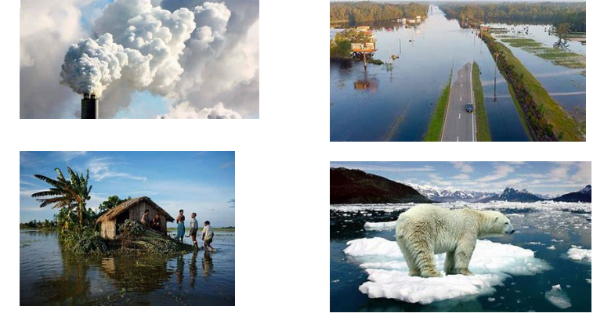
_______________________________________________________________
_______________________________________________________________
_______________________________________________________________
_______________________________________________________________

Now watch and listen to this video by George the Poet on Climate Change.
https://www.youtube.com/watch?v=Sv7OHfpIRfU

After watching the video, think about …
• What did you like?
• How did it make you feel?
• Which words did you notice?
• Do you know the meaning of the words? (If not you could look them up in a dictionary.)

Day 2, Building up a success criteria
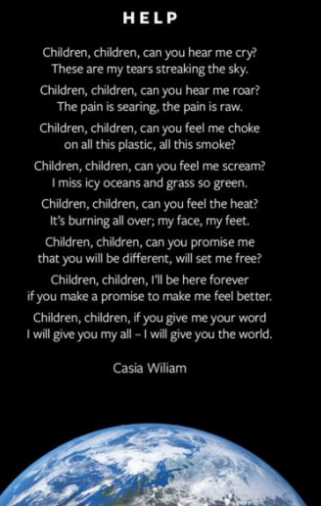
Look at these different examples of good poems, make a list of different things you like and create your own success criteria.
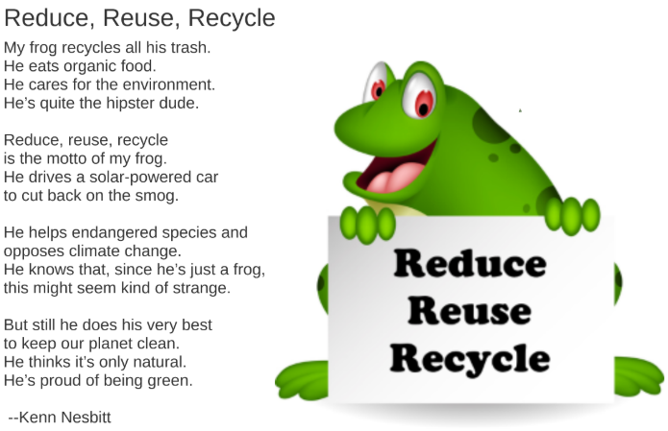
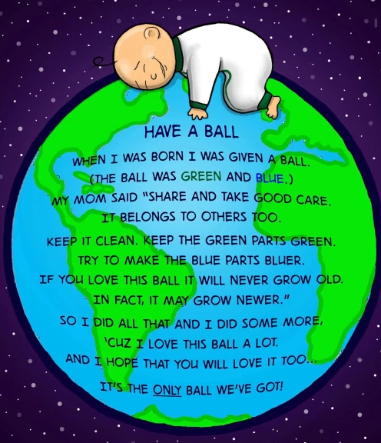
Success Criteria:-A title, Key vocabulary, ….

Day 3, Write your poem
You are now going to write your poem about climate change. Use all the ideas you have gathered for your poem and look back at the success criteria you made. Use the key words in your poem to make it more powerful.
Key words: Climate Change Ice Melting Polar bears Pollution Earth Planet Flooding Fires Deforestation Fuel Smoke Carbon footprint Environment Global

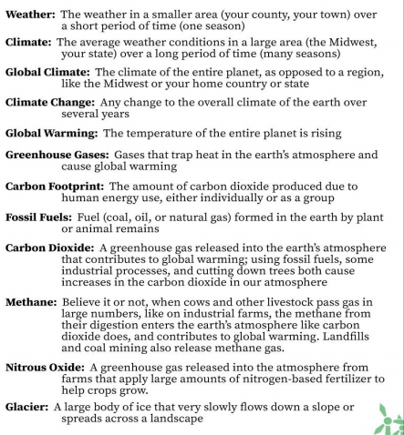

_____________________________________________________________________________
_____________________________________________________________________________
_____________________________________________________________________________
_____________________________________________________________________________
_____________________________________________________________________________
_____________________________________________________________________________
_____________________________________________________________________________
_____________________________________________________________________________
_____________________________________________________________________________
_____________________________________________________________________________
_____________________________________________________________________________
_____________________________________________________________________________
_____________________________________________________________________________
_____________________________________________________________________________
_____________________________________________________________________________
_____________________________________________________________________________
_____________________________________________________________________________
_____________________________________________________________________________
_____________________________________________________________________________
_____________________________________________________________________________
_____________________________________________________________________________
_____________________________________________________________________________
_____________________________________________________________________________
_____________________________________________________________________________
_____________________________________________________________________________
_____________________________________________________________________________
_____________________________________________________________________________

Day 5: Create a Climate Change Poster
Create a poster about climate change to go with your poem. You can choose to write up your poem neatly on the poster. Here are some ideas to inspire you.
