Badger Class English home learning
Week 4
This week we are going to be watching a visual literacy clip, and then we're going to be developing our own responses towards the clip. The clip that we're going to watch is a John Lewis advert and it's called Man on the Moon. You can access all the lessons by clicking the link below
https://classroom.thenational.academy/units/the-man-on-the-moon-narrative-writing-e7d1
Lesson 1 – Monday
Click this link to watch today’s lesson
https://classroom.thenational.academy/lessons/to-develop-initial-responses-cgvp2d
Task 1 – Draw a picture of what the man on the moon and his home might look like.
The man on the moon His home

Write down 3-5 adjectives to describe the man? Write down 3-5 adjectives to describe the home?
Task 2 – Make a prediction about what might happen in the video clip
What do you think might happen in the video?
Task 3 – Write down three questions.
- _____________________________________________________________________________________?

- _____________________________________________________________________________________?

- _____________________________________________________________________________________?
Task 4 – Write down what you like and dislike.
Task 5 – Put the Scenes in Order
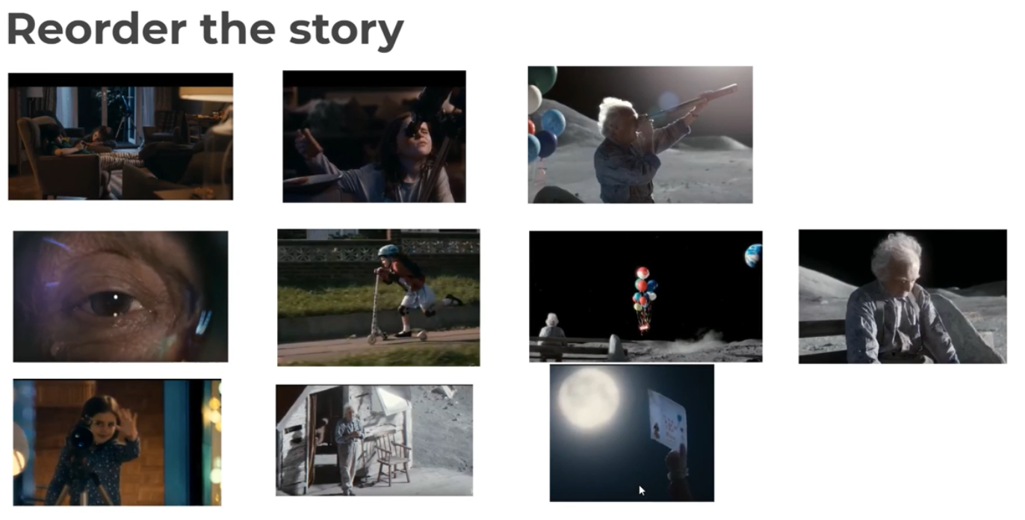
You can write 1, 2, 3, 4, 5…etc next to the picture.
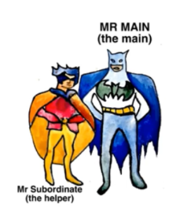
Lesson 2 – Tuesday
Click this link to watch today’s lesson
https://classroom.thenational.academy/lessons/to-explore-complex-sentences-c8r34r
Task 1 – Add a subordinate clauses to these main clauses.
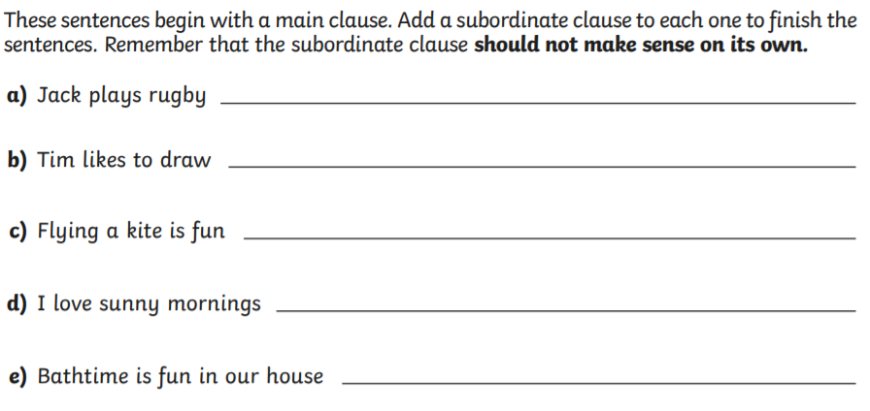
Task 3 – Add a main clause to these subordinate clauses
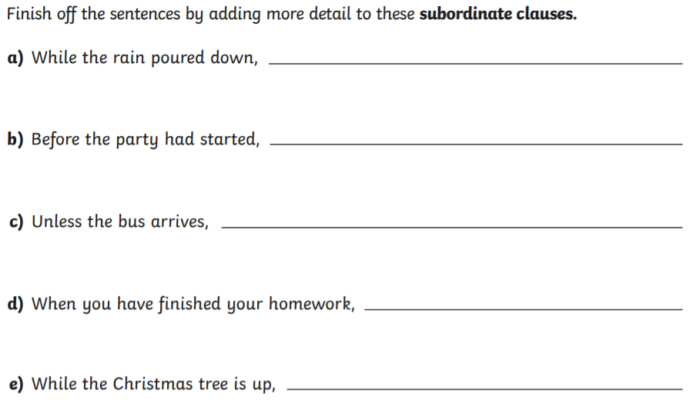
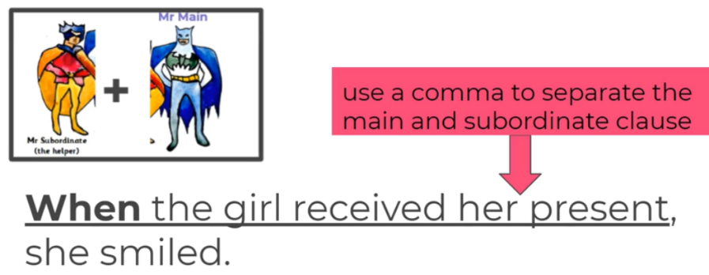
Task 3 – Write your own sentences with a main clause and subordinate clause
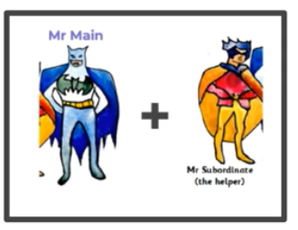

Can you identify and label the main clause in each of the sentences you have written?
Lesson 3 – Wednesday
Click this link to watch today’s lesson
https://classroom.thenational.academy/lessons/to-describe-two-contrasting-settings-and-characters-6ru3er
Task 1 – Write down adjectives (describing words) to describe the contrasting settings.
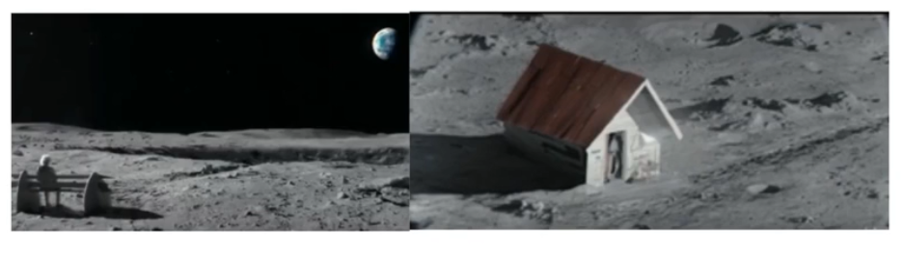
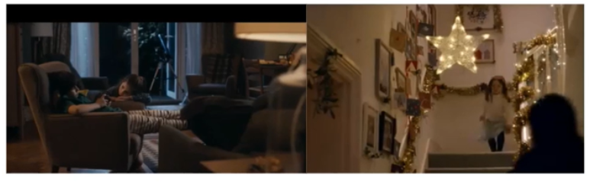

Task 2 – Write down adjectives (describing words) to describe the main characters.

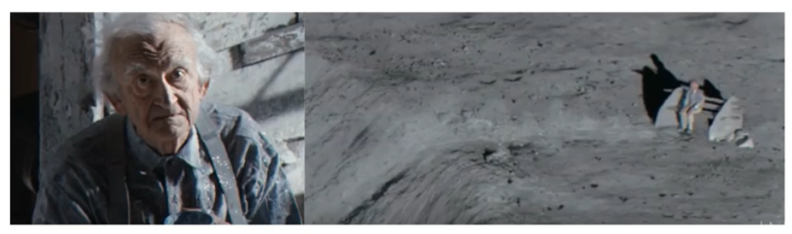

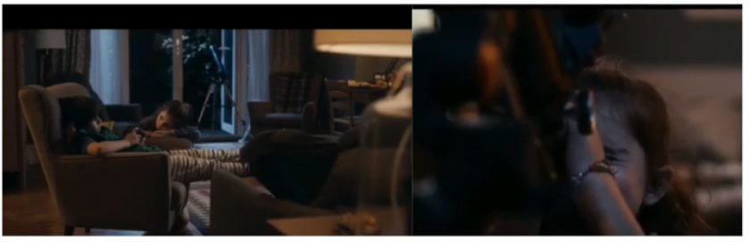

Task 3 – Write down a complex sentences to match the action.
Lesson 4 – Thursday
Click this link to watch today’s lesson
https://classroom.thenational.academy/lessons/to-write-the-opening-of-a-narrative-6xk36r
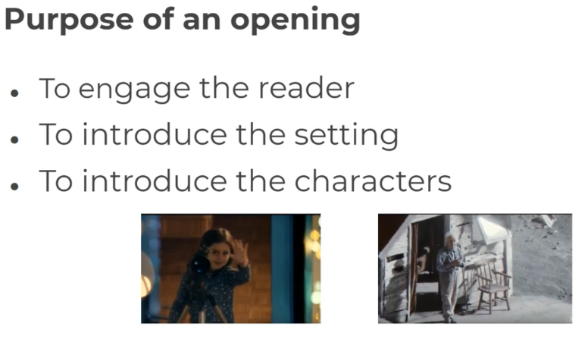
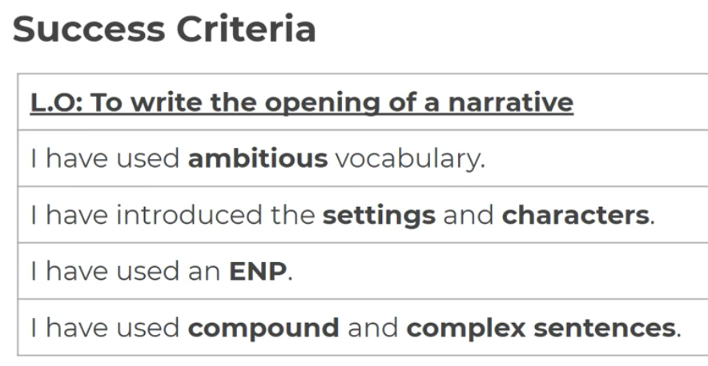

Today we are going to write the opening of the story. That is just the first three pictures below. Make sure you include all the success criteria and use complex sentences with one that has a main and subordinate clause. 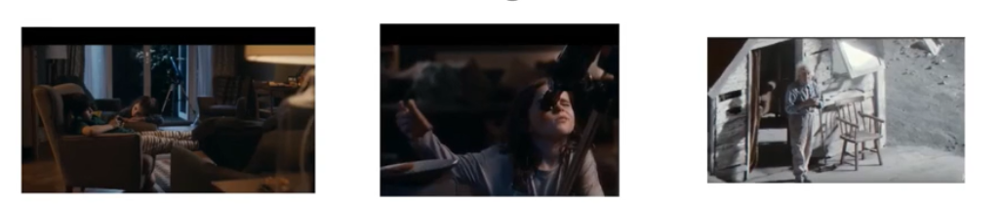
Lesson 5 – Friday
Click this link to watch today’s lesson
https://classroom.thenational.academy/lessons/to-plan-the-build-up-of-a-narrative-6djkge
Task 1 – Write complex sentences comparing the two characters and how they are feeling.
Today we are going to write complex sentences to describe how the characters are feeling. A complex sentences has both a main clause and a subordinate clause. Remember you can start you sentences with either a main or a subordinate clause.
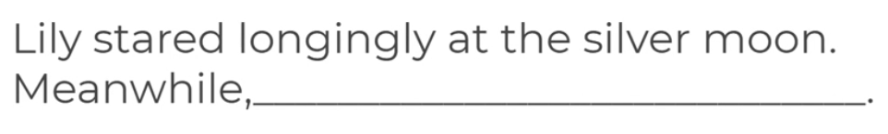
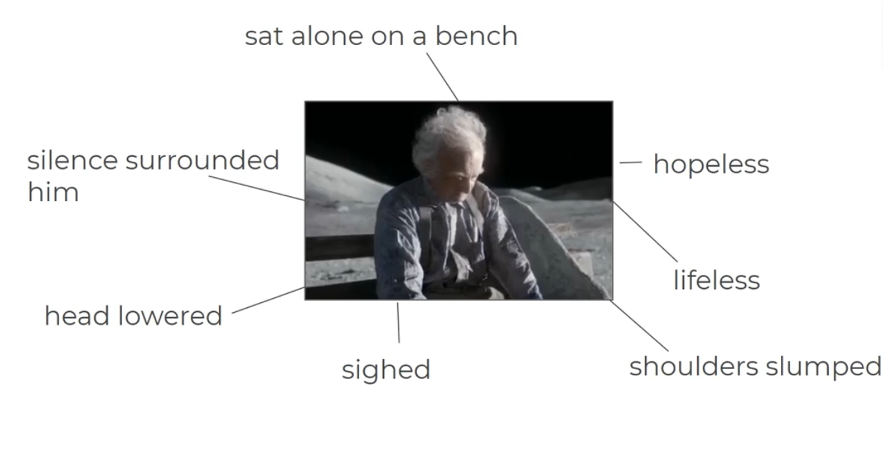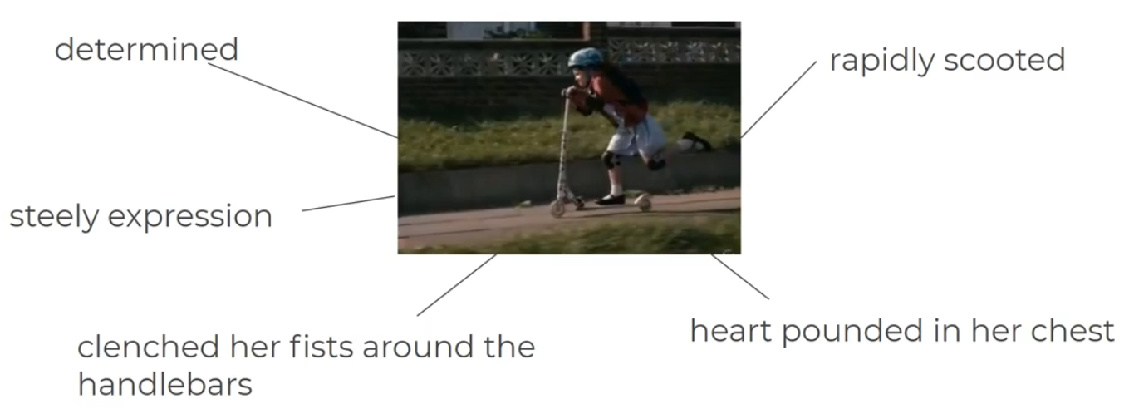
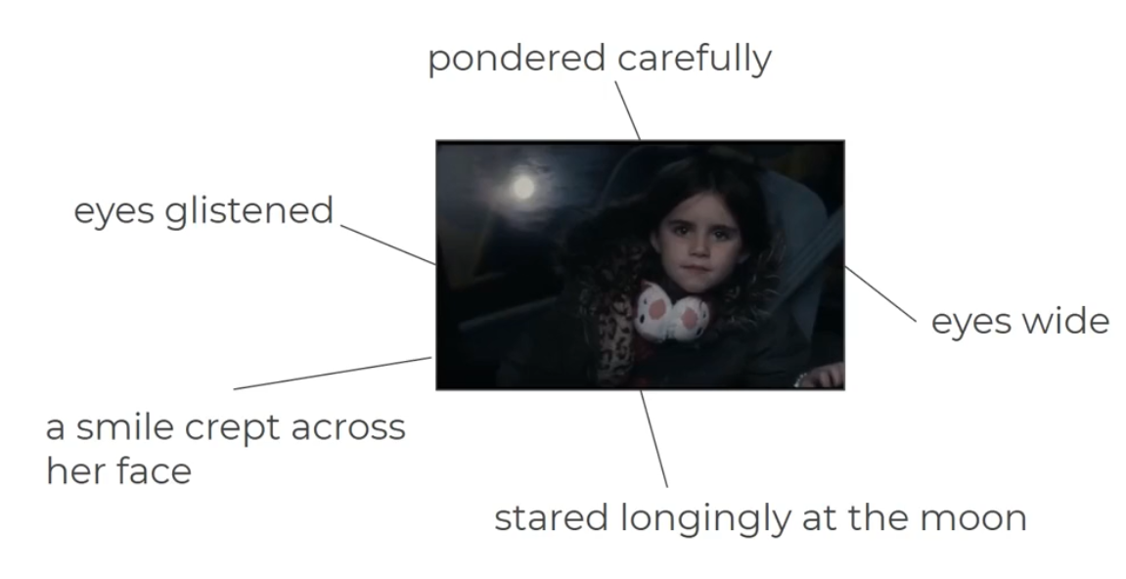

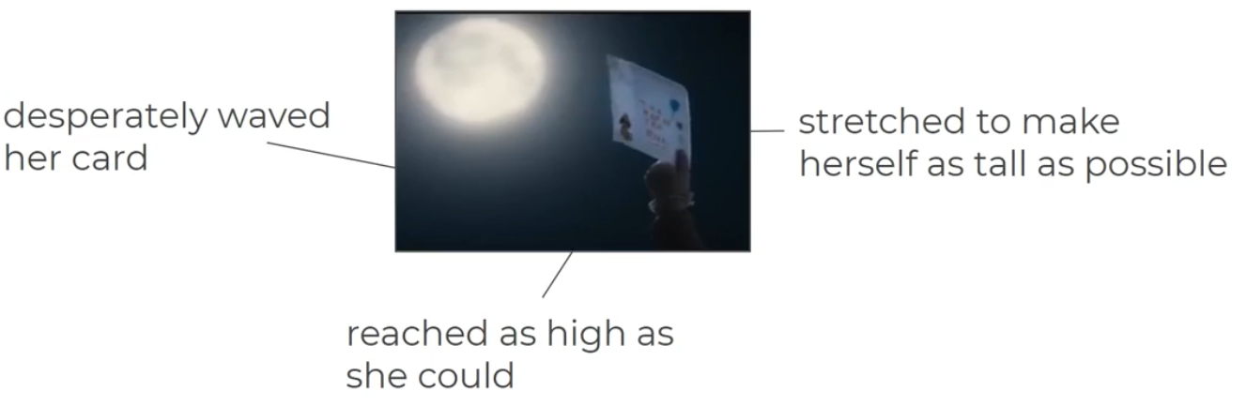
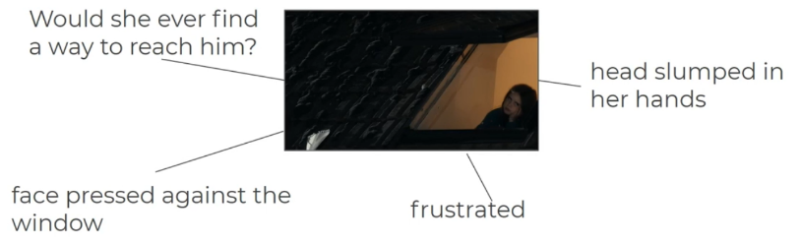

Remember to show your work to your teacher.

You can bring it to the office each week or send a photo of your work to Mr King at badgerclass@parkside.kent.sch.uk

