Badger Class suggested home learning activities

Year 4:
Writing:
This week, we would like you to become a poet. Look and listen to the poem ‘The Magic Box’ by Kit Wright. (https://www.bbc.co.uk/bitesize/clips/zkpmhyc)

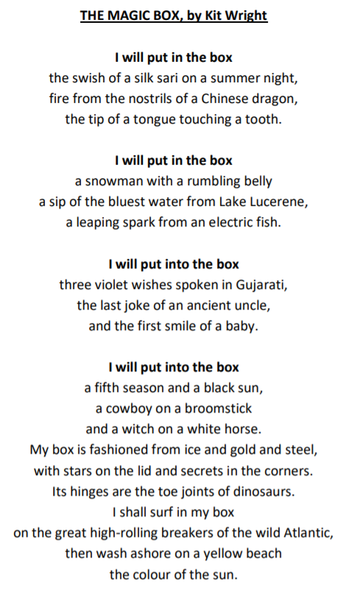

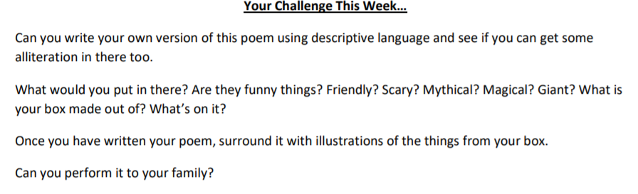
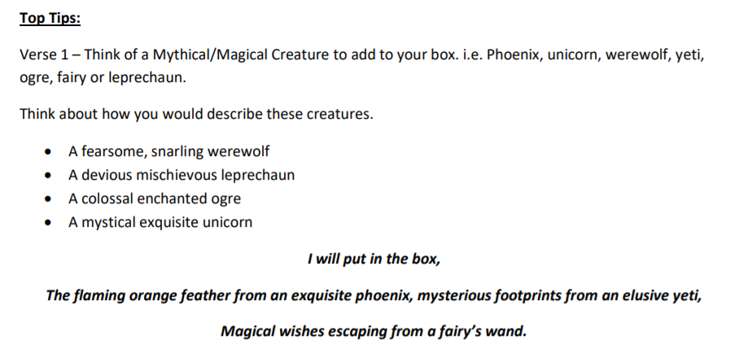

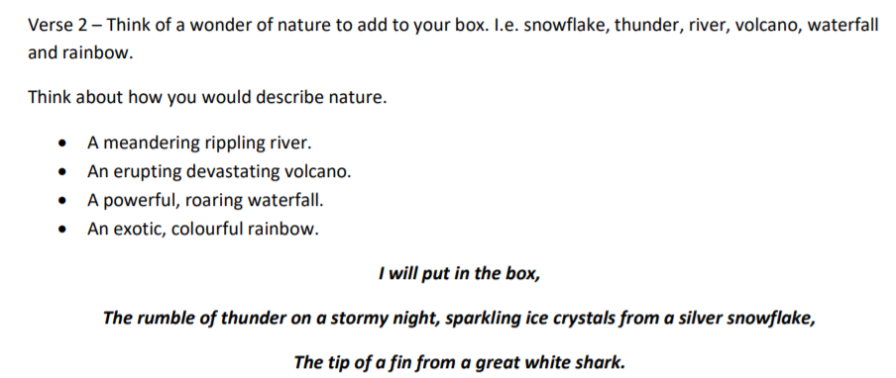

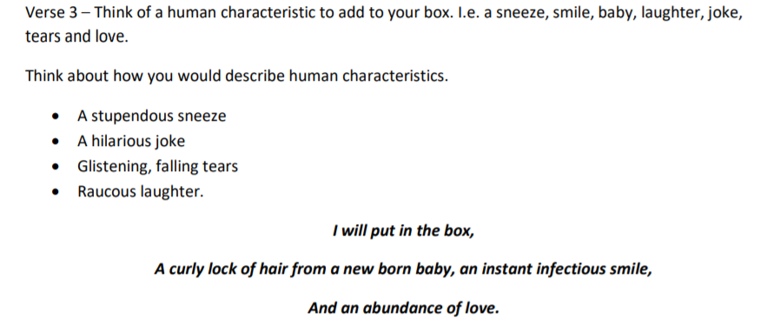

Maths:
https://whiterosemaths.com/homelearning/year-4/
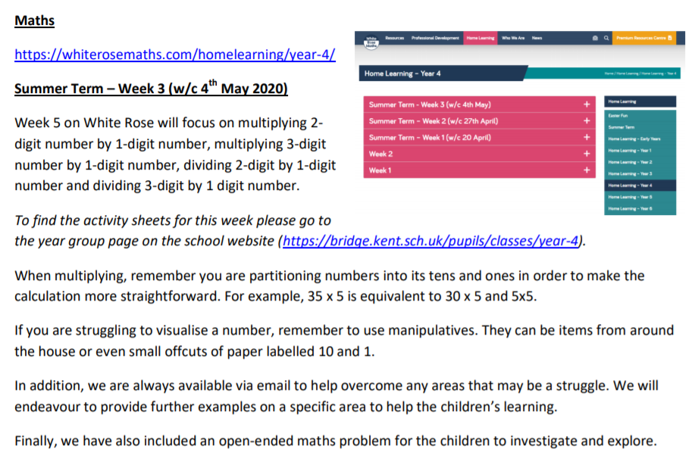

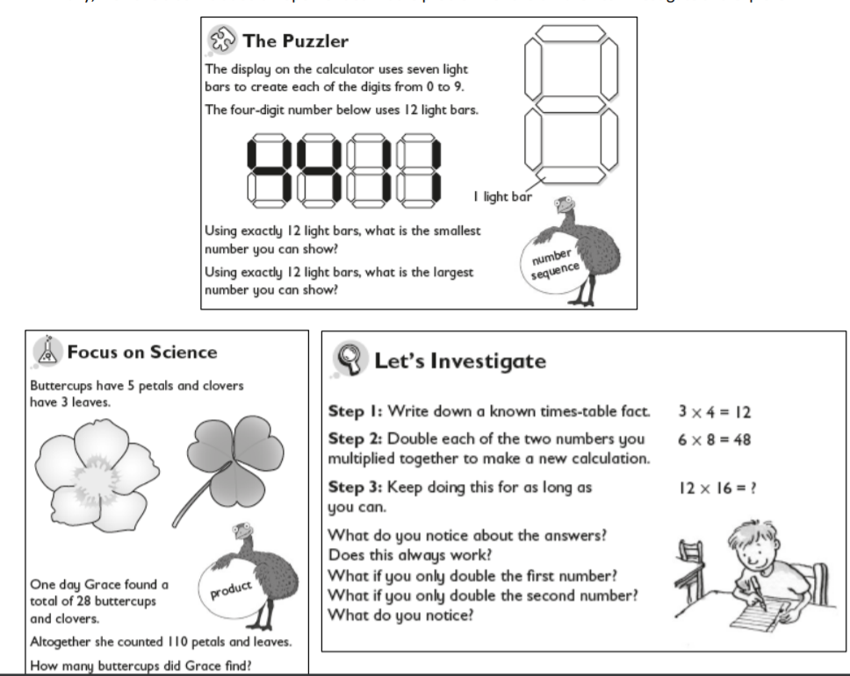

Year 5:
English
Your English task this week is based around ‘Things around us’. Follow the tasks below, spending roughly 40mins on each task per day. This week the activities are more stand alone as we thought it would be nice to mix it up and have a change, complete the tasks in any order you like – be imaginative and have fun!
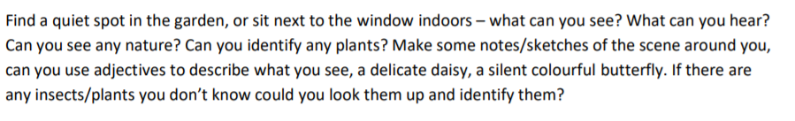
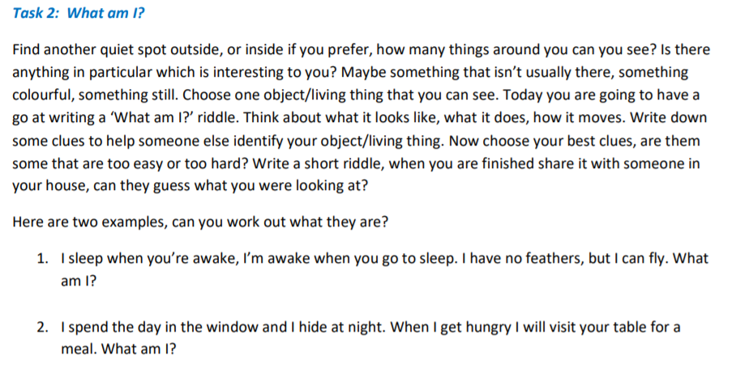

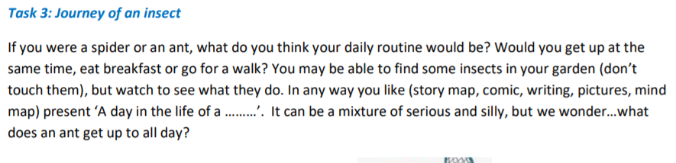
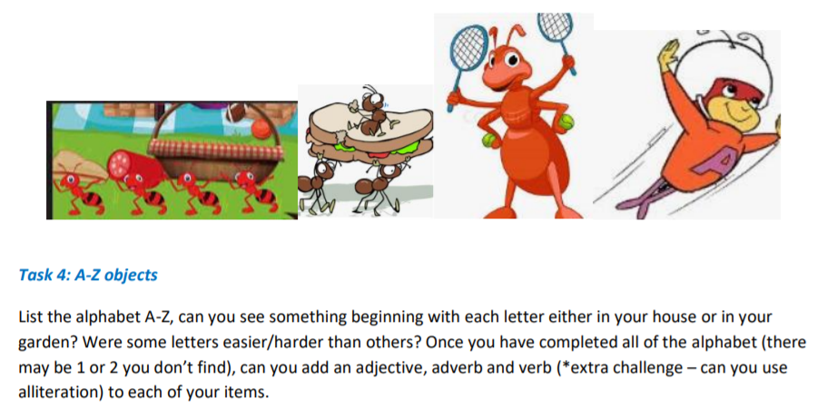
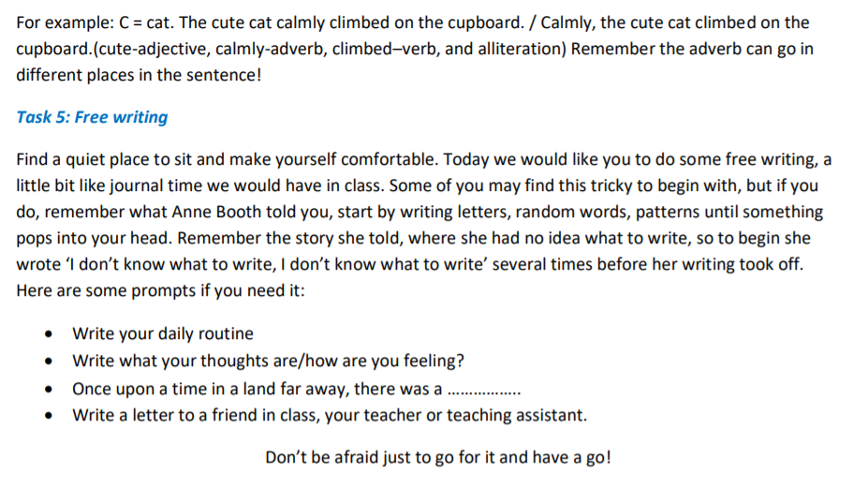
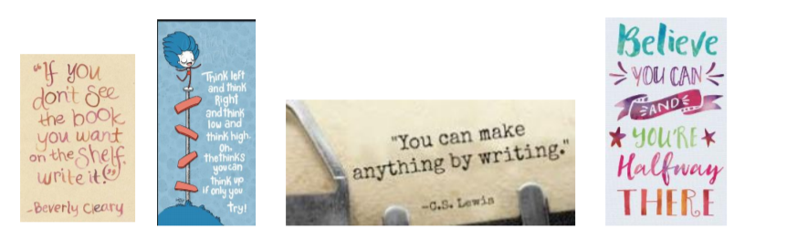

Maths
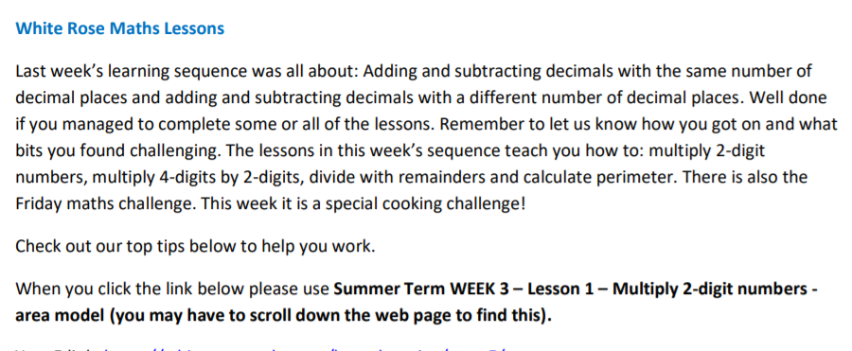
Year 5 link: https://whiterosemaths.com/homelearning/year-5/
Top Tips:
1. When using written formal methods, you MUST keep your presentation clear, using a ruler and keeping the digits in the correct column. Otherwise, you will end up changing the digits value and ultimately end up with an incorrect answer. (See picture 1 below).
2. Remember when multiplying by a 2 digit number you must start by multiplying all of the top digits by the units (see picture 2 below).
3. Then, you must remember to put in a zero at the start of the second answer row/box as here you are now multiplying by the tens not the units so by putting a zero in at the start your answer will be 10 times larger (see picture 3 below).
4. It is important that you remember to add both of your answers together to get the total after you have done both parts of the multiplication (see picture 4 below).
5. Remember, when carrying over, put the digit directly below that answer box in the next column (see picture 5 below)
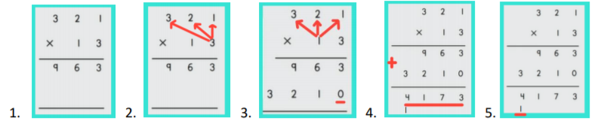

Fun Maths Challenges This week we have included some different maths activities for you to have a go at should you want to.
