Badger Class suggested home learning activities

Physical and emotional well being
Exercise Exercise helps to focus the mind and we would recommend starting the day with the Joe Wicks workout at 9.00. https://www.youtube.com/channel/UCAxW1XT0iEJo0TYlRfn6rYQ
If you are unable to view or participate, you may wish to create your very own fitness challenge. How fast can you run to the shed and back? How many skips can you complete in a minute? Create a challenge for yourself and aim to beat your personal best week on week.
PSHE A useful website for both yoga and mindfulness is Cosmic Kids. This is a fantastic resource that has a variety of videos that help teach Yoga for children. The videos range in length from 5mins to 15mins and can be sorted into videos that help, focus, calm or activeness. https://www.cosmickids.com

Year 4:
Writing:
This week we would like the children to share their favourite ‘lockdown’ recipe. It can be sweet or savoury and perhaps something that other children can have a go at making with their families at home. You could also make this for somebody local as a surprise!
Firstly, we would like the children to think of their own choice and to explain why they have chosen this particular recipe. Is it a new one that they have found or an old family favourite. The children could gather friends and families choices. It would be lovely for the children to talk to family members and ask which recipe they like the most.
Once the children have selected their recipe choices then they could write their recipe down for other families to have a go. You might want to take photos of yourself making the recipe with a step by step guide on what to do. Or you could choose to record a video. How you record this is very much up to you.
The focus should be:
• Capital letters, commas and full stops.
• Clear, concise language so somebody making your recipe knows what to do.
• Include a list of ingredients and headings such as Ingredients, you will need, how to make.
• Number your instructions and include imperative (bossy) verbs such as stir, take, fry, mix, and sieve.
• Include time conjunctions such as firstly, next, meanwhile, after, finally.
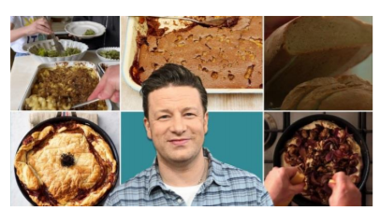

Maths:
https://whiterosemaths.com/homelearning/year-4/ Summer Term – Week 1
(w/c 20th April 2020) Week 3 on White Rose will focus on making a whole number using a mixture of decimals and fractions as well as writing, comparing and ordering decimals.
Remember to visualise a hundred square when comparing hundredths and tenths. Remember that tenths are represented by a complete row or column and each individual square represents one hundredth.
Be mindful of place value and recognising that 0.1 is the same as 1/10 (or one shaded row/column) and that 0.01 is the same as 1/100 (or one individual square shaded).
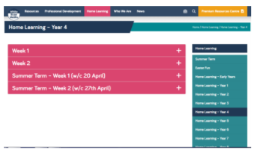

Badger Class suggested home learning activities
Year 5:

English:
Your English task this week is based around writing a persuasive piece of writing. Follow the tasks below, spending roughly 40mins on each task per day. Your persuasive writing is going to be based on the question:
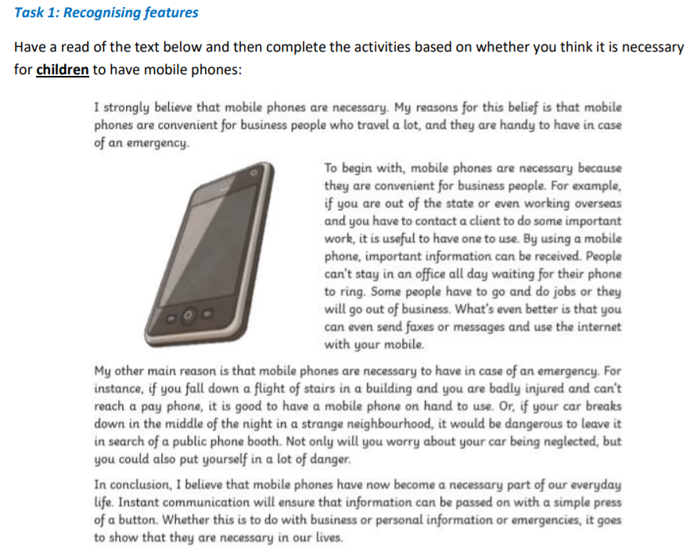

1. Clarify any words – if there are any words that you do not understand – look them up in a dictionary and write down the meaning.

2. Identify features - create a key and use a colour code system to highlight what you find. Use the feature checklist below to help you:

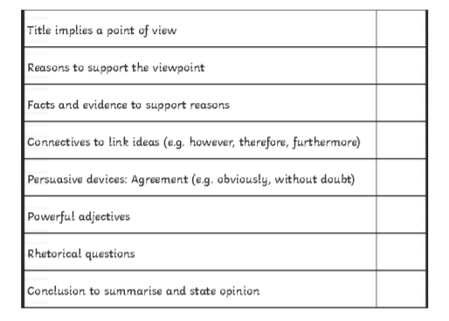

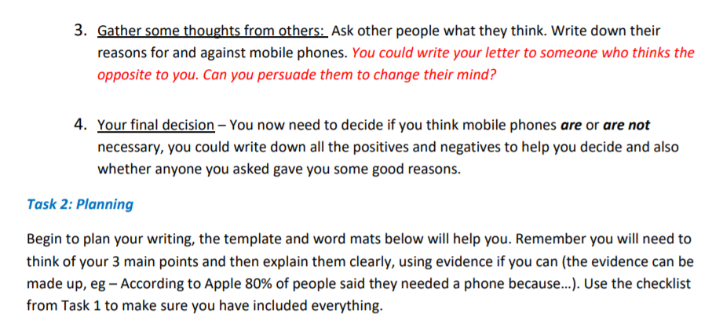

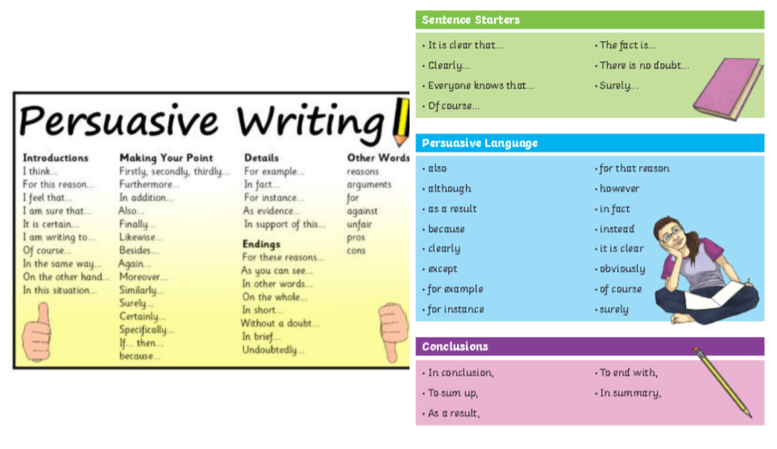

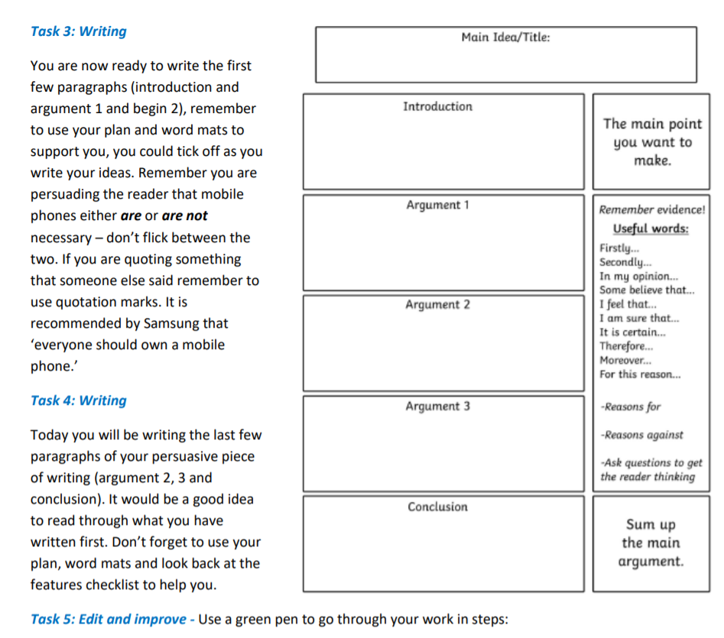

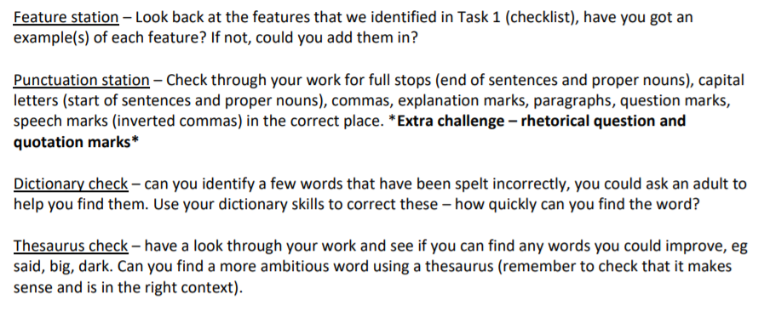

Maths
Last week’s learning sequence was all about: rounding, ordering and comparing decimals and understanding and calculating percentages. Well done if you managed to complete some or all of the lessons. Remember to let us know how you got on and what bits you found challenging.
The five lessons in this week’s sequence teach you how to: add and subtract decimals within 1, complements to 1, adding decimals crossing the whole and the Friday maths challenge linked to BBC Bitesize.
Please note that for the Friday maths challenge, questions 1-5 are most suitable for Year 5 children. Although, please feel free to have a go at the other questions if wanted, it could be fun to work these out with an older sibling or your parents, helping each other out. Check out our top tips below to help you work.
When you click the link below please use Summer Term WEEK 1 – Lesson 1 – Adding Decimals within 1. Year 5 link: https://whiterosemaths.com/homelearning/year-5/

Top Tips:
When adding and subtracting decimal numbers, don’t forget to put a zero (0) in as a place holder to help where necessary. This makes it clearer because both numbers will then have the same amount of digits, making it easier to add or subtract them. E.g. 0.26 + 0.3 change to 0.26 + 0.30 (remember, this doesn’t change the value of 0.3, it just makes it clearer to see what you are working with).
• Remember to put in the decimal points when using a column method to add or subtract decimal numbers.

• You may also find it useful to use a decimal place value grid or chart and a number line/bar model like the examples below to record numbers in whilst working to help organise them correctly.

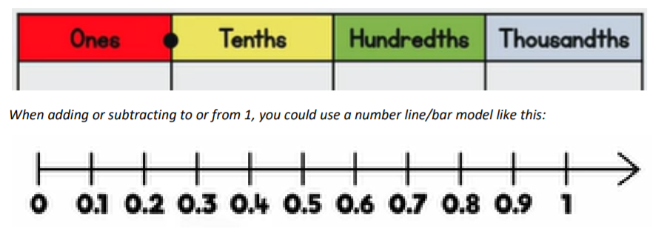

Something Different...BBC Bitesize BBC

Bitesize are releasing a range of daily lessons, all previous lessons can still be accessed (they began on 20th April), they cover a variety of subjects and we have received some positive feedback about them. We especially liked the different foundation subject activities including:
• Science – Mixing, Dissolving and Separating
• Science – The Solar System
• Geography – The World
• Geography – An Introduction to Settlements
• Wellbeing – The Importance of Teamwork
• Music – Duration, Tempo and Beethoven
• Music – Singing with Feeling
• Religious Education – An Introduction to Islam

If you would like to have a look you can find them following the link: https://www.bbc.co.uk/bitesize/tags/zhgppg8/year-5-and-p6-lessons/1

