Badger Class suggested home learning activities

Physical and Emotional Wellbeing
Exercise
Exercise is fun and helps everyone feel energised so we would recommend starting the day with the Joe Wicks live workout at 9:00am or you can take part at a time that suits you by joining in with an existing uploaded video https://www.youtube.com/channel/UCAxW1XT0iEJo0TYlRfn6rYQ
If you are unable to view or participate, you may wish to create your very own fitness challenge. Can you think of an exercise for each letter of the alphabet? Then you could create different routines by spelling out your name or other words?
PSHE
A useful You Tube channel for both yoga and mindfulness is Cosmic Kids. This is a fantastic resource that has a variety of videos that help teach Yoga for children. The videos range in length from 5mins to 15mins and can be sorted into videos that help, focus, calm or activeness. https://www.youtube.com/channel/UC5uIZ2KOZZeQDQo_Gsi_qbQ?sub_confirmation=1

Year 4:

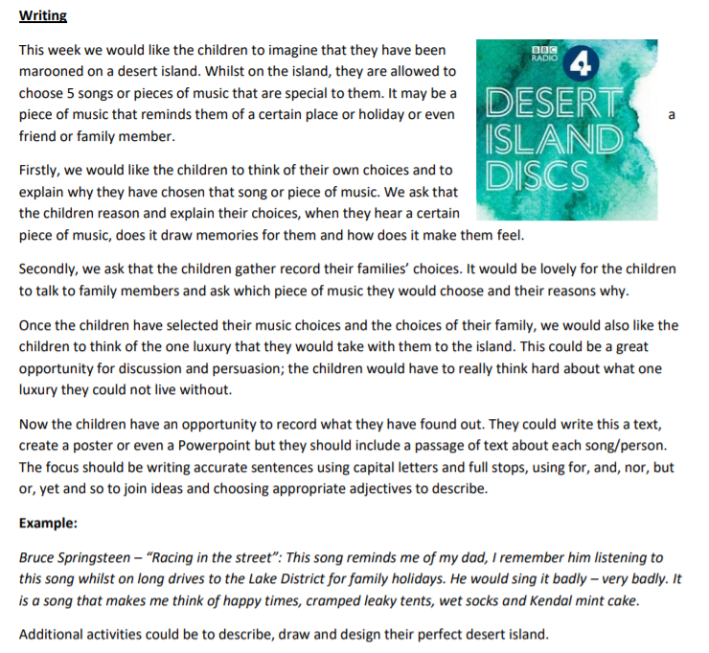

Maths:
https://whiterosemaths.com/homelearning/year-4/
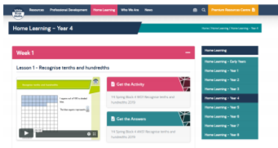

Week 2 on White Rose will focus on dividing two digits by 10, such as 12 divided by 10. We suggest visualising the numbers moving in their place value columns and seeing the numbers getting ten times smaller as they descend a column of place value. A common area of misconception can be visualising a number becoming ten times smaller. Physically moving the number using counters or whatever you have to hand is a useful way to prevent mistakes. When dividing 1 digit by 10, we suggest the children have the following place value grid in front of them for reference.

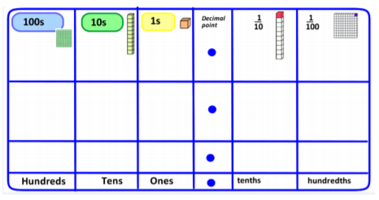

Badger Class suggested home learning activities
Year 5:

English:
Read the information below for a summary of the introduction to the book ‘Beowulf’ and the main characters. Then see below for activities linked to this.
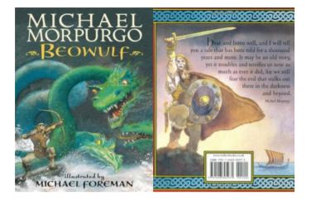

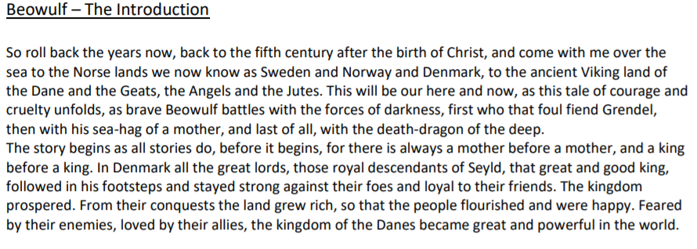
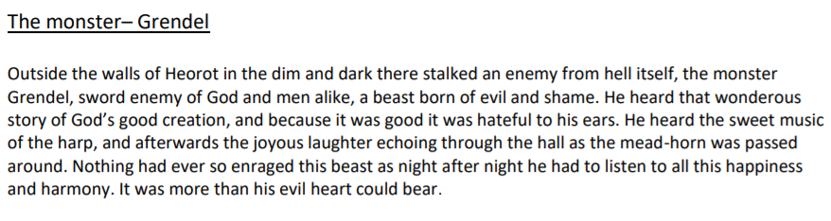

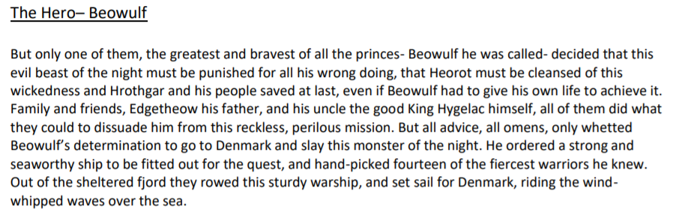
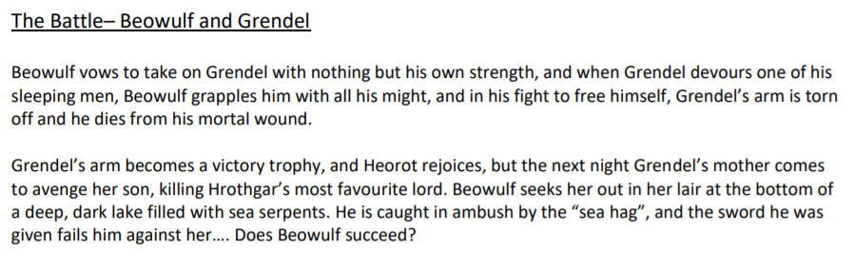

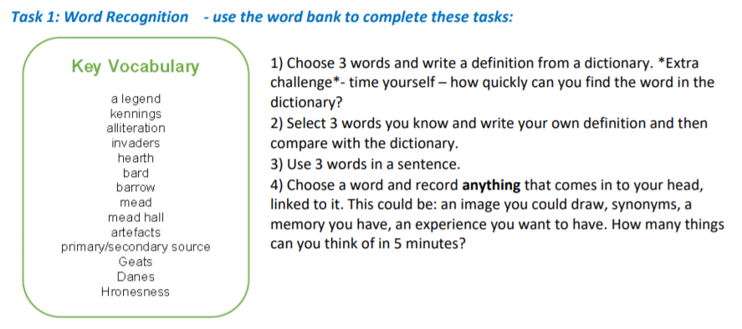

Task 2 – Identifying Features
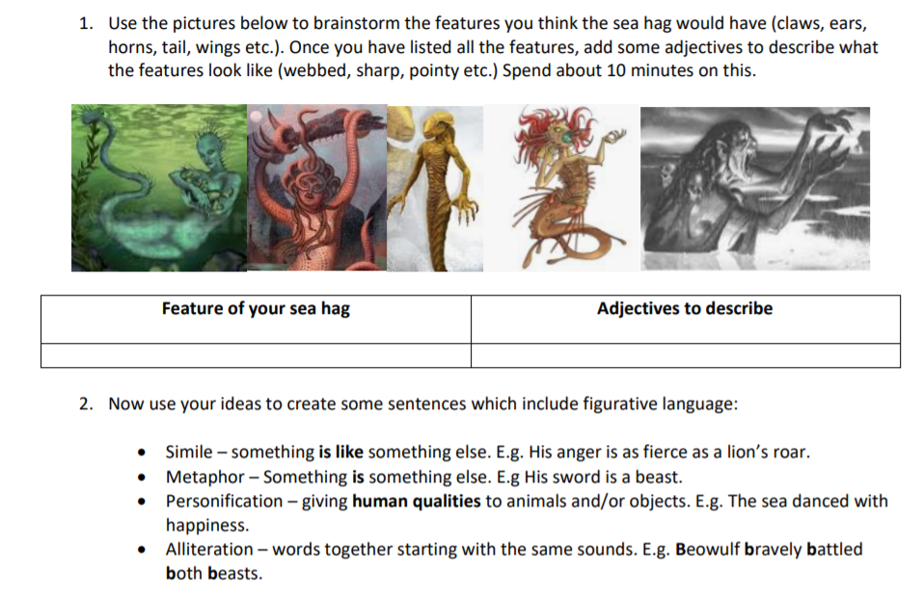

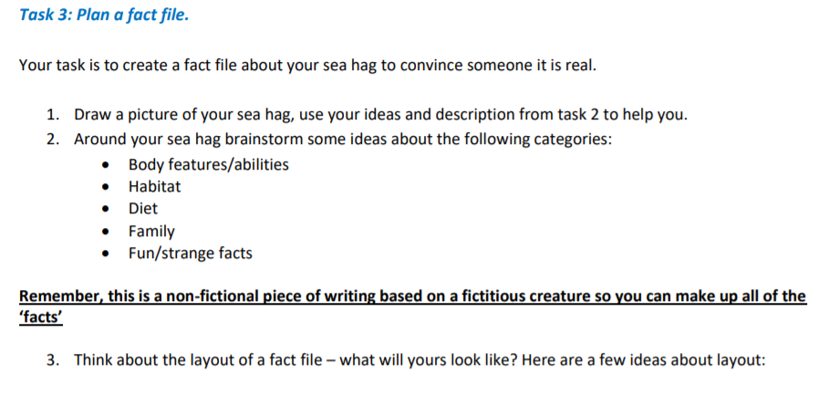
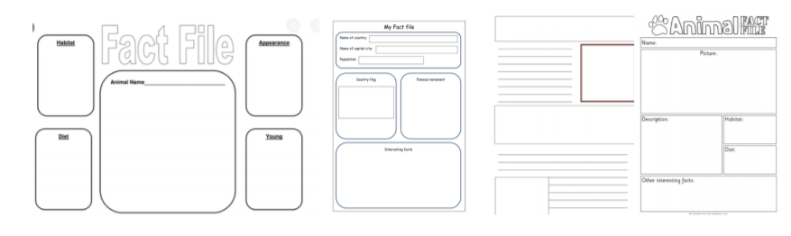

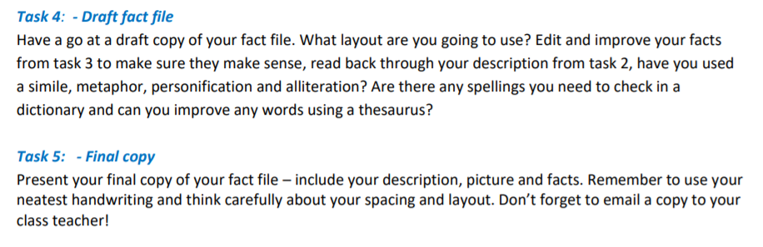

White Rose Maths Lessons – Week 2
Last week’s learning sequence was all about decimal numbers up to three decimal places. Well done if you managed to complete some or all of the lessons. Remember to let us know how you got on and what bits you found challenging. The five lessons in this week’s sequence teach you how to: round decimals; compare and order decimals; understand percentages; calculate percentages as fractions and decimals and how to find equivalent percentages, fractions and decimals. Check out our top tips below to help you work. When you click the link below please use WEEK 2 – Lesson 1 – Rounding Decimals.
Year 5 link: https://whiterosemaths.com/homelearning/year-5/

Top Tips!
- When working with numbers on a number line remember to always check what steps the interval markers go up in to ensure you accurately mark numbers on the line. When placing decimal numbers on a number line between two whole numbers, the interval markers will go up in decimal steps e.g. 0.1, 0.2, 0.3 and so on.
- • When rounding numbers we use the following rule: 5 and above, give it a shove (round up). 4 and below, let it go (round down). This rule applies when rounding decimal numbers too. E.g. 12.1, 12.2, 12.3, 12.4 all round down to 12. Whereas, 12.5, 12.6, 12.7, 12.8, 12.9 all round up to 13. This rule can be applied for rounding to the nearest 1, 2, or 3 decimal places, just remember to check what place value column (tenths, hundredths or thousandths) you are using to round.
- • Percent is always out of 100. Each percent is equivalent to 1/100 or one hundredth or 0.01 (100% is equivalent to 100/100, one whole or 1.00)
- You may also find it useful to use a decimal place value grid or chart like the one below to record numbers in whilst working to help organise them correctly

