Badger Class suggested home learning activities

Reading
This week, have a little reflection about your reading. Remember to aim for at least 20 minutes a day – you can do lots more if you wish!
Think about the reading you’ve done this week and think about the following questions:
- Why do you enjoy reading?
- What’s your favourite book/series? Why?
- Do you have a special place you like to sit when you read?
- What books do you like? (funny, scary, adventure)
- Do you read aloud?
- Do you have a favourite author?
- Have you ever not finished a book? Why did this happen?
- Are you a risk taker? Could you pick up a book that you don’t think you will enjoy and give it a go?
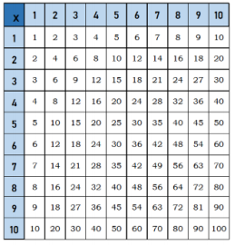
Times Tables
Practise your times tables, 10 minutes practise a day will help you to be able to recall your facts quickly and accurately. Don’t forget there are also other ways to also practise, here are a few suggestions:
- Play hit the button https://www.topmarks.co.uk/maths-games/hit-the-button
- Play Coconut Multiples https://www.topmarks.co.uk/times-tables/coconut-multiples
- Make up a rhyme/song to help you remember them.
- Play times table bingo- https://www.topmarks.co.uk/Flash.aspx?f=BingoMultiplicationv9
Spellings
It is really important to try and keep practising your spellings each week. This week will continue to revise the words that we learned at the beginning of Year 4/5. Try to do at least 15 minutes of spelling per day.
Here are some of the tips for learning your spellings.
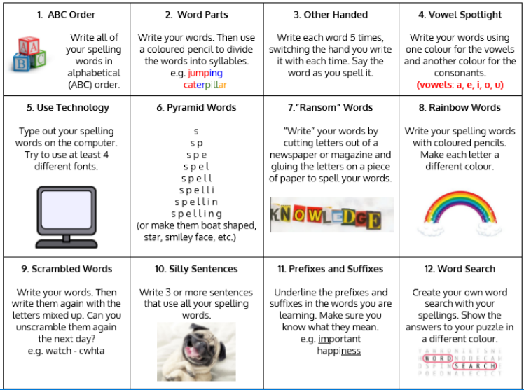
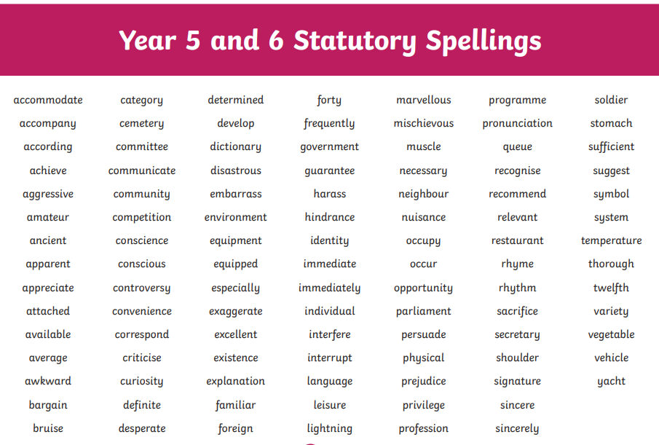

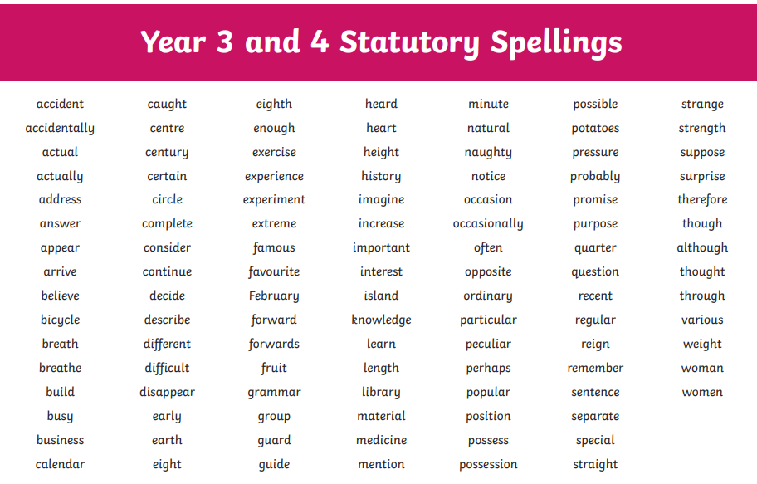
English
Your English task this week is based around wizards. Try and spend 40 minutes on each task below, we recommend doing one task per day.
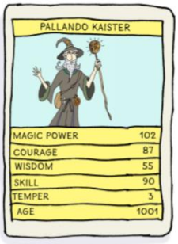
Writing Task 1 – Top Trump Wizards
Welcome to the wonderful world of wizards! For thousands of years, humans all over the world have tried to discover the power of wizards. There are many stories about what we do, where we live and the spells we cast. I’m here to introduce you to the world of wizardry and to inspire you to write about wonderful wizards!
Have you ever wondered what it’s like to be a young wizard? What if you found out you actually were one? Let’s imagine you are!
Here are some questions to think about:
- What would you look like?
- What would you wear?
- What special powers would you have?
Top Wizard cards
Let’s put all your ideas onto ‘Top Wizard’ cards in Top Trump style. First, take a look at mine on the right.

Create your Top Wizard cards:
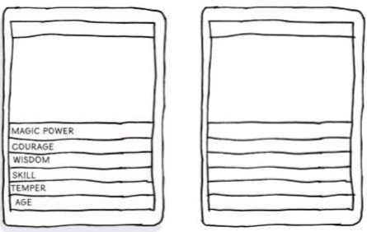
★ Creative challenge – make a set of wizard ‘Top Trumps’ and play with someone else at home or school. Here are some wizards to get you going but you can create as many as you like.
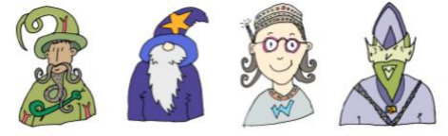
If you don’t know how to pay Top Trumps you can find out here: http://www.toptrumps.com/how-to-playtoptrumps/

Writing Task 2: Word meanings
Let’s go to wizard school! So now you are a wizard, there’s a place just for you! Take a look at this advert for The School of Wizardry. It is written to persuade you to join the school and learn to be a great wizard. Read it through and see if this is the school for you!
Welcome to the School of Wizardry
Are you a budding wizard, full of spells and magic? Do you long to be the finest wizard in all the land? If so, come along to our School of Wizardry and learn to be a Master Wizard! Don’t miss out on this once-in-a millennium opportunity. The School of Wizardry offers remarkable education for wizards of all calibres. Learn new skills from highly qualified professors of wizardry and enjoy our stunning curriculum, which boasts a multitude of outstanding classes. The choice of lessons here is unrivalled and includes: - preparing magic spells and inventing potions; - broomstick manoeuvres and expert flying skills; - specialist invisibility and advanced disguise; - perfection in wand-handling skills. Our exceptional school is renowned around the globe and places are highly sought after. Study here and we can guarantee you’ll pass every wizard exam with flying colours. It is certain you’ll be the envy of all your wizard friends. Study with the best! We have been rated ‘Super-Terrific’ in a recent inspection by the W.S.B (Wizard School Board) and you won’t find tutelage like this anywhere else in the universe. We also have up-to-the minute equipment, beautifully decorated classrooms and the most divine, freshly cooked school dinners. What are you waiting for? Apply now! Come, join us. Leave other wizards far behind! Win in the world of wizards! What do the words mean?
★Let’s investigate this text a little more. Use a dictionary to find the meaning of the following words:
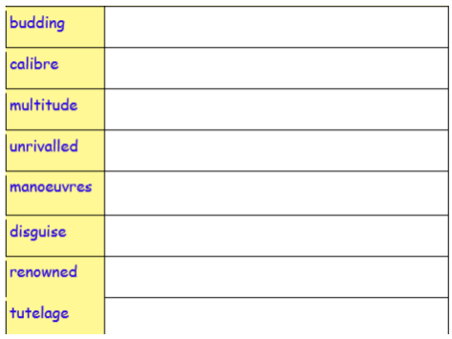

Which synonym? ★ Synonyms are words with the same or similar meanings. ★ Match the synonyms below this table to the target words. ★ Can you find any more synonyms to add into the table?
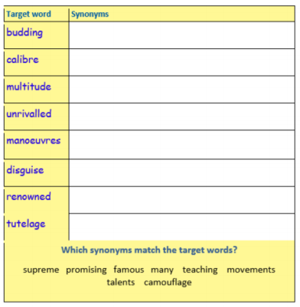
Use an example ★ Look at your definitions and synonyms above. Draw a small image in each box to help you remember the meaning of the word.
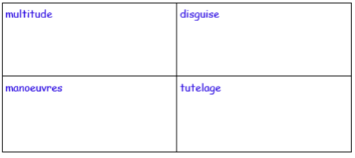
English Task 3: Comprehension
Wizard comprehension! Here’s a quick-fire reading quiz about the wizard advert in Task 2. How many questions can you answer?
- How can you become the finest wizard in the land?
- Does budding mean you are becoming good at something or you are old?
- Anyone can go to the School of Wizardry. TRUE or FALSE?
- Which phrase in the text means the same as latest?
- Which two lessons will make you better at casting spells?
- Find and copy four words that show you this school is great and make you really want to go.
- Why might the school have been rated ‘Super-terrific’?
- Why might you be the envy of your friends if you go to this school?

Task 4: Potion poem
Wonderful Wizard Potions Let’s get creative. There has been a lot of talk about magic and potions, so I thought it would be fun to create one. Take a look at what I have put in my potion:
My Wonderful Wizard Potion
Into my potion, I will drop …
Glitter from the wings of the fastest fairy,
Slime from the skin of the slowest slug,
The sound of starlight bursting in a black sky,
The smell of ocean mist tumbling,
A cloak made of cobwebs,
Some shoes made of rain,
1000 blinking eyes,
One dot stolen from the letter i,
A spoonful of words that start with p,
A touch of happiness.
©Maria Richards

Now have a go at writing your potion poem. What magical things would you drop into your potion? Follow the pattern above and think about the language you can use. Be as inventive as you can.
★ Try to make your items sound exciting by using alliteration – where words start with the same sound e.g. fastest fairy, slowest slug
★ Use precise, powerful verbs that show things in a more exciting way e.g. bursting, tumbling
★ Choose unusual things to add to your potion. Be as inventive as you can e.g. a cloak made of cobwebs, shoes made of rain
★ Use opposites or pairs to create interest: 1000 and then 1, the fastest and then the slowest, ‘the sound of …’ and then ‘the smell of …’
★ Use a measure of something e.g. a touch of, a pinch of, a handful of, a spoonful of, a list of …
Use this planning template to help you:
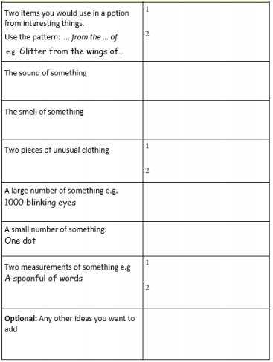
Writing Task 5: Publish your poem
Once you have checked your poem, publish it by writing it inside a bottle (example below):
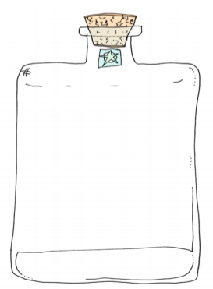
Don’t forget to email a copy to the school office so I can have a read as well!

Maths – Year 4
Summer Term – Week 10 - Interpreting data and looking at graphs
You can find the Year 4 links to the worksheets below:
Year 4 Week 7 Lesson 1
Year 4 Week 7 Lesson 2
Year 4 Week 7 Lesson 3
Year 4 Week 7 Lesson 4
Once you have completed your work you may want to investigate how you use data in day to day life. For example, who drinks the most cups of tea in a day, how many times can you and a family member run up and down the garden in one minute. How could you present your results as a graph.
Top tips
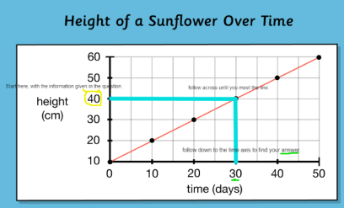
Look carefully at the axis and how they are numbered and labelled. If you draw your own graph then use a ruler and be careful at measuring the intervals. Read the questions three times and make sure you understand.
Read the title and axis of the line graph to know what the line graph is about, e.g. the graph below is about the height of a sunflower over time. Draw straight lines on the graph to find out the height and time. e.g. After how many days is the sunflower 40 cm tall?
Additional Tasks
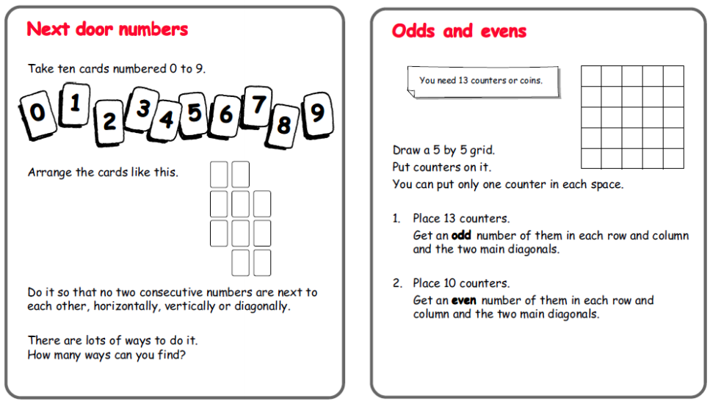

Maths – Year 5
This week’s maths learning is all about using a protractor to measure and draw angles.
You can find the Year 5 links to the worksheets below:
Year 5 Week 7 Lesson 1
Year 5 Week 7 Lesson 2
Year 5 Week 7 Lesson 3
Year 5 Week 7 Lesson 4

Top Tips:
- Angles on a straight line add up to 180 degrees.
- 90 degrees makes a right-angle, an angle smaller than 90 degrees is acute, an angle larger than 90 but smaller than 180 degrees is obtuse and an angle larger than 180 degrees is a reflex angle.
- An angle is a measure of the amount of turn between two lines
- Follow the instructions below to use a protractor accurately
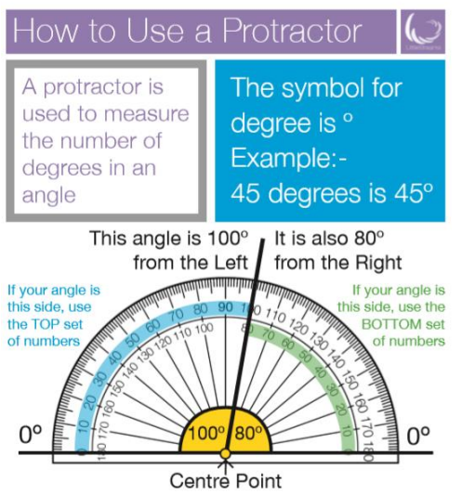
Fun Maths Learning
Continue to challenge yourself with some of the investigations on the nrich website. Can you challenge yourself to a harder challenge? Can you try something new? You could even make up your own problem and ask someone else to solve it.
Can you complete a challenge every day?
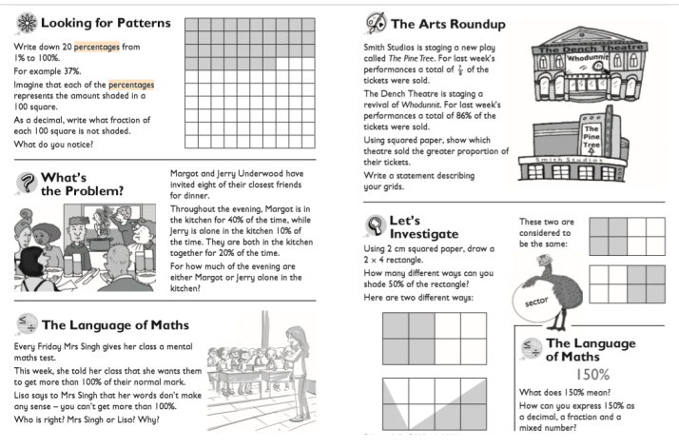
Plastic Free July
Did you know that July encourages people to be plastic free? You could spend some time looking at the amount of plastic used in the world, and maybe in your home. Is there any way you could reduce plastic? Could you create a poster to go up in your window, could you go plastic free for a day or a week? You can sign up (you must ask your parents permission), and you will be emailed various activities that you can carry out. Let’s see how eco-friendly you can be. To find out more information, follow this link: https://www.plasticfreejuly.org/

Exercise
In school at 9am, and I’m sure in many of your households, we have been taking part in the Joe Wicks daily workout. https://www.youtube.com/channel/UCAxW1XT0iEJo0TYlRfn6rYQ If you have been doing something different we would love to hear about it and how it’s been going. It has been great to hear the variety of ways you have been keeping fit, cycling, running, horse riding, dancing and so much more. The weather has been so good to us so make sure you continue to enjoy the outdoors.

Something a little different – Oak National Academy
Oak National Academy is a brand new enterprise created by teachers across England. It provides 180 lessons each week across a broad range of subjects. It is worth a visit if you want to try something different this week.
https://classroom.thenational.academy/subjects-by-year/year-4/subjects/
https://classroom.thenational.academy/subjects-by-year/year-5/subjects/

