Badger Class suggested home learning activities
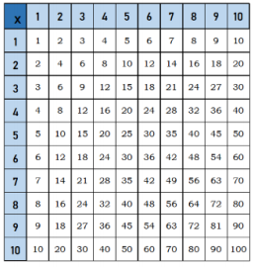
Times Tables
Practise your times tables, 10 minutes practise a day will help you to be able to recall your facts quickly and accurately. Don’t forget there are also other ways to also practise, here are a few suggestions:
- Play hit the button https://www.topmarks.co.uk/maths-games/hit-the-button
- Play Coconut Multiples https://www.topmarks.co.uk/times-tables/coconut-multiples
- Make up a rhyme/song to help you remember them.
- Play times table bingo- https://www.topmarks.co.uk/Flash.aspx?f=BingoMultiplicationv9

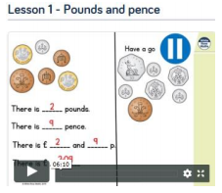
Maths – Year 4
Last week we will be focusing on decimals and money with a focus on ordering and problem solving. https://whiterosemaths.com/homelearning/year-4/
You can find the work sheets below. Read to follow the Top Tips.
Year 4 Week 6 Lesson 1
Year 4 Week 6 Lesson 2
Year 4 Week 6 Lesson 3
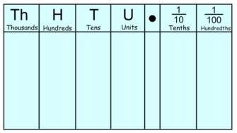
Year 4 Week 6 Lesson 4 Mr King’s Top Tips
- Remember your place value grid when you divide. Draw a place value grid to help you.
- Hold the ‘blank’ spaces with a zero. 2.6 = 2.60.
- Think of decimals in term of money and this will help you to order the numbers quickly. 2.6 = £2.60
- When ordering think carefully about whether you round up or down.

Maths – Year 5
Last week the learning sequence was all about: : understanding percentages, percentages as fractions and decimals, adding decimals with the same number of decimal places and adding decimals with a different number of decimal places. Well done if you managed to complete some or all of the lessons. Remember to let me know how you got on and what bits you found challenging.
The five lessons in this week’s sequence teach you how to: Subtract decimals with the same number of decimal places, subtract decimals with different number of decimal places, multiply decimals by 10, 100, 1000 and divide decimals by 10, 100 and 1000.
There is also the Friday maths challenge. Check out our top tips below to help you work. When you click the link below please use Summer Term WEEK 9 – Lesson 1 – Subtracting decimals with the same number of decimal places. You can find the Year 5 links to the worksheets below: https://whiterosemaths.com/homelearning/year-5/
Year 5 Week 6 Lesson 1
Year 5 Week 6 Lesson 2
Year 5 Week 6 Lesson 3
Year 5 Week 6 Lesson 4
Top Tips:
- When rounding, remember to use the rhyme to help you – 5 and above, give it a shove, 4 and below kick it down low.
- 1/10 is the same as 0.1, 1/100 is the same as 0.01. 1/1000 is the same as 0.001. Don’t forget that 0.10 and 0.1 are equivalent, 0.10 just has a place holder on the end.
- 32/100 is the same as 0.32.
- 0.363, the value of the underlined number is 6 hundredths, or 6/100, or 0.06
- Remember when you are ordering, you could add a place holder to help you. For example: Which is larger 0.32 and 0.342? If we add a place holder to 0.32 we have 0.320 and 0.342, these numbers are now much easier to compare because they have the same number of digits after the decimal point. The largest number is 0.342.

Use a grid like the one below if you need to:
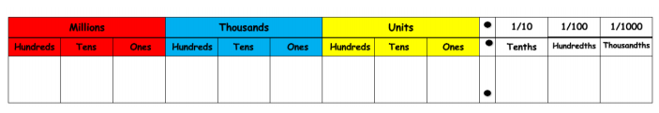

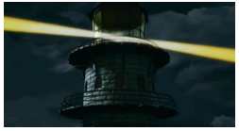
English
Video: https://www.literacyshed.com/the-lighthouse.html
Follow the link above and watch the video. This is all about a lighthouse keeper who needs some help when a ship gets into trouble.
- Discuss the setting and the title – can you make any predictions.
Pause the film after the lighthouse keeper slams the window shut.

- Does he think about the people outside the window having fun?
- Why does the author put this scene in? (to make you think the villagers are up to no good/untrustworthy).
- How does the creator build up the tension in the film?
Pause the film when the lighthouse keeper breaks the lamp
- What do you think he might do next?
Writing Task 1
Write a newspaper story of the event, include interviews with lighthouse keeper, villagers and men from the boat. Remember your work from last week. Make sure you include all these features:
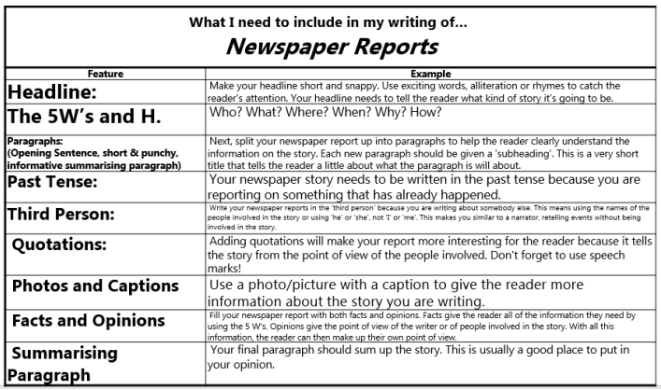
Use this newspaper planning grid to help. 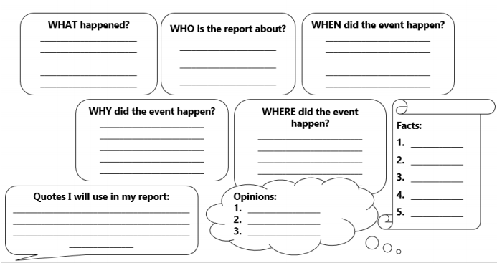

Writing Task 2
Write some dialogue for the film. This could be the lighthouse keeper asking for help from his neighbours and the conversation about what they could do to help the ship.
Remember to use inverted commas (speech marks) and a new line for a different speaker.
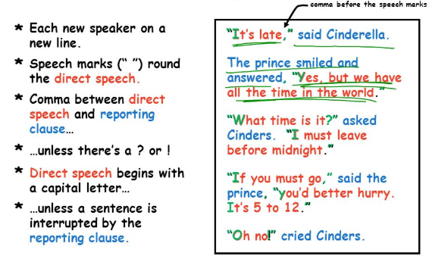

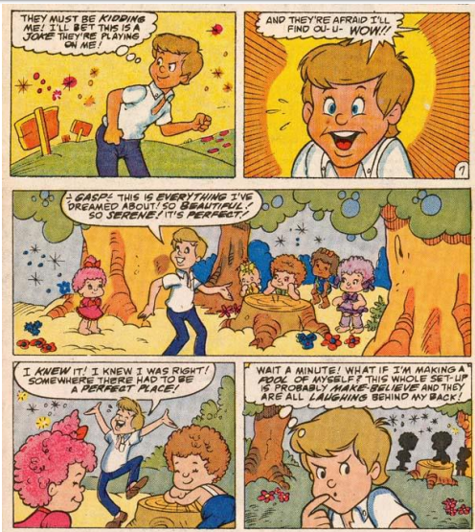
Writing Task 3
Create a cartoon board of key events in the story of the lighthouse. Here is an example of a cartoon.
To create your cartoon, you can divide your page into 6 and write sentences and draw pictures to match.
Or you can use this template below:
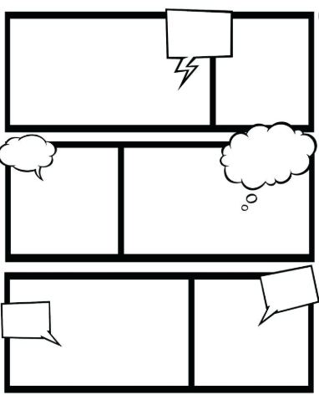

Writing Task 4
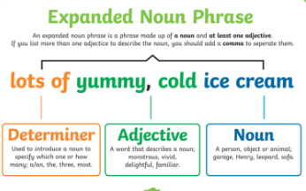
Write own story where the problem is solved in a different way.
Here is a good example which includes some fronted adverbials and expanded noun phrases:
"Suddenly, the bright lighthouse flickered away to darkness. Astonished, horrified and confused the villagers froze: they froze with no idea of what had happened... "
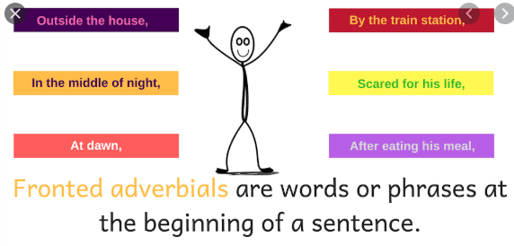

Writing Task 5: Writing/Edit and Improve
Finish your writing and go through your work and edit and improve.
Punctuation station - Check through your work for full stops (end of sentences and proper nouns), capital letters (start of sentences and proper nouns), commas, explanation marks, paragraphs and question marks. Are they in the correct place? *Extra challenge – brackets and semi-colons*
Feature station – Look back at the features that we identified in Task 1 (checklist), have you got an example(s) of each feature? If not, could you add them in?
Dictionary check – can you identify a few words that have been spelt incorrectly, you could ask an adult to help you find them. Use your dictionary skills to correct these – how quickly can you find the word?
Thesaurus check – have a look through your work and see if you can find any words you could improve, e.g. early, later, said. Can you find a more ambitious word using a thesaurus (remember to check that it makes sense and is in the right context).

Fun Maths Learning
Last week I encouraged you to explore nrich. Well done if you had a go at some of the problem solving and reasoning investigations. I would like you to spend this week further exploring nrich. Can you challenge yourself to a harder challenge? Can you try something new? You could even make up your own problem and ask someone else to solve it.
Can you complete a challenge every day?
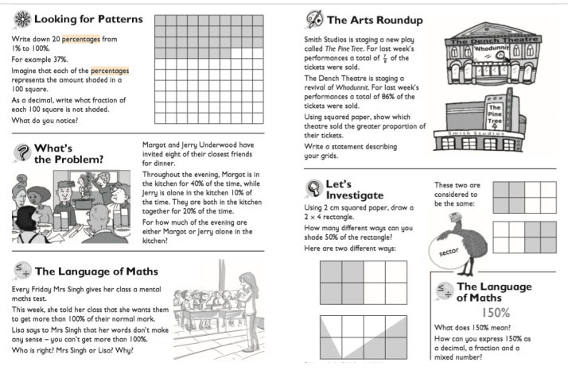

Project Time - Geography
Last week we asked you to spend some time exploring the Alps, we would like you to continue learning about the Alps this week. Remember you can represent your findings in any way you like (PowerPoint, leaflet, poster, writing, drawings).
You can use the links below to help you:
- https://kids.kiddle.co/Alps
- https://www.bbc.co.uk/bitesize/topics/z3fycdm/articles/zb3ywty
- https://easyscienceforkids.com/the-alps/
- https://kids.britannica.com/kids/article/Alps-The/346078

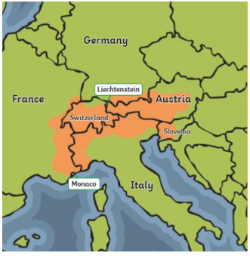
Week 2: Have a look at the tasks below as a starting point and then do some research, remember you can present your findings in any way you like. You may like to explore all, one or a few of the ideas below:
- Research some animals and plants that live in the Alps and create some Top Trumps cards.
- Can you identify some plants and animals that live at different altitudes?
- Why do tourists visit the Alps?
- What attractions are there in the Alps?
- Choose one of the countries that is part of the Alps, find 5 facts about that county.
- How big/long/wide/high are the Alps? Can you compare your findings with another mountain range?

Something a little different – Oak National Academy
Oak National Academy is a brand new enterprise created by teachers across England. It provides 180 lessons each week across a broad range of subjects. It is worth a visit if you want to try something different this week.
https://classroom.thenational.academy/subjects-by-year/year-4/subjects/
https://classroom.thenational.academy/subjects-by-year/year-5/subjects/

