Badger Class suggested home learning activities
Exercise
Exercise helps to focus the mind and we would recommend starting the day with the Joe Wicks workout at 9.00. https://www.youtube.com/channel/UCAxW1XT0iEJo0TYlRfn6rYQ.
English – Writing Task
Your English task this week is based around newspaper reports. Try and spend 40 minutes on each task below, we recommend doing one task per day.
Task 1: Explore newspapers
Today we would like you to explore newspapers.
Follow this link to watch a short clip, and then have a go at the quiz (scroll to bottom of the page): http://www.bbc.co.uk/bitesize/ks2/english/writing/newspapers/read/1/
If you have a newspaper around your house, you may find it useful to have a look at it. Using your knowledge from the video clip and quiz, have a go at answering these questions:
- What is a newspaper?
- Why do people read them?
- What types of things are written in them?
- Who writes news stories?
- What are the features of a newspaper? (Check with the list below, did you find them all?)
- What kinds of questions might a journalist ask? Think of 5.
- Where do you find newspapers? • Who reads newspapers?
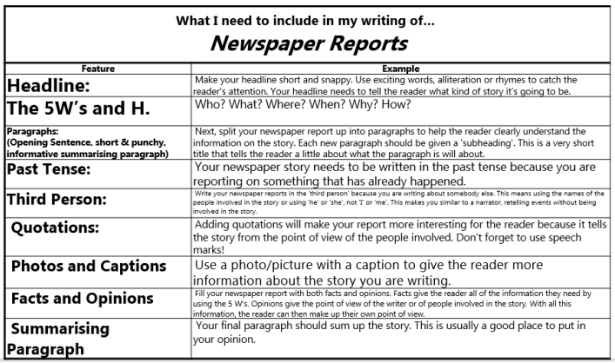
(You can find a larger version of the planning sheet at the end of this document.)
Task 2: Planning
For today’s task you are going to plan your newspaper report, you could report on something that is happening in the world today (you could do some research), or something you feel strongly about (too much palm oil being used, oceans have been damaged) or you could create a fictitious (made-up) event (aliens have landed, ants take over the world).
You can use real or made-up facts and perhaps ask people in your house for quotes on what they saw or heard, and ask them what their opinion is about the situation.
Remember to use quote marks if you are reporting something that someone else said (Jim from Bridge told us that he saw ‘Twenty thousand ants walking along the footpath’.)
Use the planning sheet below:
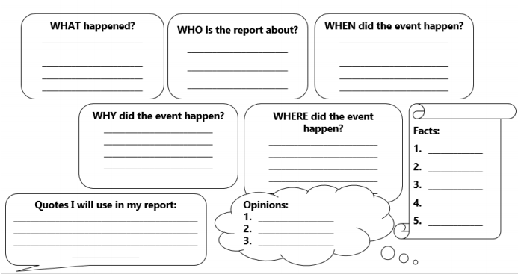
(You can find a larger version of the planning sheet at the end of this document.)

Task 3: Writing
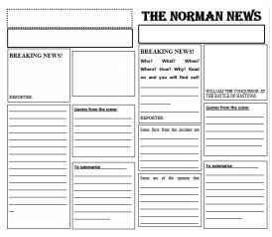
Your next task is to write up your newspaper report, spend a few minutes thinking about the design, what will it look like? How many pictures will you use? Use the examples below for ideas if you are stuck. When you start writing remember to use the features checklist (task 1), and your plan.
Use the newspaper template below to write your newsreport.

Task 4: Writing/Edit and Improve
Finish your writing and then add your illustrations. Will your newspaper be black and white or colour? Then go through your work with a green pen.
Punctuation station - Check through your work for full stops (end of sentences and proper nouns), capital letters (start of sentences and proper nouns), commas, explanation marks, paragraphs and question marks. Are they in the correct place? *Extra challenge – brackets and semi-colons*
Feature station – Look back at the features that we identified in Task 1 (checklist), have you got an example(s) of each feature? If not, could you add them in?
Dictionary check – can you identify a few words that have been spelt incorrectly, you could ask an adult to help you find them. Use your dictionary skills to correct these – how quickly can you find the word?
Thesaurus check – have a look through your work and see if you can find any words you could improve, e.g. early, later, said. Can you find a more ambitious word using a thesaurus (remember to check that it makes sense and is in the right context).
Task 5: Final copy
Write or type up your final copy! Remember to include any improvements that you made. Don’t forget to email a copy to the school office so I can read it too!
Use this newspaper template above to write your final copy.

Maths (Year 4)
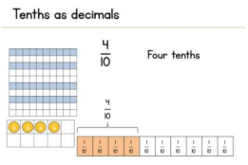
Summer Term – Week 7 Decimals, tenths and hundredths.
This week’s lessons are about writing decimals. A tenth (1/10) is written as 0.1
Year 4 Week 5 Lesson 1
Year 4 Week 5 Lesson 2
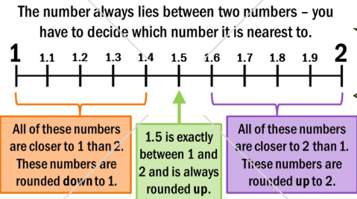
Year 4 Week 5 Lesson 3
Year 4 Week 5 Lesson 4

Maths (Year 5)
White Rose Maths Lessons Last week the learning sequence was all about: multiplying unit and non-unit fractions by integers, multiplying mixed numbers by integers, fractions of an amount and fractions as operators.
Well done if you managed to complete some or all of the lessons. Remember to let us know how you got on and what bits you found challenging. The lessons in this week’s sequence teach you how to: Decimals as fractions, understanding thousandths, round decimals and order and compare decimals. There is also the Friday maths challenge. Check out our top tips below to help you work.
When you click the link below please use Summer Term WEEK 8 – Lesson 1 – Understand Percentages (you may have to scroll down the web page to find this). Year 5 link: https://whiterosemaths.com/homelearning/year-5/
You can find the worksheets here:-
Year 5 Week 5 Lesson 1
Year 5 Week 5 Lesson 2
Year 5 Week 5 Lesson 3
Year 5 Week 5 Lesson 4

Mr King’s Top Tips:
• When rounding, remember to use the rhyme to help you – 5 and above, give it a shove, 4 and below kick it down low.
• 1/10 is the same as 0.1, 1/100 is the same as 0.01. 1/1000 is the same as 0.001. Don’t forget that 0.10 and 0.1 are equivalent, 0.10 just has a place holder on the end.
• 32/100 is the same as 0.32.
• 0.363, the value of the underlined number is 6 hundredths, or 6/100, or 0.06
• Remember when you are ordering, you could add a place holder to help you.
For example: Which is larger 0.32 and 0.342? If we add a place holder to 0.32 we have 0.320 and 0.342, these numbers are now much easier to compare because they have the same number of digits after the decimal point. The largest number is 0.342.
Use a grid like the one below if you need to:
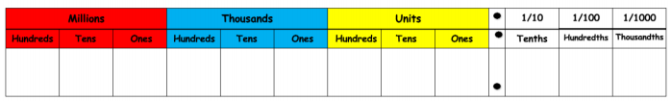
Fun Maths Learning
Last week I encouraged you to explore nrich. Well done if you had a go at some of the problem solving and reasoning investigations. I would like you to spend this week further exploring nrich. Can you challenge yourself to a harder challenge? Can you try something new? You could even make up your own problem and ask someone else to solve it.
Can you complete a challenge every day?
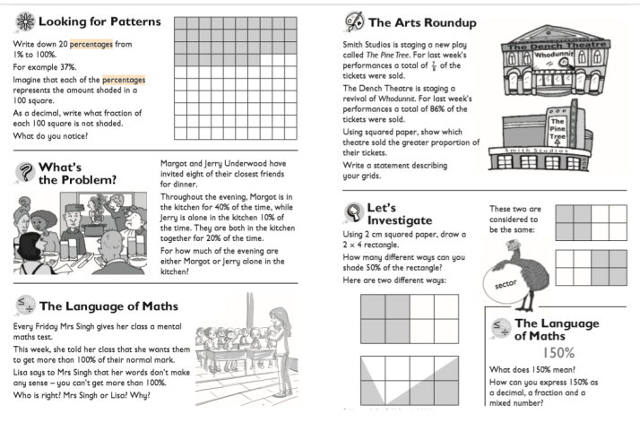

Times Tables
Don’t forget there are also other ways you can practise your times tables, here are just a few ideas:
- Play hit the button https://www.topmarks.co.uk/maths-games/hit-the-button
- Play Coconut Multiples https://www.topmarks.co.uk/times-tables/coconut-multiples
- Make up a rhyme/song to help you remember them.
- Play times table bingo https://www.topmarks.co.uk/Flash.aspx?f=BingoMultiplicationv9

Project Time – Geography
For the next two weeks we would like you to spend some time exploring the Alps. Remember you can represent your findings in any way you like (PowerPoint, leaflet, poster, writing, drawings). You can use the links below to help you:
1. https://kids.kiddle.co/Alps
2. https://www.bbc.co.uk/bitesize/topics/z3fycdm/articles/zb3ywty
3. https://www.oddizzi.com/teachers/explore-the-world/physical-features/mountains/mountaincase-study/the-alps/
4. https://kids.britannica.com/kids/article/Alps-The/346078

Week 1
Explore the following questions:
- Where are the Alps located?
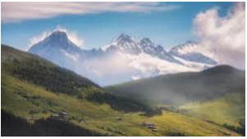
- What features do the Alps have? Can you find out about the glacier features?
- What is the vegetation like in the Alps?
- Explore the climate of the Alpine mountains.
- *Extra challenge – make a model of the Alps using junk modelling*

Something a little different – Oak National Academy
Oak National Academy is a brand new enterprise created by teachers across England. It provides 180 lessons each week across a broad range of subjects. It is worth a visit if you want to try something different this week. https://classroom.thenational.academy/

