Badger Class suggested home learning activities

Exercise
Exercise helps to focus the mind and we would recommend starting the day with the Joe Wicks workout at 9.00. https://www.youtube.com/channel/UCAxW1XT0iEJo0TYlRfn6rYQ.

English
Writing Task 1
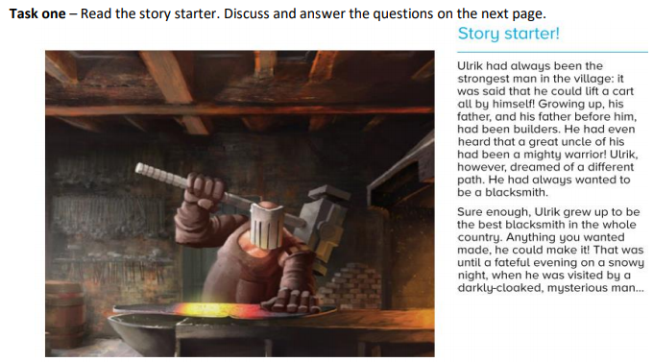

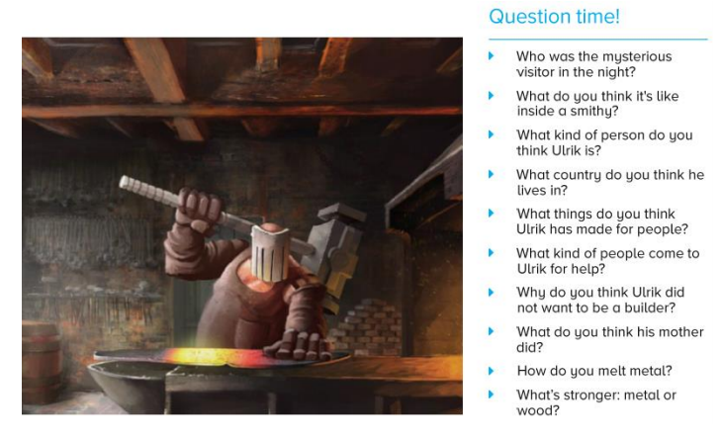

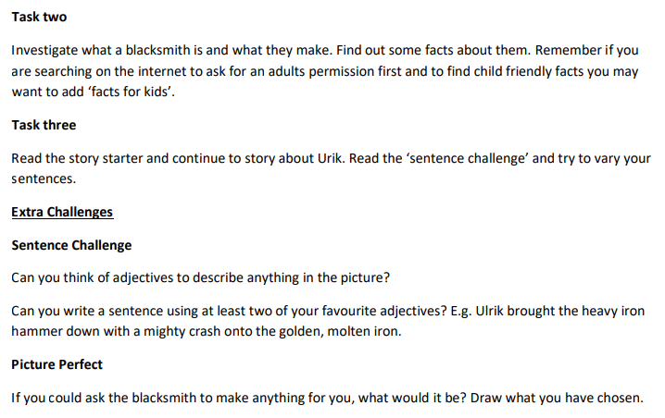

Writing Task 2
Your English task this week is based around comics. Try and spend 40minutes on each task below, we recommend doing one task per day. Task 1: Explore comics Have a look around your house… have you got any comics? If you haven’t, look at the examples below. Answer the following questions:
- How are comics different to stories?
- What is the layout like?
- How is the text/ speech written?
- What is the language like?
- Are comics better or worse than stories?
- Who can read comics? Why?
- What are the features of a comic?
Examples:
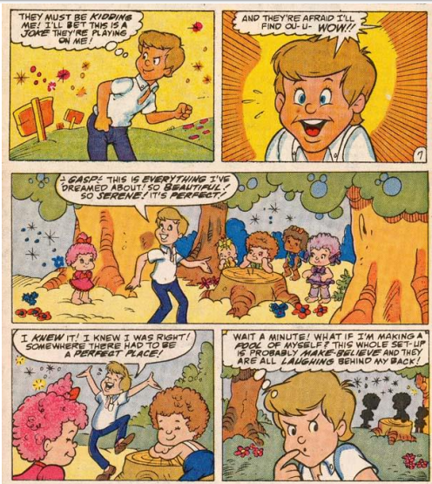

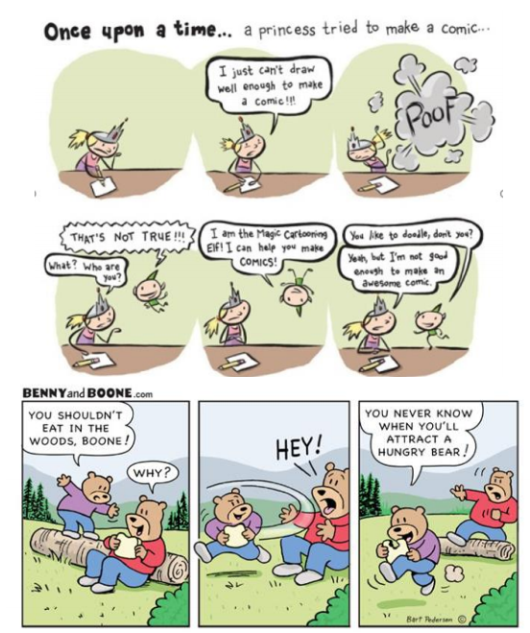
Features: All comics have certain features, spend some time reading the slides below and see if you can annotate/highlight/discuss the features about a page in your comic book.
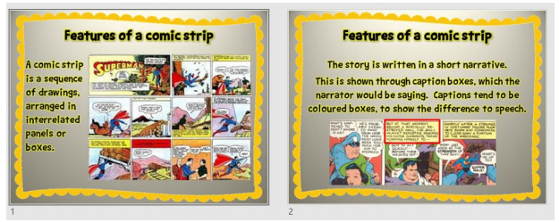
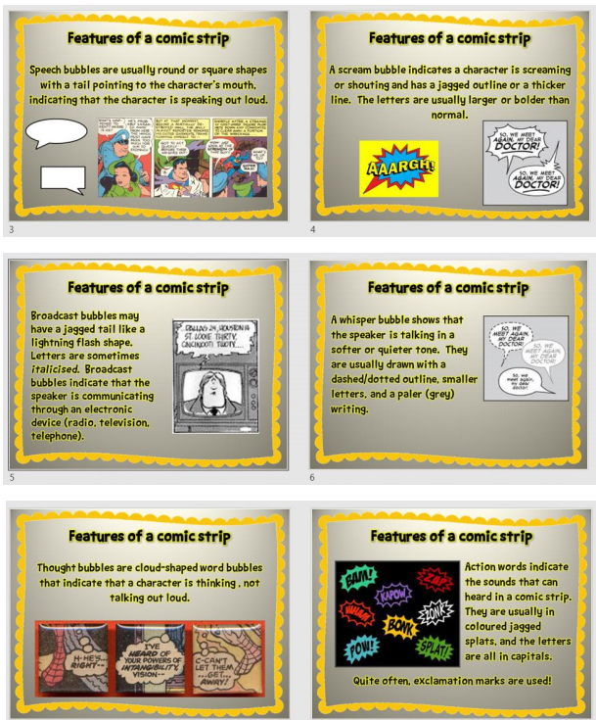

Task 2: Planning your characters
This week I would like you to create your own comic strip. To begin with, have a go at drawing your characters. What/who will they be? Will they be human, animals or even aliens? What will they look like? Remember comics don’t usually have lots and lots of characters so you may like to only think of 2 or 3. Around your character use these subheadings to annotate what your character is like – you may like to create a Top Trumps type card for each character. Name , Age / DOB, Personality , Appearance , Superpowers , Traits (a characteristic or quality that makes a person or animal different from others. Kindness is a trait that we look for in our friends. A striped coat is a trait of the tiger.)
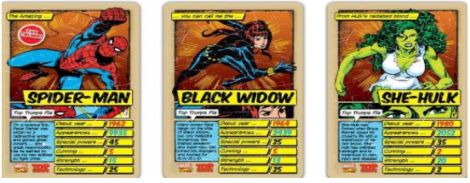
Task 3: Planning your comic strip
You are now ready to plan your comic strip. Using your characters from above, think of a simple adventure that they could go on. Remember to use the feature checklist (action words, caption boxes, different types of speech bubbles). Use the planning sheet below to plan your comic strip:
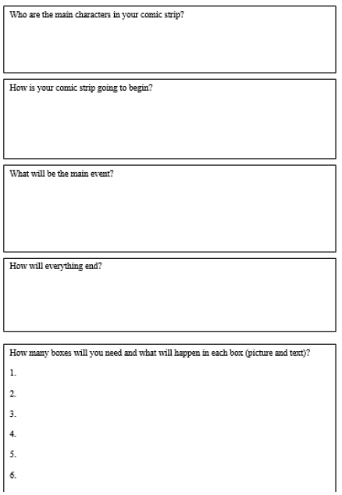
Task 4: Write/draw your comic
Think about the layout of your comic (look at the examples below for some inspiration), draw your boxes and how you would like your comic to look, it would be a good idea to draw your caption boxes too so you leave room for them. Begin your comic, use your plan, features checklist and examples above to help you.
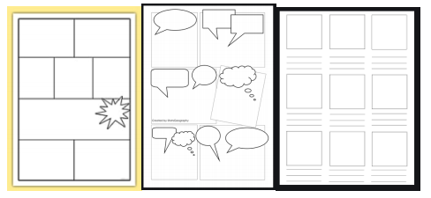
Task 5: Finish your comic and read it out loud
Spend some time completing your comic, make sure it is bright and colourful, edit and improve if you need to. Read your comic to someone else. Afterwards, ask them what they like about your comic? Is there anything they would suggest you could do to improve it? Ask them to read it to you, what do you like about it and what would you change? Don’t forget to email a copy to Mr King so I can read it too!

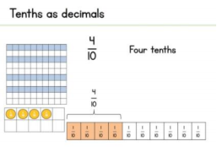
Maths (Year 4)
Summer Term – Week 7 Decimals, tenths and hundredths. https://whiterosemaths.com/homelearning/year-4/
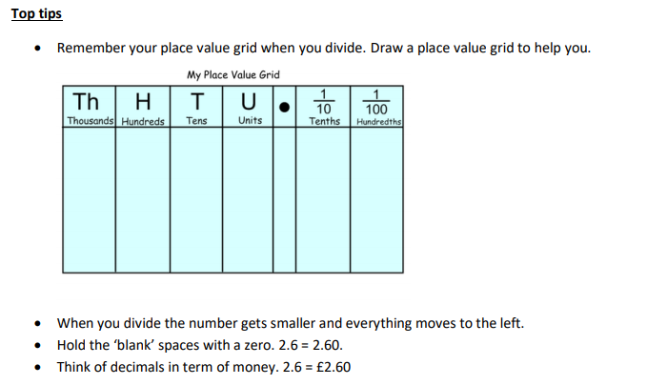
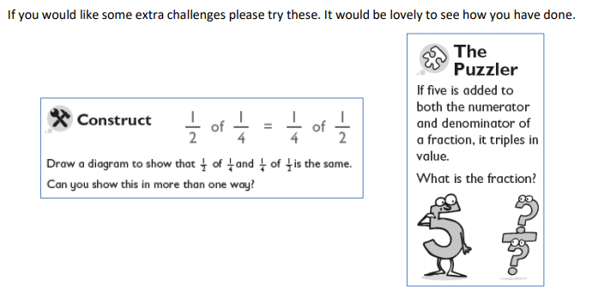

Maths (Year 5)
White Rose Maths Lessons
Last week the learning sequence was all about: multiplying unit and non-unit fractions by integers, multiplying mixed numbers by integers, fractions of an amount and fractions as operators. Well done if you managed to complete some or all of the lessons. Remember to let us know how you got on and what bits you found challenging. The lessons in this week’s sequence teach you how to: Decimals as fractions, understanding thousandths, round decimals and order and compare decimals.
There is also the Friday maths challenge. Check out our top tips below to help you work. When you click the link below please use Summer Term WEEK 7 – Lesson 1 – Decimals as Fractions (you may have to scroll down the web page to find this).
Year 5 link: https://whiterosemaths.com/homelearning/year-5/
Top Tips:
- When rounding, remember to use the rhyme to help you – 5 and above, give it a shove, 4 and below kick it down low.
- 1/10 is the same as 0.1, 1/100 is the same as 0.01. 1/1000 is the same as 0.001. Don’t forget that 0.10 and 0.1 are equivalent, 0.10 just has a place holder on the end.
- 32/100 is the same as 0.32.
- 0.363, the value of the underlined number is 6 hundredths, or 6/100, or 0.06
- Remember when you are ordering, you could add a place holder to help you. For example: Which is larger 0.32 and 0.342? If we add a place holder to 0.32 we have 0.320 and 0.342, these numbers are now much easier to compare because they have the same number of digits after the decimal point. The largest number is 0.342.

Use a grid like the one below if you need to:
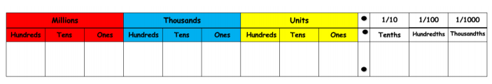
Fun Maths Challenges
Last week we encouraged you to explore nrich. Well done if you had a go at some of the problem solving and reasoning investigations. We would like you to spend this week further exploring nrich. Can you challenge yourself to a harder challenge? Can you try something new? You could even make up your own problem and ask someone else to solve it. Follow this link: (https://nrich.maths.org/9084 ). I recommend:
Dancing with Maths - https://nrich.maths.org/5502
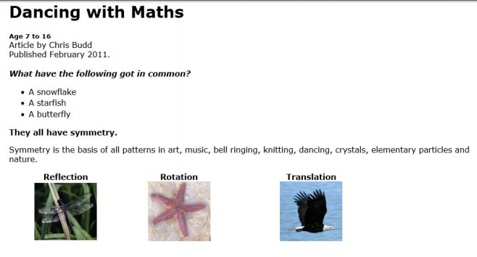

Twice as Big – https://nrich.maths.org/5561
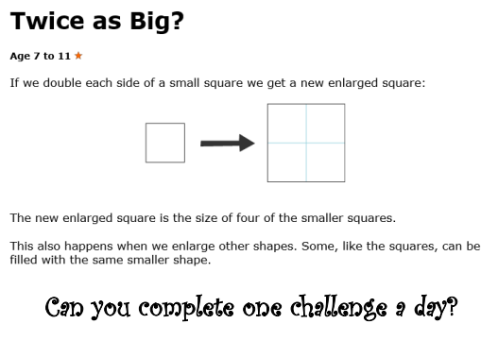

Times Tables
Multiplication and division facts are the key to unlocking so many areas of maths (such as fractions) and the better your mental recall of them, the less time you have to spend thinking about them the less they will hold you back. Remember practising little and often is the key. Don’t forget there are also other ways you can practise your times tables, here are just a few ideas:
- Play hit the button https://www.topmarks.co.uk/maths-games/hit-the-button
- Play Coconut Multiples https://www.topmarks.co.uk/times-tables/coconut-multiples
- Make up a rhyme/song to help you remember them.
- Play times table bingo https://www.topmarks.co.uk/Flash.aspx?f=BingoMultiplicationv9
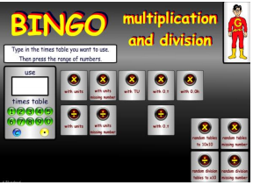

Something a little different – Oak National Academy
Oak National Academy is a brand new enterprise created by teachers across England. It provides 180 lessons each week across a broad range of subjects. It is worth a visit if you want to try something different this week. English this week has a focus on persuasion with 5 separate lessons. The final task is to write a persuasive rap! https://classroom.thenational.academy/subjects-by-year/year-4/subjects/english/
Maths this week is a focus on shape and symmetry. There are 9 lessons in this sequence which also explores angles. https://classroom.thenational.academy/subjects-by-year/year-4/subjects/maths
You can find shape lessons for Year 5s at https://classroom.thenational.academy/subjects-by-year/year-5/subjects/maths

