Badger Class suggested home learning activities

Exercise
Exercise helps to focus the mind and we would recommend starting the day with the Joe Wicks workout at 9.00. https://www.youtube.com/channel/UCAxW1XT0iEJo0TYlRfn6rYQ.
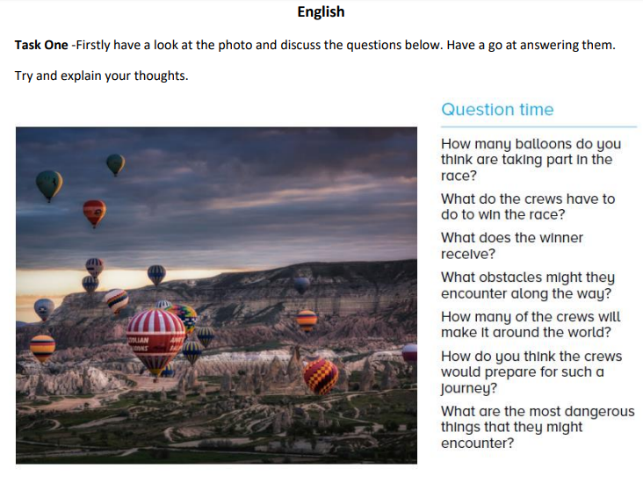
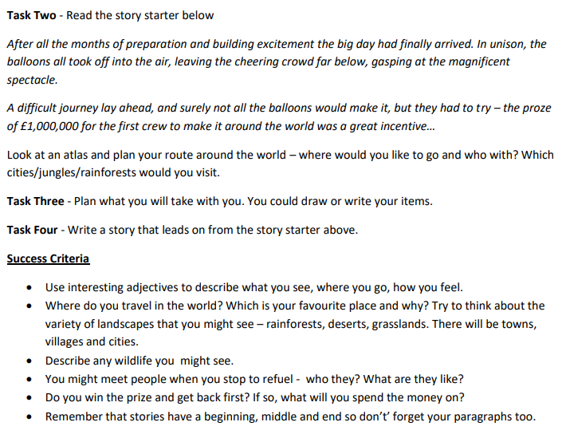
Maths (Year 4)
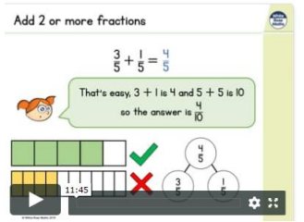
When you click the link below please use Summer Term WEEK 6 (you may have to scroll down the web page to find this). Year 4 link: https://whiterosemaths.com/homelearning/year-4
Please note, this link will take you to the videos introducing the Maths concept, the worksheets can be found on the Year 4 page on the school website
This clip is very good and explains clearly how to add and subtract fractions. https://www.bbc.co.uk/bitesize/topics/zhdwxnb/articles/z9n4k7h
Maths (Year 5)
White Rose Maths Lessons Last week the learning sequence was all about: adding and subtracting fractions and adding and subtracting mixed numbers. Well done if you managed to complete some or all of the lessons. Remember to let us know how you got on and what bits you found challenging. The five lessons in this week’s sequence teach you how to: multiply unit and non-unit fractions by integers, multiply mixed numbers by integers, fractions of an amount and fractions as operators There is also the Friday maths challenge. Check out our top tips below to help you work. When you click the link below please use Summer Term WEEK 6 – Lesson 1 – Multiply unit and non-unit fractions by integers (you may have to scroll down the web page to find this). Year 5 link: https://whiterosemaths.com/homelearning/year-5/
Mr King’s Top Tips:
- A unit fraction is when the numerator is 1, a non-unit fraction is when the numerator is any number but 1.
- Remember ‘repeated addition’ is the same as ‘multiplying’, so for example 1/3 + 1/3 = 2/3, 2 x 1/3 is 2/3.
- 3 x 1/5 is the same as 1/5 x 3, remember we call this commutative.
- Sometimes drawing a bar model makes the problem more visible to see – it is ok to draw a picture.
- When multiplying a mixed number by an integer, remember to partition, multiply and combine back together. For example, 2 1/3 x 4, partition 2 2/3 (I have 2 and I have 1/3), first multiply 2 by 4 = 8, then next multiply 1/3 by 4 = 4/3 or 1 1/3. Now combine together your answers, 8 + 1 1/3 = 9 1/3.
- To find a fraction of an amount, divide your total by how many parts you have (denominator). Eg 2/3 of 24, 24 is the total, divided by 3 (denominator) 24 divided by 3 = 8, because the numerator is 2 we now multiply 8 by 2 which is 16. So 2/3 of 24 is 16.
Even More Fun Maths Challenges
This week we would like you to visit nrich (https://nrich.maths.org/9084 ). Nrich is full of lots of open ended problem solving and reasoning problems. Have a look at the topics and choose something that interests or will challenge you. We recommend: Tricky Track - https://nrich.maths.org/2150 and Orange Drink - https://nrich.maths.org/2420

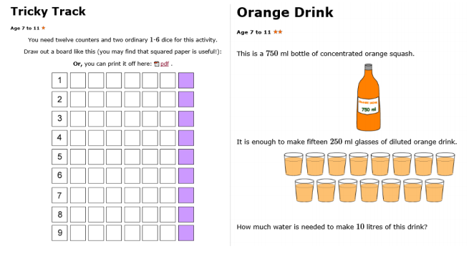
Can you complete a challenge a day?
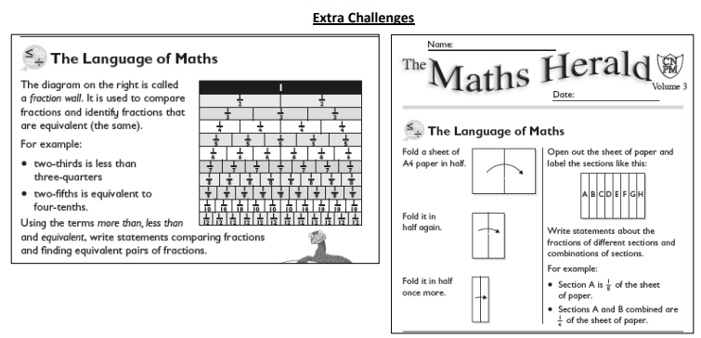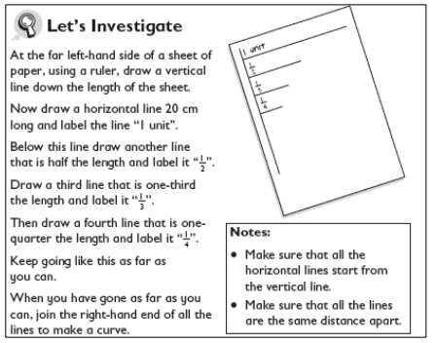
Something a little different – Oak National Academy
Oak National Academy is a brand new enterprise created by teachers across England. It provides 180 lessons each week across a broad range of subjects. It is worth a visit if you want to try something different this week. English this week has a focus on persuasion with 5 separate lessons. The final task is to write a persuasive rap! https://classroom.thenational.academy/subjects-by-year/year-4/subjects/english/
Maths this week is a focus on shape and symmetry. There are 9 lessons in this sequence which also explores angles. https://classroom.thenational.academy/subjects-by-year/year-4/subjects/maths
You can find shape lessons for Year 5s at https://classroom.thenational.academy/subjects-by-year/year-5/subjects/maths

