Badger Class suggested home learning activities

Physical and emotional well being
Exercise Exercise helps to focus the mind and we would recommend starting the day with the Joe Wicks workout at 9.00. https://www.youtube.com/channel/UCAxW1XT0iEJo0TYlRfn6rYQ
If you are unable to view or participate, you may wish to create your very own fitness challenge. How fast can you run to the shed and back? How many skips can you complete in a minute? Create a challenge for yourself and aim to beat your personal best week on week.
PSHE A useful website for both yoga and mindfulness is Cosmic Kids. This is a fantastic resource that has a variety of videos that help teach Yoga for children. The videos range in length from 5mins to 15mins and can be sorted into videos that help, focus, calm or activeness. https://www.cosmickids.com

Year 4:
Writing:
Writing focus: Choose a fairy tale or short story that you enjoy. Take the characters and write your own innovative short story – what could happen to the characters instead? Perhaps the story takes place in a different order or the baddie wins. You might want to change the setting from woods to a city. Perhaps there are new events and we meet another character in the story. Draw illustrations; create a front cover and a blurb for your story. You might like to give it a new title. Remember that all stories have a clear beginning, middle and end. In the middle there is usually a problem which then gets resolved by the end.
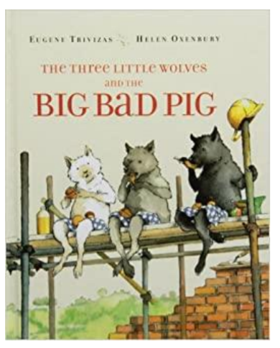

Remember to:
Describe the setting – Where are they? Are they in a town, cave, mountain etc?
Describe the characters – What do they look like?
Describe their hair, nose, eyes, clothes, face, teeth.
How are they feeling? What is their personality like? Do they have hobbies?
Try and use a range of punctuation such as full stops, commas, question marks, exclamation marks.

Maths:
https://whiterosemaths.com/homelearning/year-4/ Summer Term – Week 2 (w/c 27 th April 2020)
Week 4 on White Rose will focus on rounding decimals, halves and quarters, money (pounds and pence) and ordering money.
Please remember the place value columns when rounding decimals. Be aware of the differences between 0.01 and 0.1 and remember to visualise a hundred square when comparing hundredths and tenths. Remember that tenths are represented by a complete row or column and each individual square represents one hundredth.
Be mindful of place value and recognising that 0.1 is the same as 1/10 (or one shaded row/column) and that 0.01 is the same as 1/100 (or one individual square shaded).
In addition, we are always available via email to help overcome any areas that may be a struggle. We will endeavour to provide further examples on a specific area to help the children’s learning.

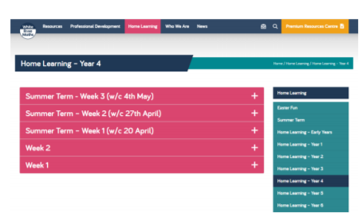

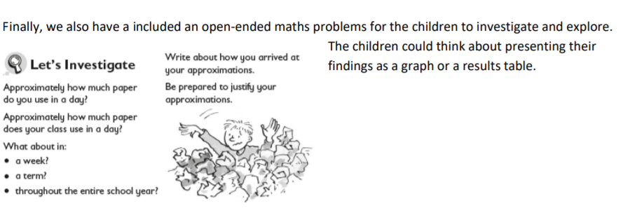

Year 5:
English
Poetry Your English task this week is based around poetry. Follow the tasks below, spending roughly 40mins on each task per day. To begin with, find an animal poem that interests you. If you prefer you can use the examples below. It could be a funny poem, silly poem, sad poem but the main thing is you like it! Once you have found your chosen poem complete task 1 below.
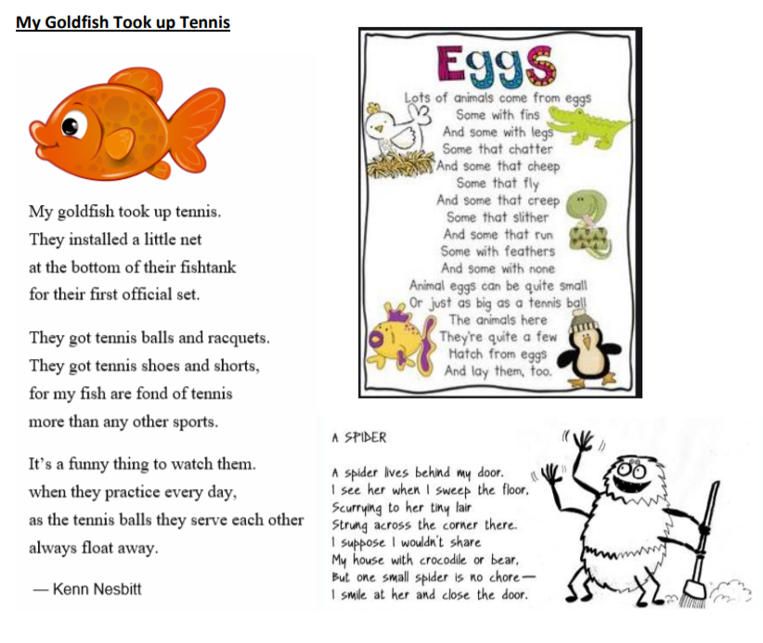
Task 1: Performance Poetry and recognising features:
1. Read your poem quietly to yourself – jot down anything you notice (rhyming, sentence length, punctuation, structure)
2. Now read the poem out loud – jot down anything new that you notice.
3. This time when you read it out loud change the tone of your voice. Can you read it in a deep voice, high voice, scary voice, grumpy voice) Have a few attempts using a different tone – perhaps ask someone to video so you can watch it back.

4. Ask someone else to read it to you, listen carefully for things that you didn’t notice before. 5. You should have now identified some features of poetry. Use the checklist below to see what features are shown in this poem.
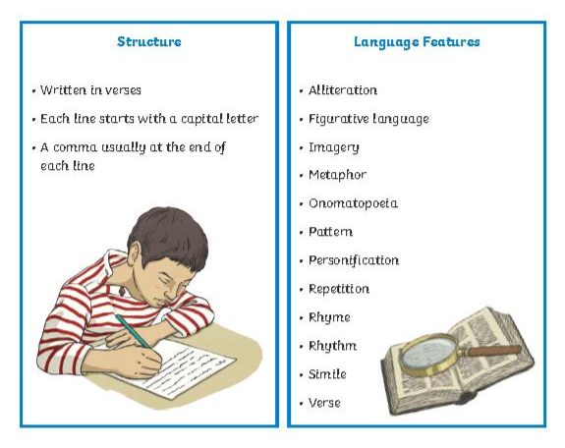

Task 2: Planning and rhyming words
1. Think of a creature that you will write your poem about – spider, cow, grasshopper, horse, snake
2. Draw your creature and around it label its body parts (legs, ears, tail, antennae, claws etc.)
3. Next to each body part list some adjectives/adverbs to describe what that body part is like and how it moves – e.g. skin – soft, green, wrinkly, swiftly, slithering
4. Now we need some rhyming words – see how many rhyming couplets you can make (for example for skin – green and seen, wrinkly and crinkly, soft and loft). Try and get a simile, metaphor, personification, onomatopoeia (WHIZZ! KAOOM! SPLASH!)

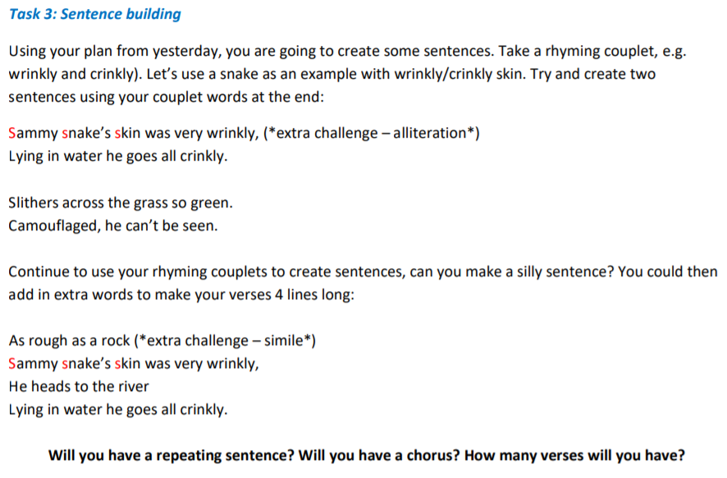

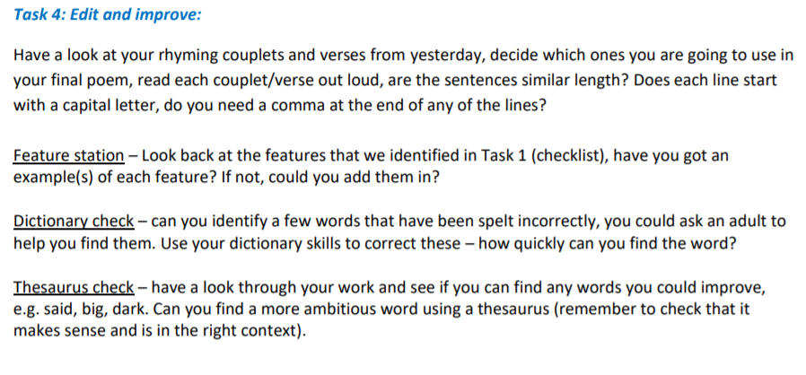

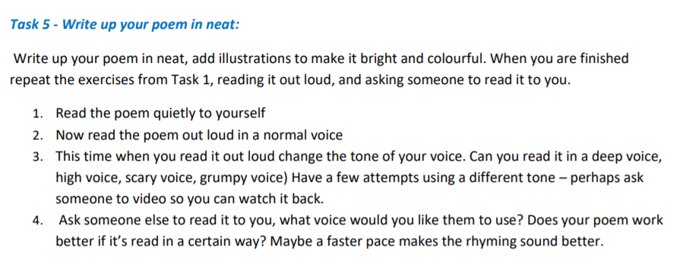

Maths
White Rose Maths Lessons – Week 3
Last week’s learning sequence was all about: adding and subtracting decimals within 1, complements to 1, and adding decimals crossing the whole. Well done if you managed to complete some or all of the lessons. Remember to let us know how you got on and what bits you found challenging. The five lessons in this week’s sequence teach you how to: add and subtract decimals with the same number of decimal places, add and subtract decimals with a different number of decimal places and the Friday maths challenge. Please note that for the Friday maths challenge, questions 1-5 are most suitable for Year 5 children. Although, please feel free to have a go at the other questions if wanted, it could be fun to work these out with an older sibling or your parents, helping each other out.
Check out our top tips below to help you work. When you click the link below please use Summer Term WEEK 2 – Lesson 1 – Adding Decimals with the same number of decimal places (you may have to scroll down the web page to find this). Year 5 link: https://whiterosemaths.com/homelearning/year-5/
Top Tips:
- When adding and subtracting decimal numbers, don’t forget to put a zero (0) in as a place holder to help where necessary. This makes it clearer because both numbers will then have the same amount of digits, making it easier to add or subtract them. E.g. 0.26 + 0.3 change to 0.26 + 0.30 (remember, this doesn’t change the value of 0.3, it just makes it clearer to see what you are working with).
- It is important that you keep your numbers in the correct column and your layout neat when using the column method to add or subtract, otherwise you might end up getting confused resulting in the wrong answer. You could always draw vertical lines on your paper if that helps.
- • Remember to put in the decimal points when using a column method to add or subtract decimal numbers.
- • You may also find it useful to use a decimal place value grid or chart like the example below to record numbers in whilst working to help organise them correctly.

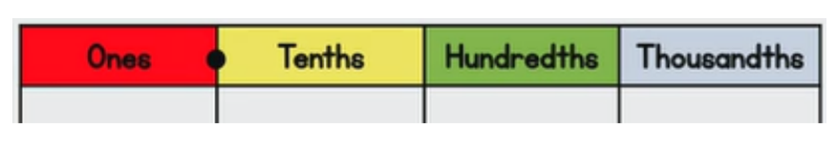

Fun Maths Challenges
This week we have included some different maths activities for you to have a go at should you want to.
