Badger Class Topic Home Learning
Week 1
This term our topic is Mountains. For the first week we will learn all about Mountain, Volcanoes and Earthquakes. following the Oak National Academy online lessons at https://classroom.thenational.academy/units/mountains-volcanoes-and-earthquakes-e02a
Keep up-to-date with your home learning, try to get this home learning pack back to me by next Monday, so
Monday
Lesson 1 – Geography - What is the earth made of?
Click for the video for today’s lesson
https://classroom.thenational.academy/lessons/what-is-the-earth-made-of-6hk3ec
In this lesson, we are going to be learning about the structure of the earth, what the earth is made of and where volcanoes and earthquakes occur and why.
Task 1 – Label the structure of the Earth
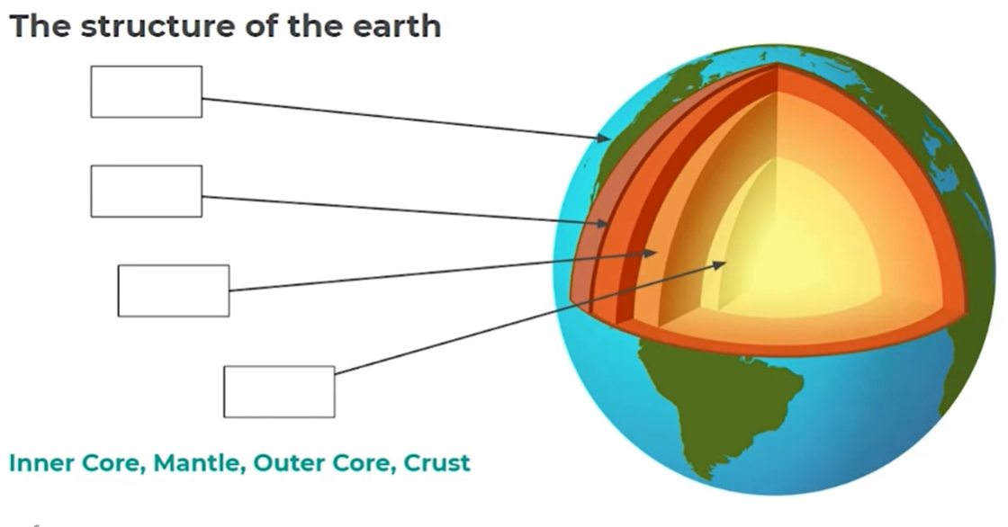
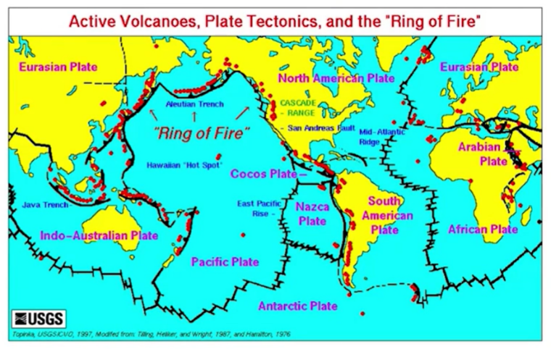
Task 2 – Where do volcanoes occur and why?

Tuesday
Lesson 2 – Geography - What are fold mountains?
Click for the video for today’s lesson
https://classroom.thenational.academy/lessons/what-are-fold-mountains-61hp2r
Task 1 - What are fold mountains?
In this lesson, we are going to be learning about mountain ranges across the world and how they are formed. We will also learn about how ocean trenches are formed.
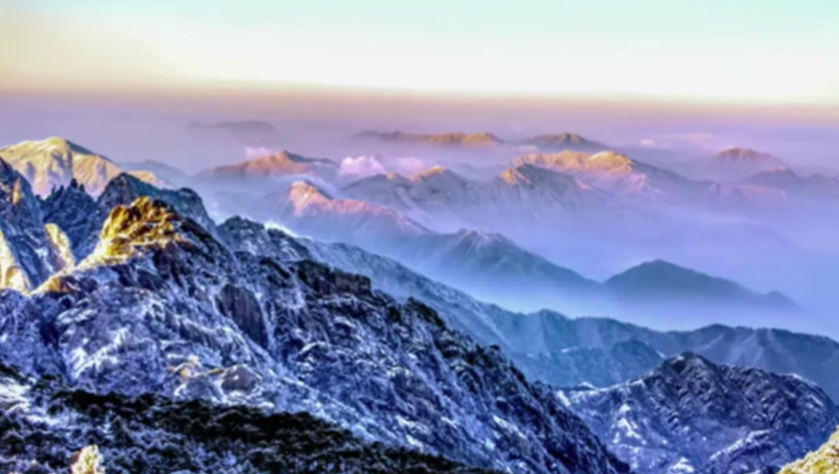
Task 2 - What are fold mountains?
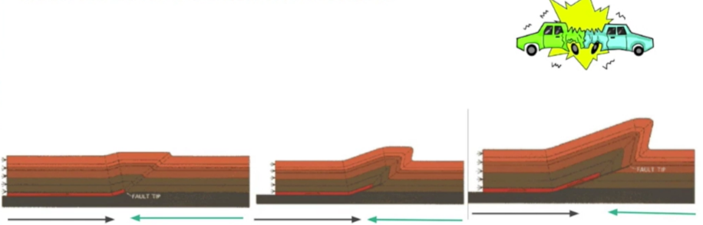
Describe how fold mountains are formed. Use the diagrams to help you
Task 1 – Fill in the blanks

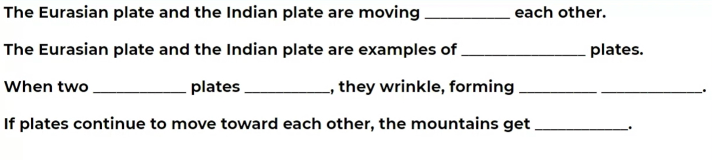

Lesson 3 – Geography – How are volcanoes made
Click for the video for today’s lesson
https://classroom.thenational.academy/lessons/how-are-volcanoes-made-71h3cd
In this lesson, we are going to be learning about how volcanoes are formed. We will then think about different types of volcanoes and we will conclude by recapping on where volcanoes are located.
Task 1 – How are volcanoes formed?
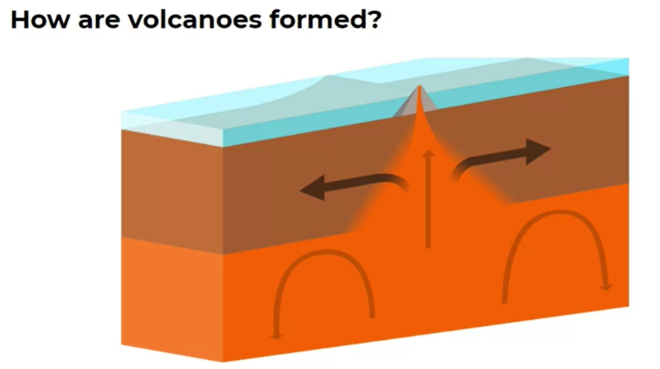

Task 2 – Label the features of a shield volcano
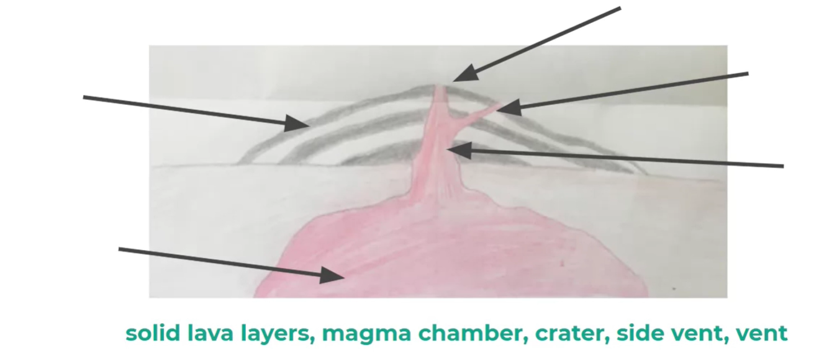
Task 2 – Label the features of a shield volcano
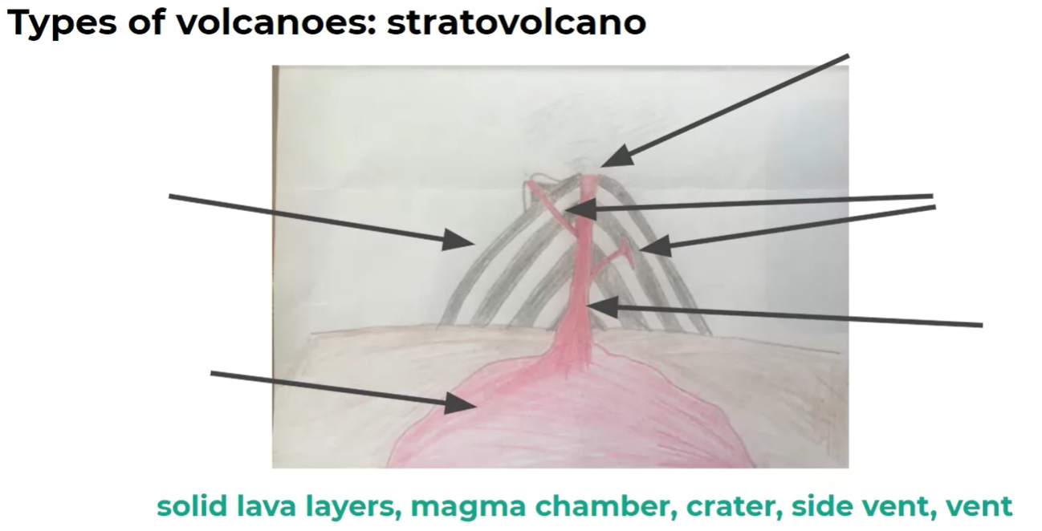

Task 3 – Complete this table comparing shield volcanoes and stratovolcanoes
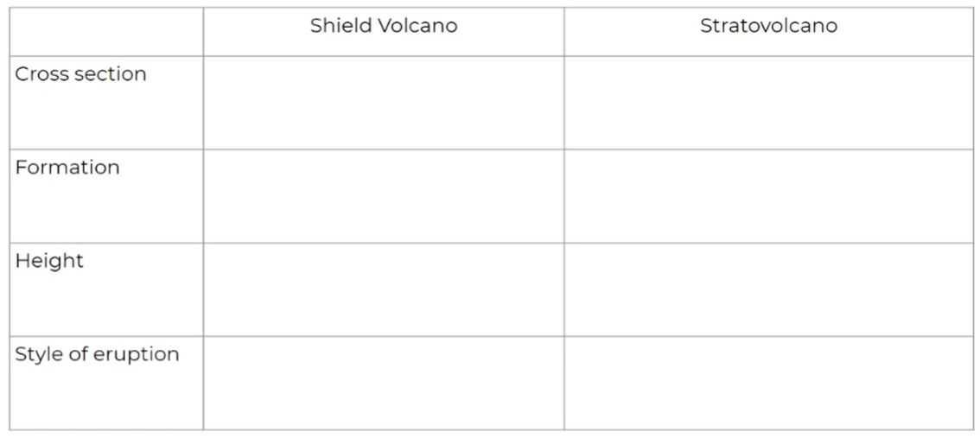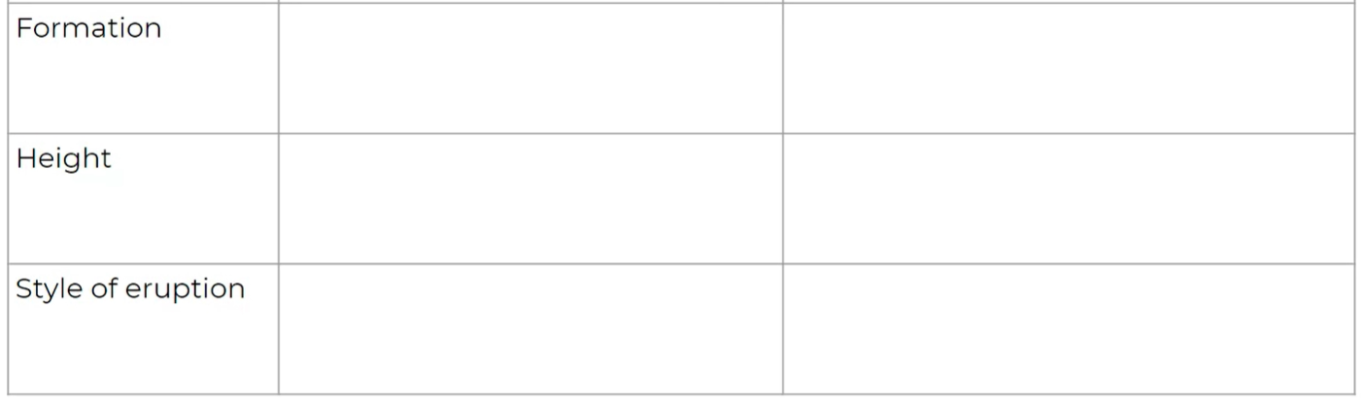

Lesson 4 – Thursday - Geography
Click for the video for today’s lesson
https://classroom.thenational.academy/lessons/how-does-an-earthquake-occur-6dk3gt
How does an earthquake occur?
In this lesson, we are going to be learning about why tectonic plates move, what an earthquake is and why they occur.
Task 1 – Write why the tectonic plates are moving.

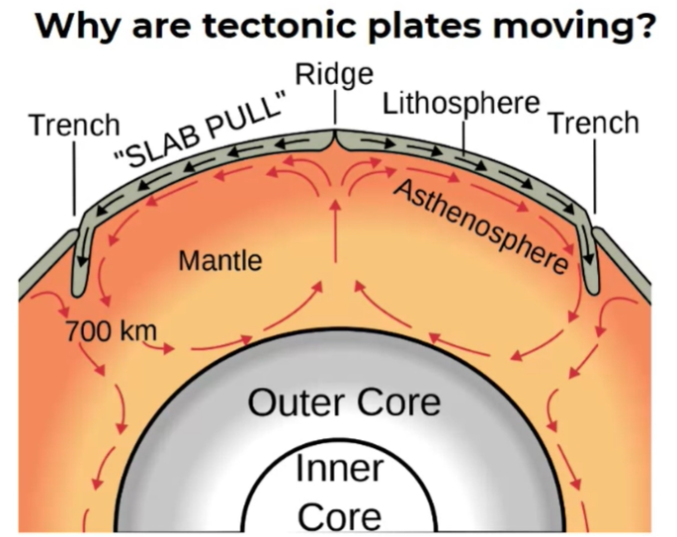
Task 2 – What causes an earthquake?
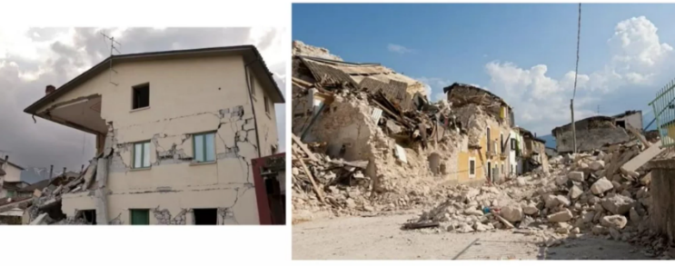
What causes an earthquake? Why are they a surprise?

Task 3 – What causes an earthquake?
Can you find out anything else about earthquakes?

Lesson 5 – Friday - Geography
Click for the video for today’s lesson
https://classroom.thenational.academy/lessons/what-happens-when-an-earthquake-occurs-6xhp2t
What happens when an earthquake occurs?
In this lesson, we are going to be looking at a case study, which means an example, of an earthquake. We will also learn about the causes of a tsunami.
Task 1 – Research about the Tohoku earthquake in Japan?
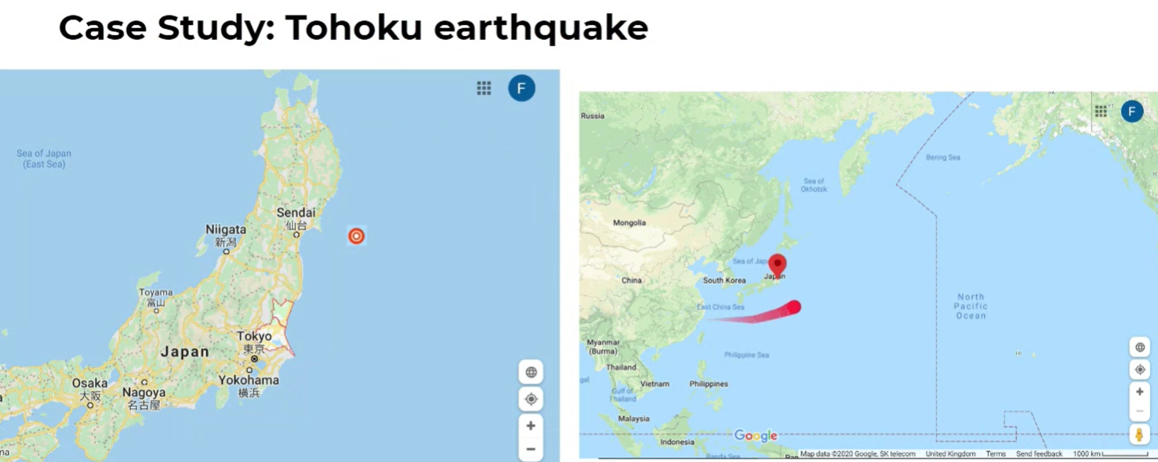
Task 2 – Complete this table on the effects of the earthquake in Tohoku, Japan
Use the information from the video to complete this table of the effects of the earthquake on society and people, the economy and the environment.
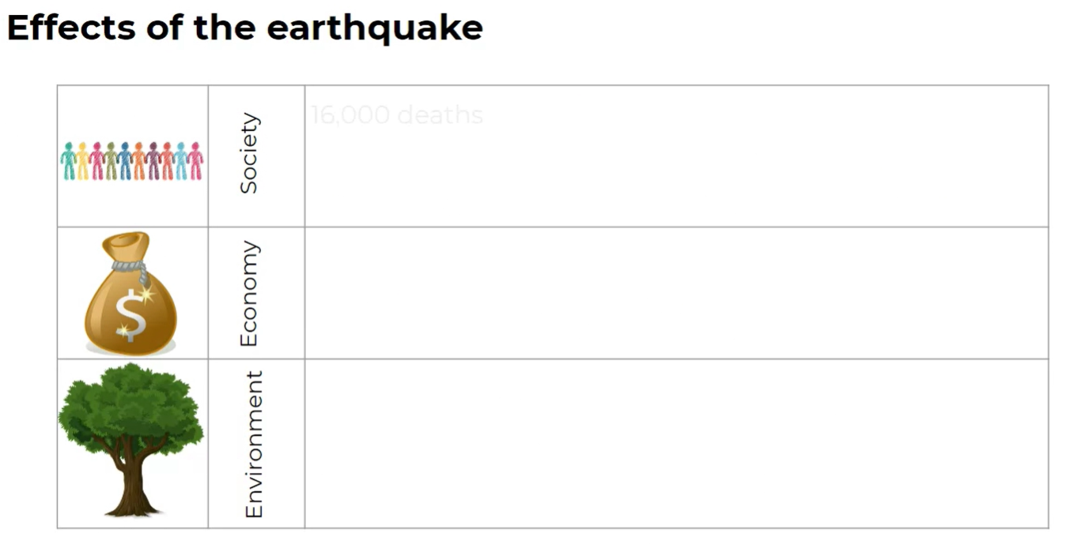

Task 2 – What causes a tsunami?
What causes a tsunami?
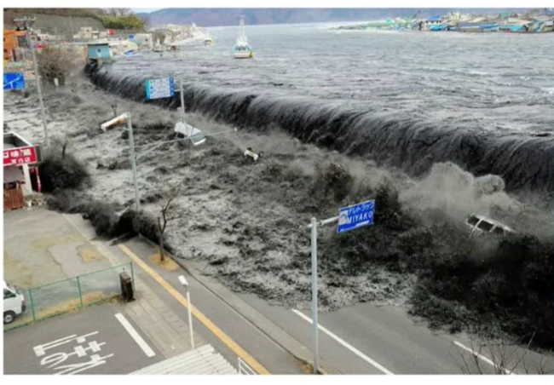

Task 3 – Find out more about tsunamis and earthquakes.

