Badger Class Maths home learning
Year 5
Week 3 - Maths – Multiplication and Division
For our Maths home learning, we are following the White Rose Maths. This is the same resource we use in school. For each lesson there is a helpful 10 minute video to provide home learning support before the worksheets.
1 - Watch the Video Lesson for That Day
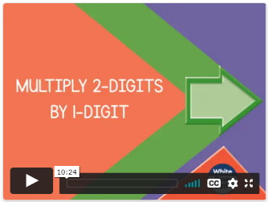
Click this https://whiterosemaths.com/homelearning/year-5/week-1-number-multiplication-division/ to go to the White Rose website and watch the 10 minute support video for that lesson before doing the worksheets:

Monday Multiply 2-digits by 1-digit

Tuesday Multiply 3-digits by 1-digit

Wednesday Multiply 4-digits by 1-digit

Thursday Multiply 2-digits (area model)

Friday Multiply 2-digits (area model)
Have a go at the questions with the video on a piece of paper or in a book. Pause or rewind the video as often as you need to answer the questions as you go along.
2 - Complete the Worksheets after the Video Lesson
There are two worksheets a front and a back (just like we do in class). The questions get trickier towards the end. Just do your best and have a go at the questions. Re-watch the video lesson if you need a reminder of the method.
Write answers down on a piece of paper or in an exercise book (remember to number the answers). You can collect a paper printouts of this learning pack from the school office if that’s better for you to write your answers on.
3 - Send Me Your Work So I Can Mark It
Once you have finished send your work to me so I can have a look, mark it and get it back to you with feedback.

How can you get your work to me?
- Take a photo of your work and email it to badgerclass@parkside.kent.sch.uk
- Drop it off at the office when you collect your next home learning pack

Times Tables
Remember to practise your times tables for 10 minutes every day.
This website is good to practise at home by yourself https://www.timestables.co.uk/
Mr King

Monday Multiply 2-digits by 1-digit (sheet 1)
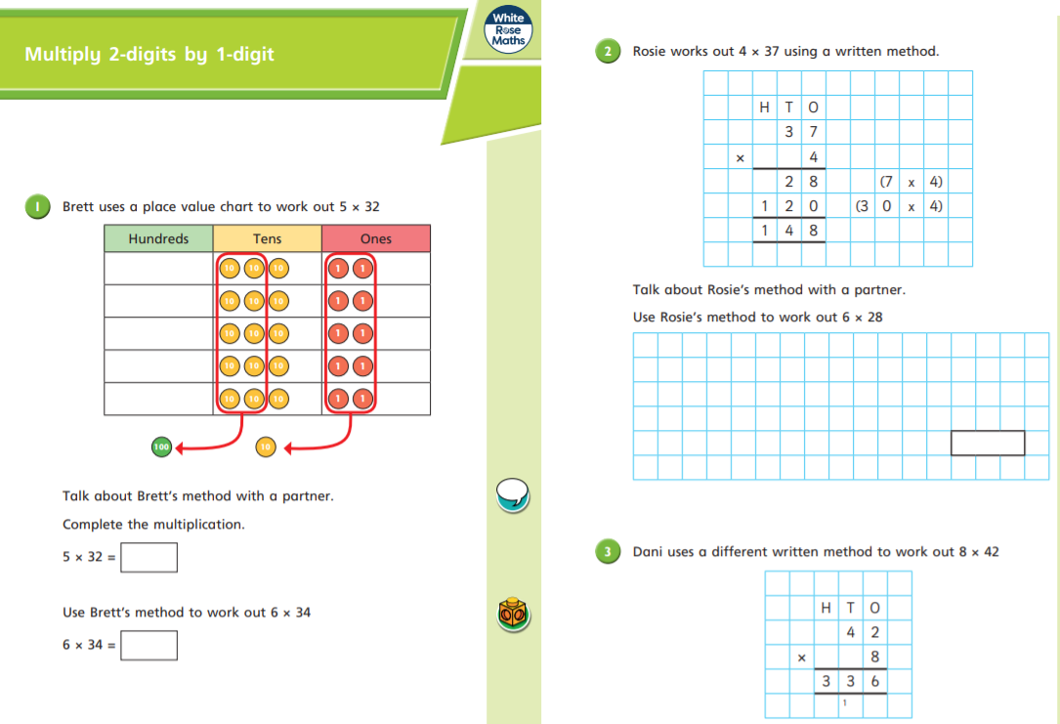
Monday Multiply 2-digits by 1-digit (sheet 2)
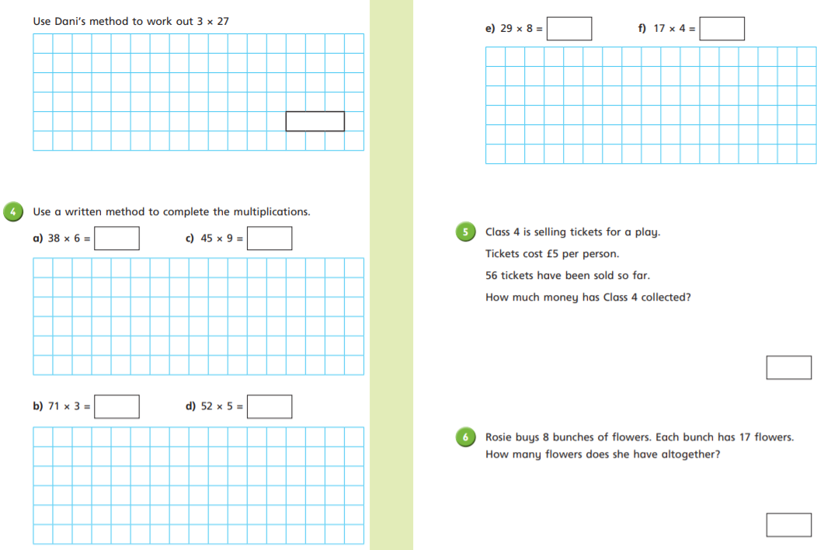

Tuesday Multiply 3-digits by 1-digit (sheet 1)
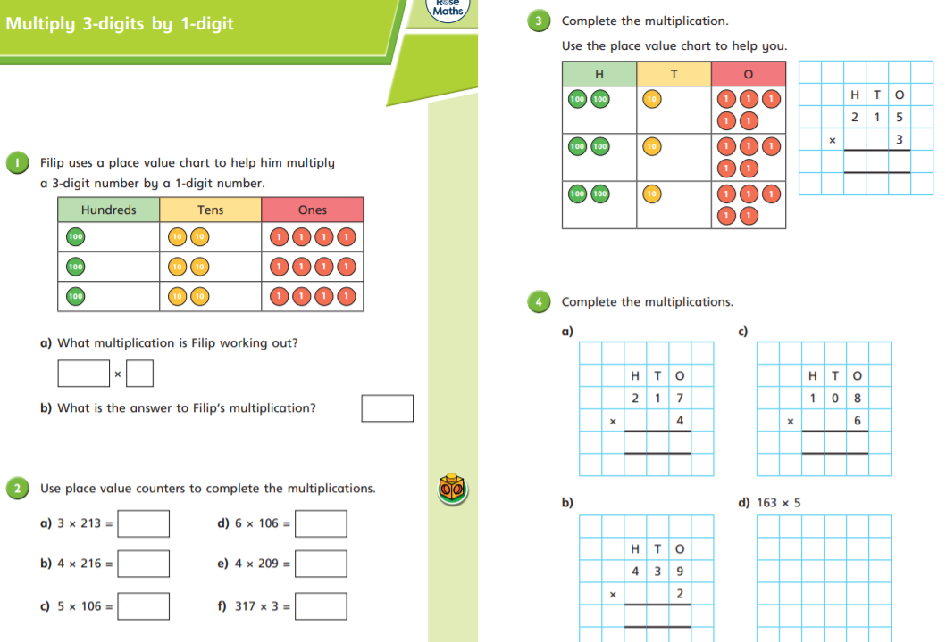

Tuesday Multiply 3-digits by 1-digit (sheet 2)

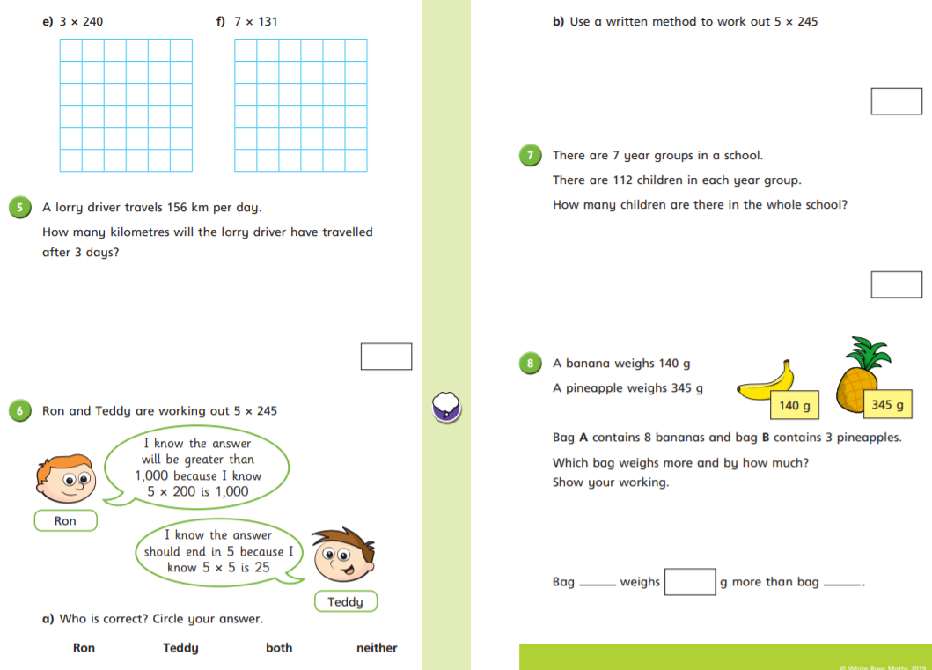

Wednesday Multiply 4-digits by 1-digit (sheet 1)

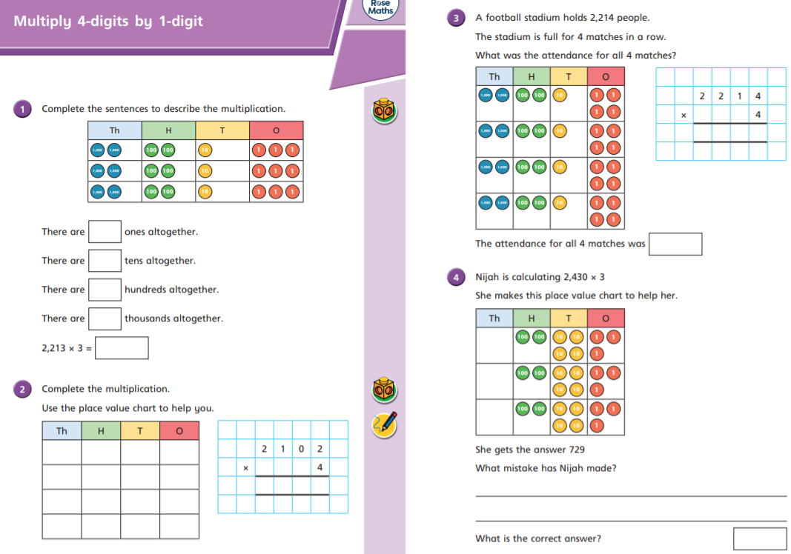

Wednesday Multiply 4-digits by 1-digit (sheet 2)

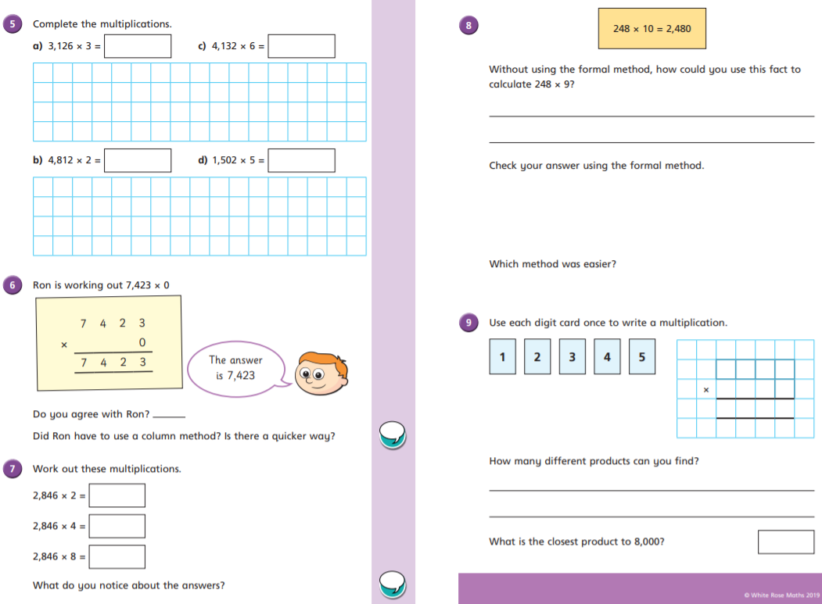
Thursday Multiply 2-digits (area model) (sheet 1)
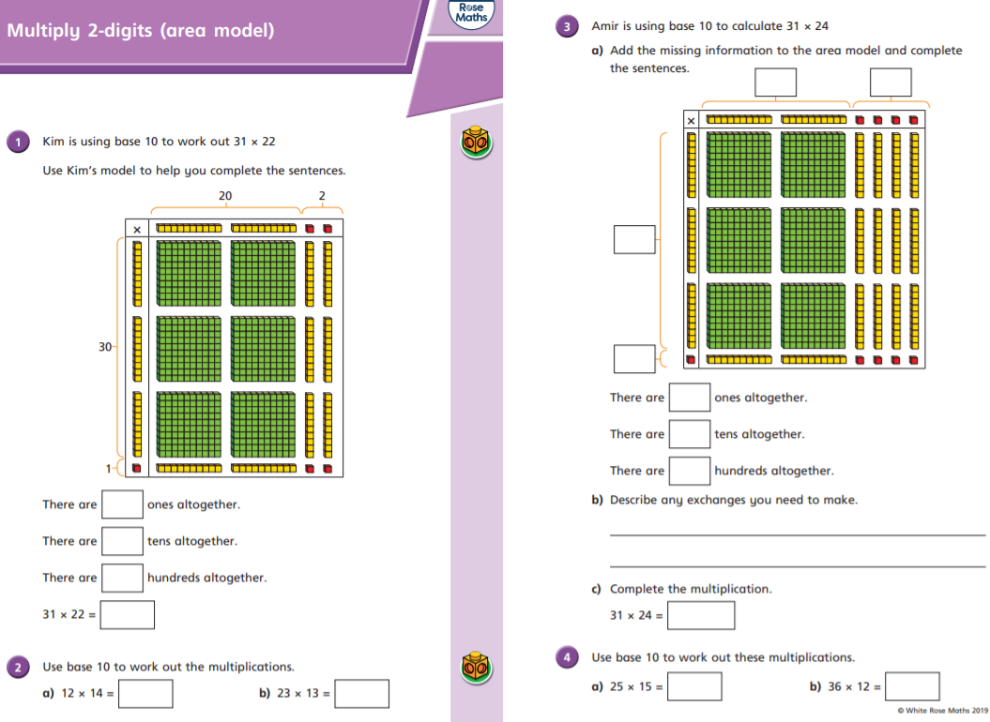

Thursday Multiply 2-digits (area model) (sheet 1)
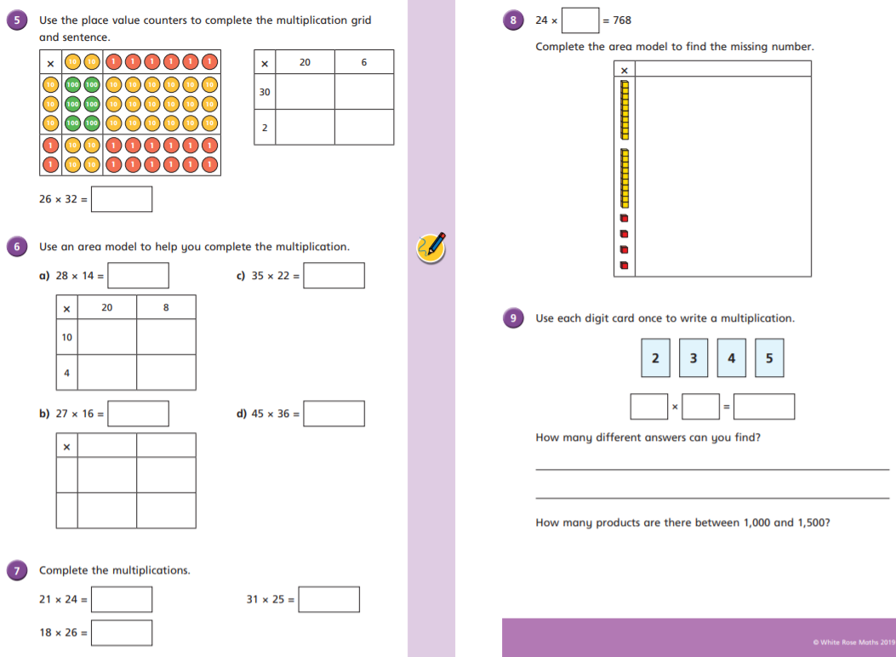

Friday Multiply 2-digits (area model) (sheet 1)
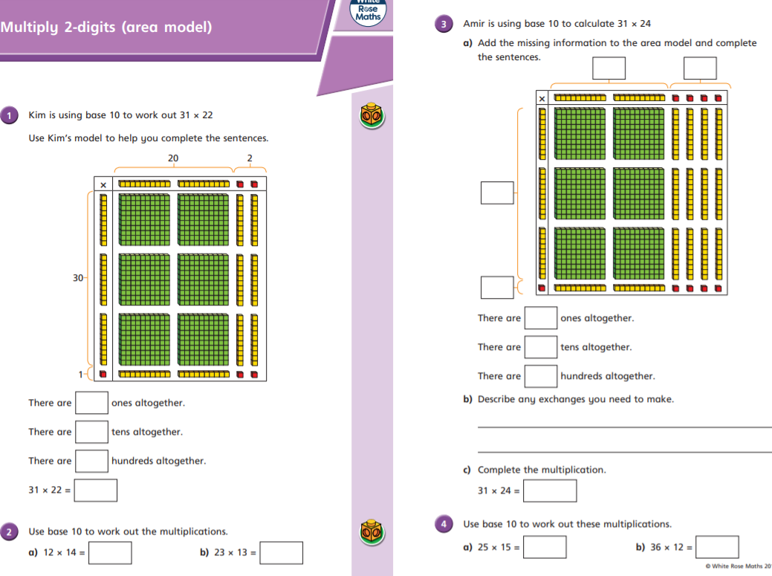

Friday Multiply 2-digits (area model) (sheet 1)
