Badger Class Topic home learning
Monday – Science
L.O. To know the main functions of the digestive system.
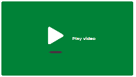
How do humans digest food?
In this lesson, we will learn about the digestive system. We will learn about the different stages, including what happens in the mouth, the stomach, and the intestines. We will also watch a demonstration and be able to explain the digestive system in our own words. https://classroom.thenational.academy/lessons/how-do-humans-digest-food-60rp4c
Task 1 - Label the organs involved in digestion in humans.
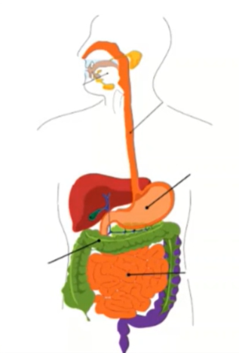
Put these labels on the diagram of the digestive system.

stomach
mouth
oesophagus
small intestine
large intestine

Task 2 – Answer these questions from the video lesson.
Can you name the three types of teeth?
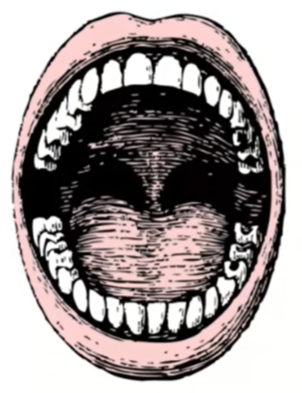

Task 3 – Answer these questions from the video lesson.
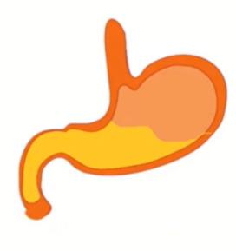
Task 4 – Numbers the steps in the digestive system.
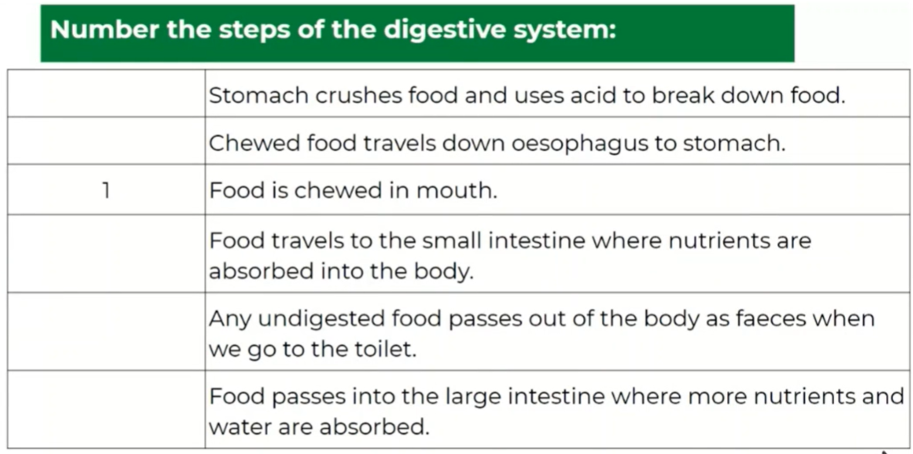
Tuesday – Music
To follow the pitch.
In this lesson, we will learn and practise how to follow the pitch of a piece of music.
https://classroom.thenational.academy/lessons/following-the-pitch-6ruk6r 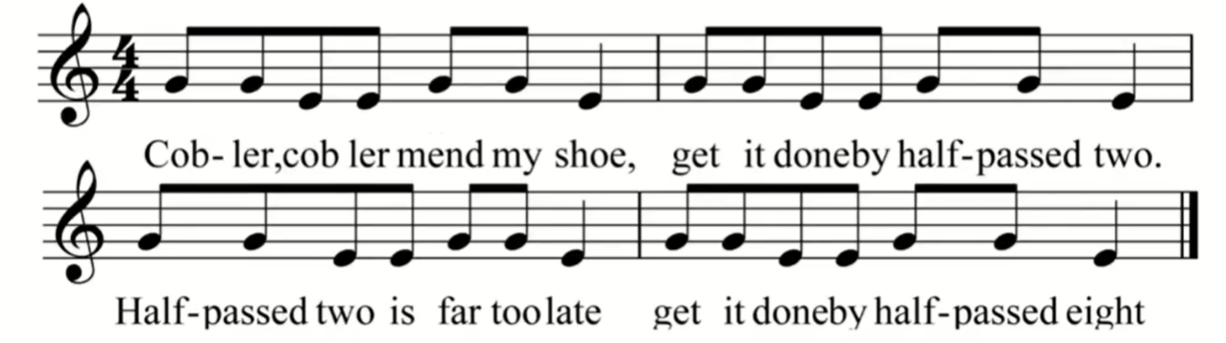
Wednesday – R.E.
L.O. To know the parables of Jesus.
In this lesson, we will be learning about the parables of Jesus. Parables are stories that Jesus told. We will be looking at three parables (stories) and will also be learning a song! You will need a piece of paper and a pencil for this lesson.
https://classroom.thenational.academy/lessons/what-are-the-parables-of-jesus-6ngp4r
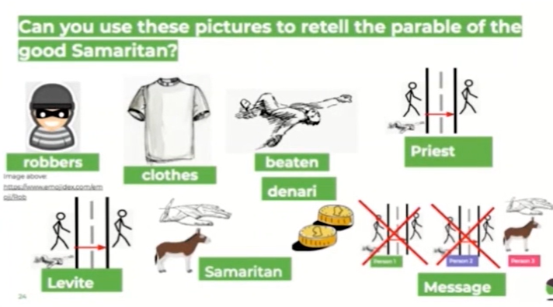
Task 1 – Retell the parable of the good Samaritan

Task 2 – Watch the video lesson about the Parable of the Sower, then match up the headings
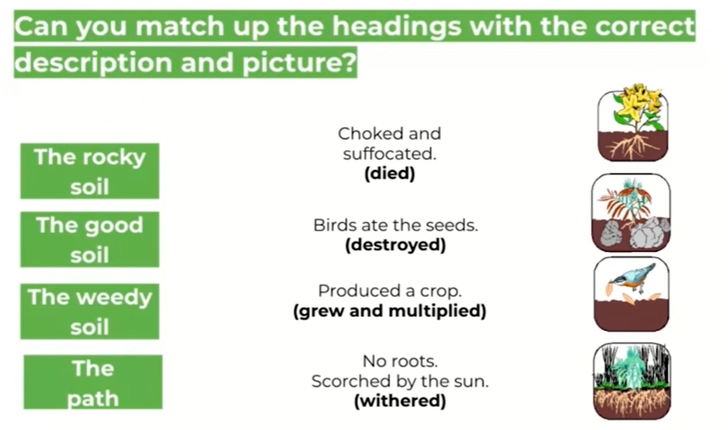
Task 3 – Which parable was your favourite? Why?

Thursday - French
L.O. To know how to count to 12 and say your age.
In this lesson, we will recap our phonics sounds and greetings from the previous lesson. Then we will learn numbers 1-12 in French and practise those by counting objects. Finally we will learn how to say our age in French.
https://classroom.thenational.academy/lessons/how-is-oxygen-transported-around-our-bodies-60vk6r
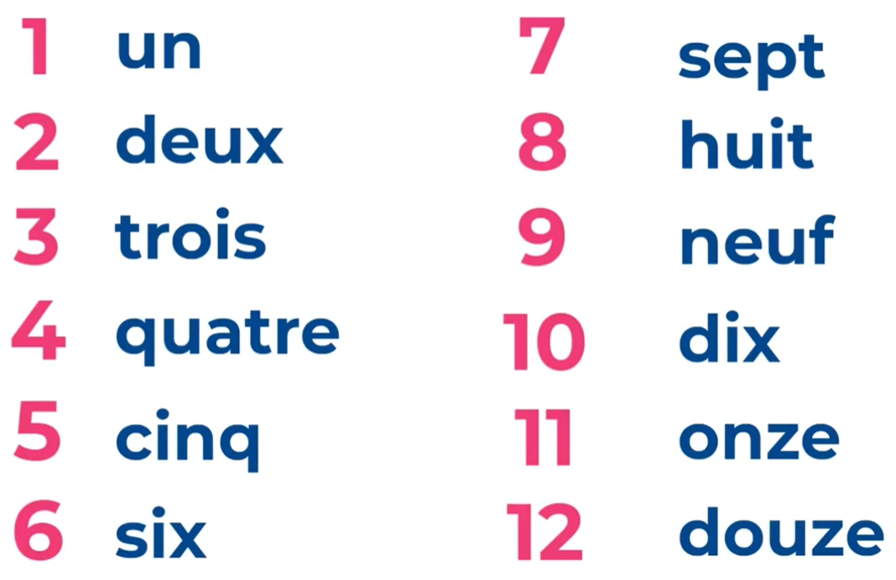 Practise with a partner at home! 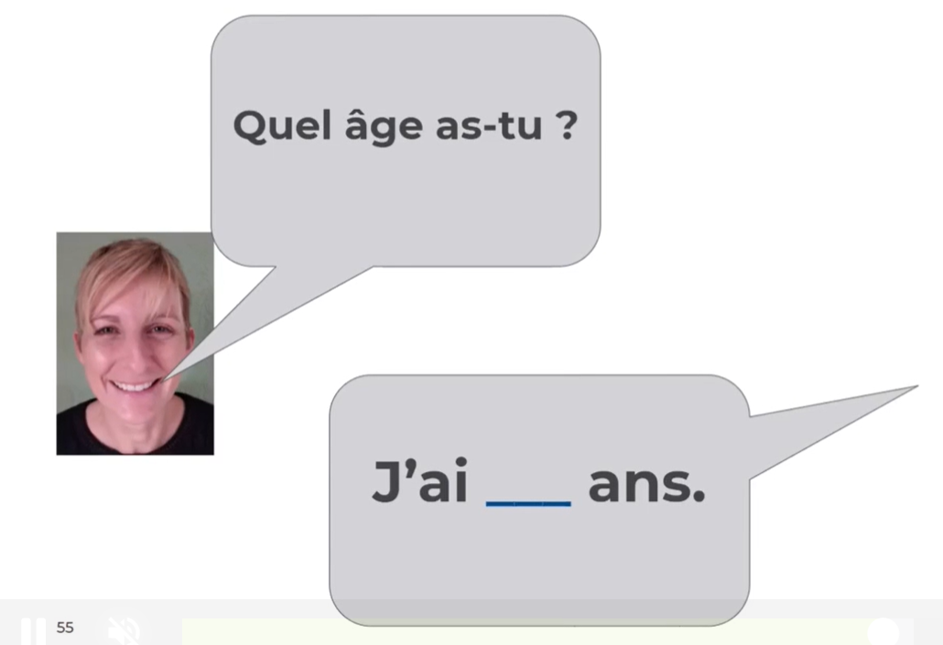
Friday - PSHE
L.O. To recognise time signatures.
We have been learning about human digestion and our teeth.
To begin the lesson, we will be exploring the term million dollar smile and define what this term means. Thereafter, we will visit the dentist who will speak to us about the importance of looking after your teeth and how it plays a role in having a million dollar smile. We will then learn about how to brush our teeth using the correct toothbrush before writing a set of instructions on how to create a million dollar smile!
https://classroom.thenational.academy/lessons/pearly-whites-6tjked
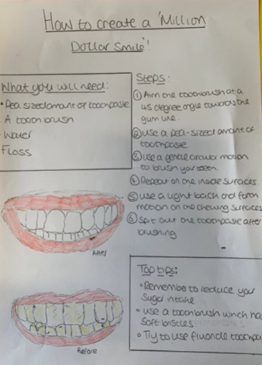
Task 1 – Create instructions for how to have a ‘million dollar smile’
Follow the video lesson and create your own instructions for how to look after your teeth.

Remember to use bullet points, ‘bossy’ imperative verbs, fact boxes, and labelled diagrams of teeth.

I look forward to seeing all your hard work.

Please bring all your hard work to school for our classroom home learning wall.
I am looking forward to seeing you all again on Monday 29th March 2021
Mr King

