Badger Class English home learning
Week 3
This week we are going to write a persuasive letter based on the picture book ‘The Day the Crayons Quit!’
You can access all the lessons that will help you write a great persuasive letter this week by clicking the link below.
https://classroom.thenational.academy/units/the-day-the-crayons-quit-persuasive-writing-0c4a
Lesson 1 – Monday
Click this link to watch today’s lesson
https://classroom.thenational.academy/lessons/to-share-and-discuss-a-story-c9h36c
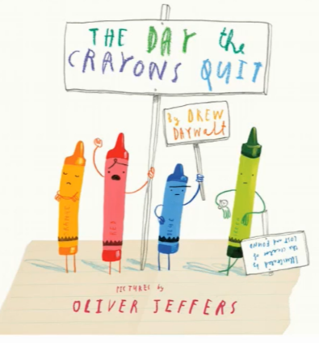
Task 1 – Make a Prediction about the story
What do you think this book will be about?
Task 2 – Infer How the Characters are Feeling
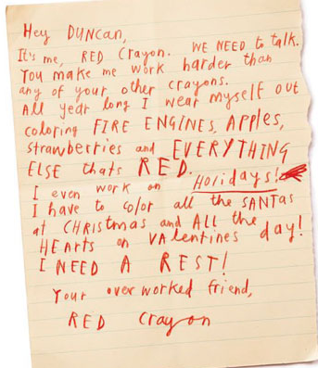
How is the red crayon feeling? What words or phrase tell us this?
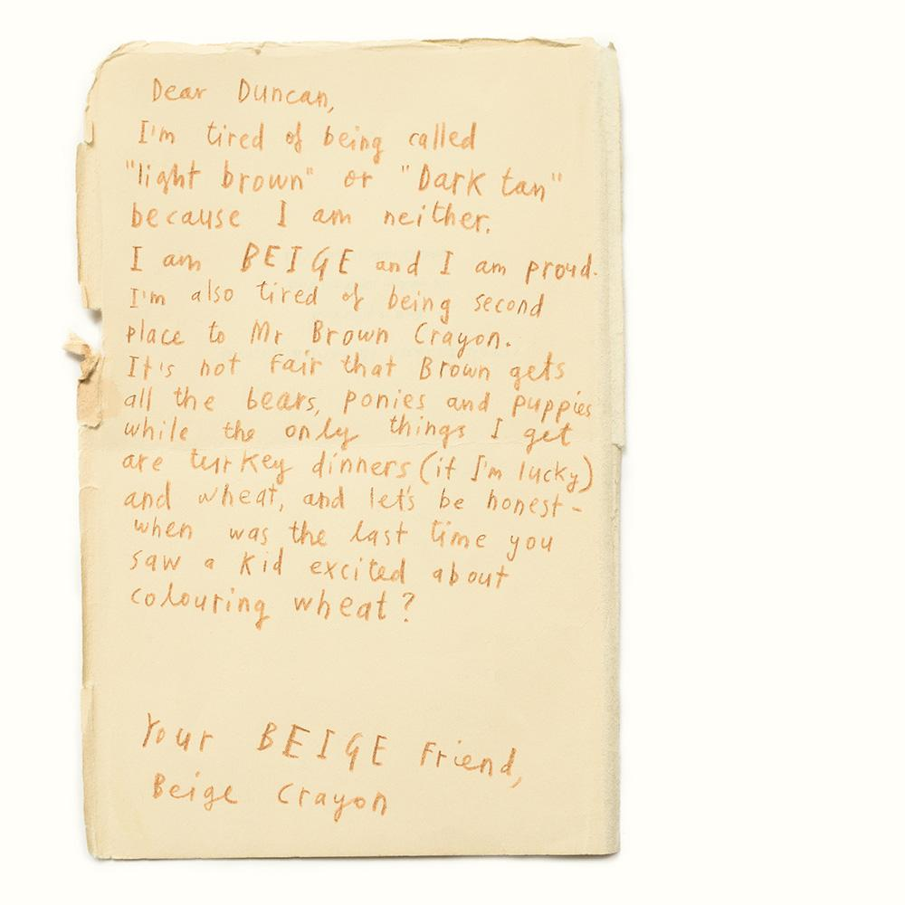

How is the beige crayon feeling? What words or phrase tell us this?
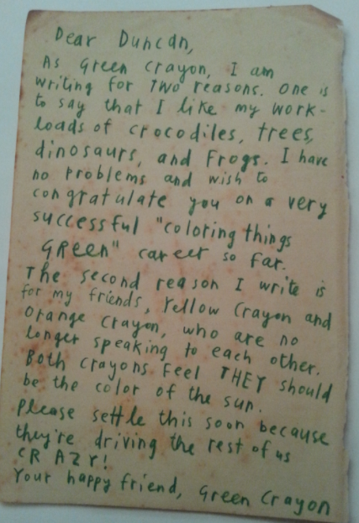
How is the green crayon feeling? What words or phrase tell us this?
What do you think will happen next?
Task 3 – Write sentences with the conjunction ‘because’
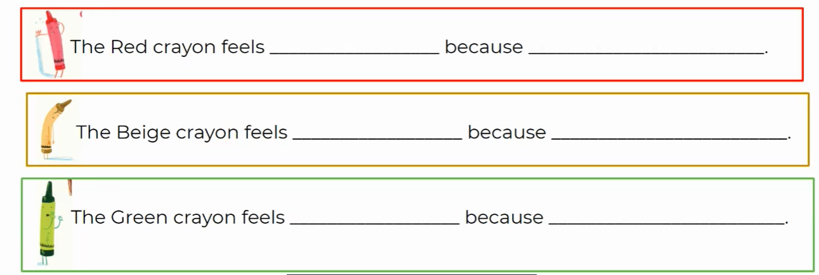
Task 4 – Use other subordinating conjunctions in sentences about the crayons.
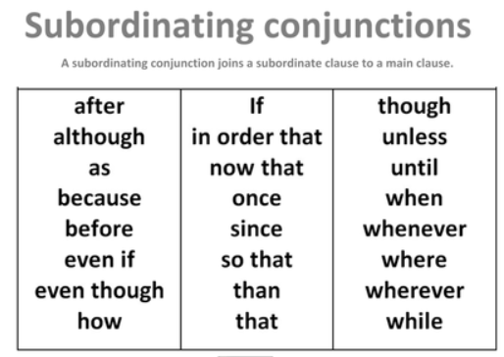

Lesson 2 – Tuesday
Click for the video for today’s lesson about the features of a persuasive letter
https://classroom.thenational.academy/lessons/to-explore-the-features-of-a-persuasive-letter-cgvked
Task 1 - Match the words to their synonym.
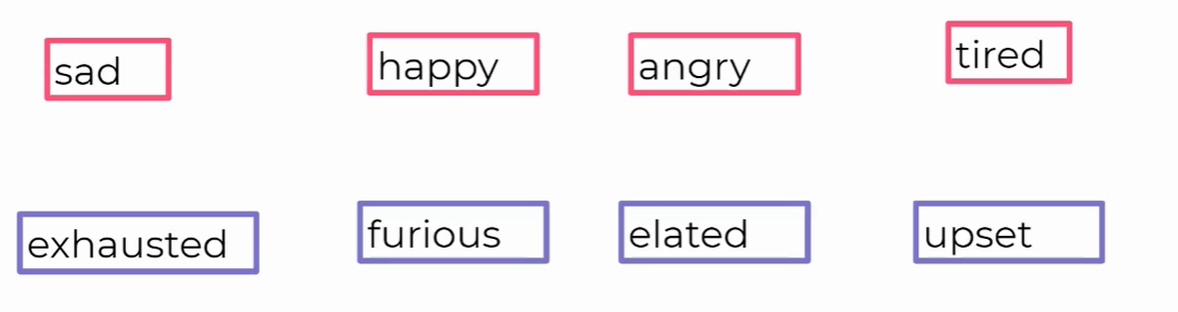
Can you think of synonyms for these words?
Sad Happy Angry Tired
Task 2 – Label the persuasive features in the letter.
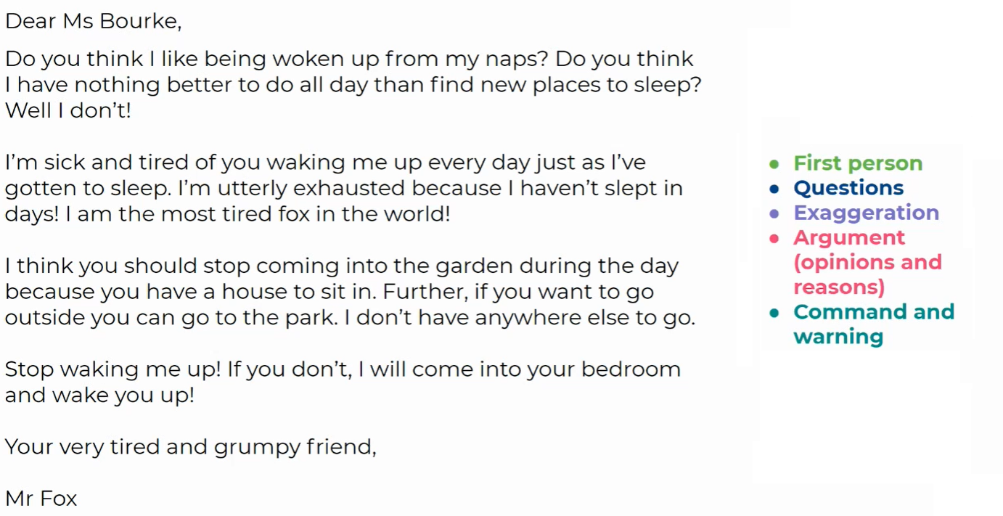

Lesson 3, Wednesday
In the lesson today we will look at synonyms and develop a rich understanding of word associated with negative emotions and create our own character. Helpfully, there are two video lessons for today!

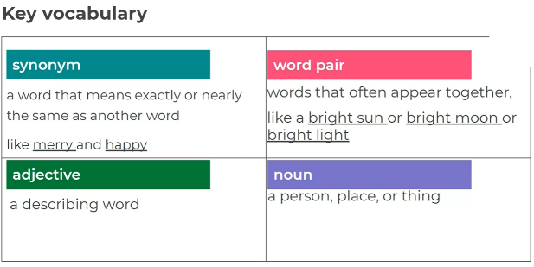
Click the video or the link for today’s lesson
https://classroom.thenational.academy/lessons/to-develop-a-rich-understanding-of-words-associated-with-negative-emotions-chhp8c

Task 1 – Writing sentences using ‘word pairs’
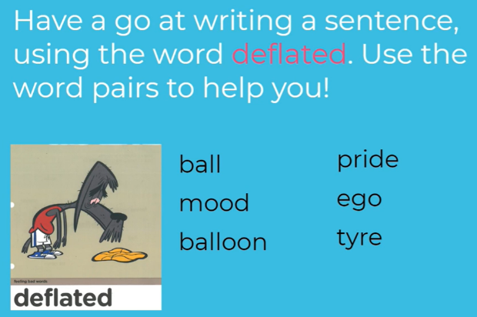

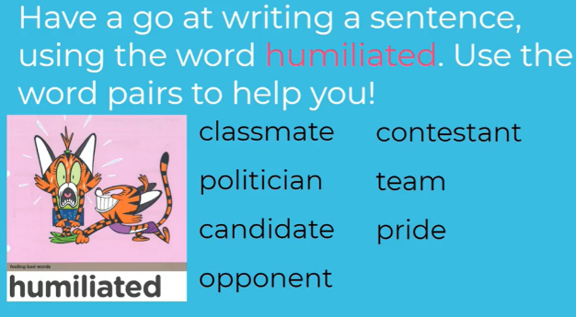

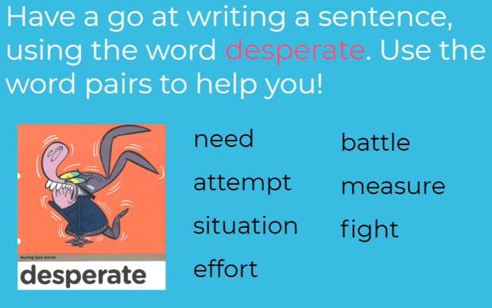

Task 3 – Write sentences with ‘bossy’ imperative verbs
Click for the video for today’s lesson about creating a character and describing their feelings
https://classroom.thenational.academy/lessons/to-devise-a-character-and-describe-how-they-are-feeling-cnjk4d

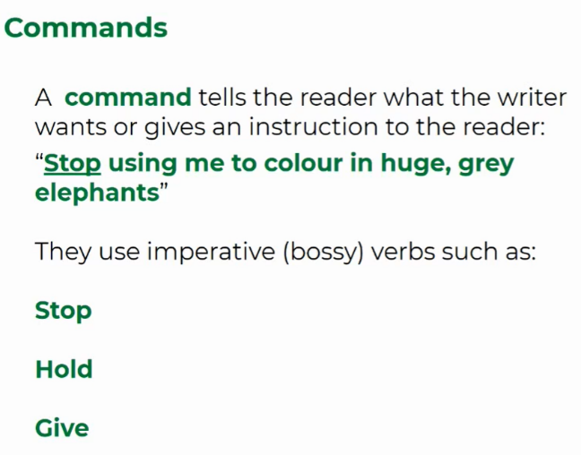
Task 4- Think of reasons why these objects might want to quit
Why might your trainers want to quit? How might they be feeling?
What might they say?
Why might your teddy bear want to quit? How might they be feeling?
What might they say?

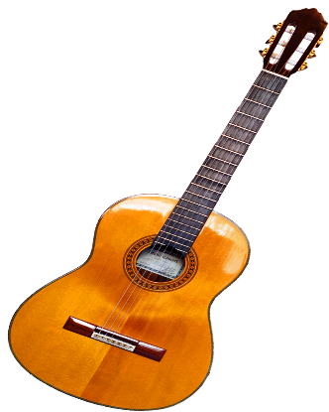
Why might your guitar want to quit? How might it be feeling?
What might it say?

Task 5- Think about your own character and how it might feel
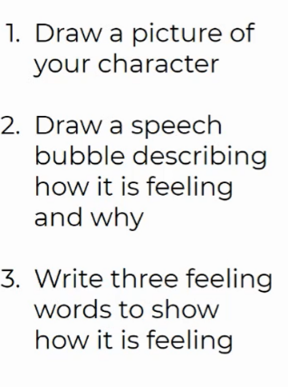

Three words to show how my character is feeling

______________ ______________ ______________

Can you think of any synonyms for these words?

Lesson 4 – Thursday
Click for the video for today’s lesson about the features of a persuasive letter
https://classroom.thenational.academy/lessons/to-orally-rehearse-paragraph-one-of-a-persuasive-letter-61hpcr
Task 1 – Plan Your Persuasive Writing
Think about the character you created that would ‘quit’. Think about how they feel and that they might say.
How do you feel?
Why do you feel that way?
What do you want your owner to change?
What would make you happy?
Task 2 – Plan your first paragraph
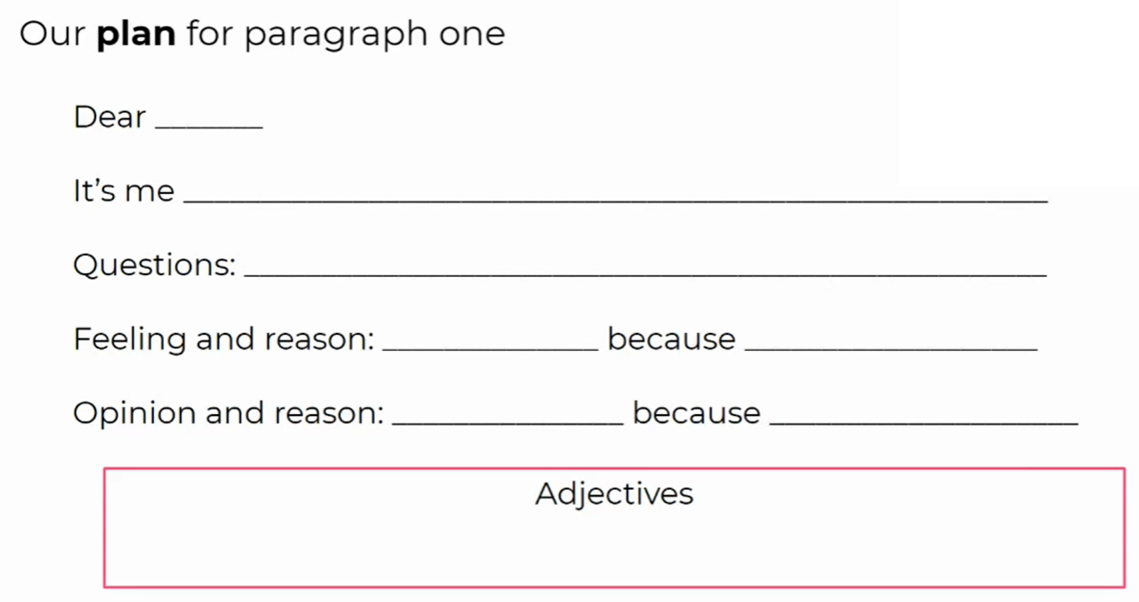

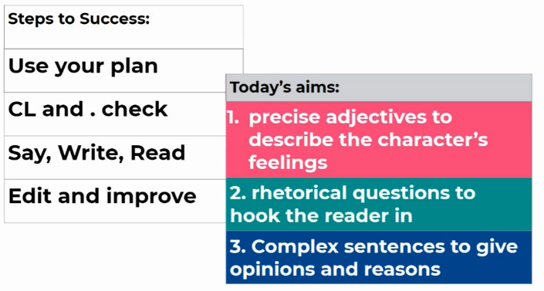
Task 3 –Write your first paragraph to your persuasive letter
Click for the video for today’s lesson about the features of a persuasive letter
https://classroom.thenational.academy/lessons/to-write-the-first-paragraph-of-a-persuasive-letter-74u3jt
Follow the video above to write your first paragraph of your persuasive letter from your ‘character’ to its owner. Read to use your plan and what you have learned so far this week!

Lesson 5 – Friday
Click for the video for today’s lesson about the features of a persuasive letter
https://classroom.thenational.academy/lessons/to-write-the-second-paragraph-of-a-persuasive-letter-c9k3cc
Task 1 –Read the example letter and identify the success criteria
Can you identify all the features you have learned this week?
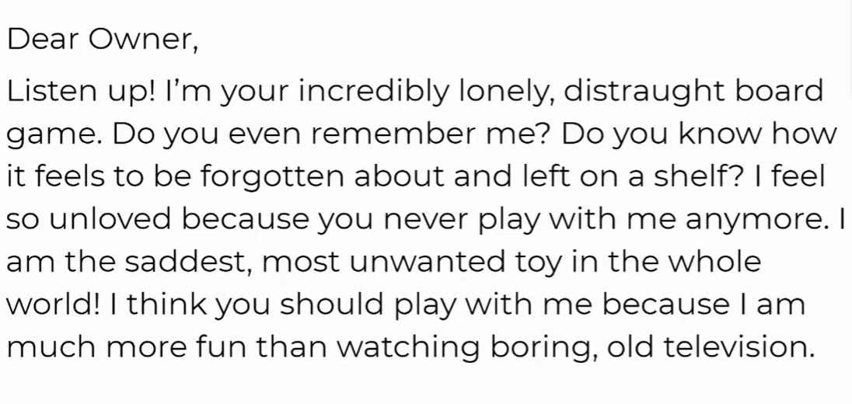
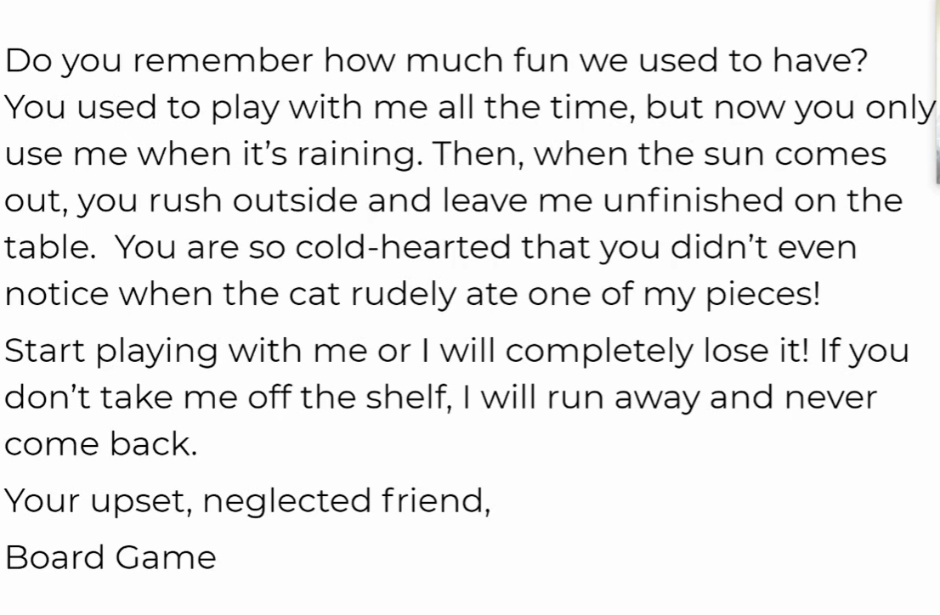
Task 2 – Plan Your Persuasive Writing
Think about the character you created and read back over yesterday’s paragraph. Follow the video lesson and look at the plan for paragraph two. 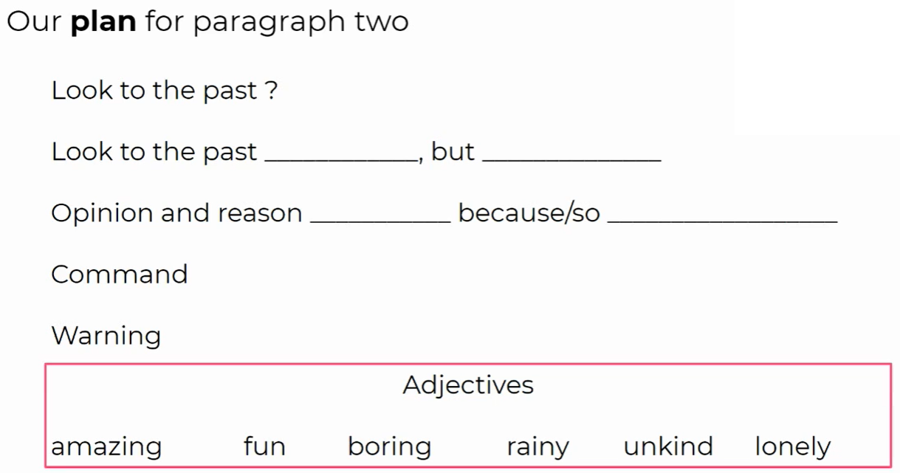

Task 3 – Write your second paragraph following the plan

Remember to share your work with your teacher. Take a photo and email it to badgerclass@parkside.kent.sch.uk or drop off this learning pack to the school office when you collect the pack next week. Mr King

